

GRADE 10
COMPETENCE BASED CURRICULUM
SENIOR SCHOOL
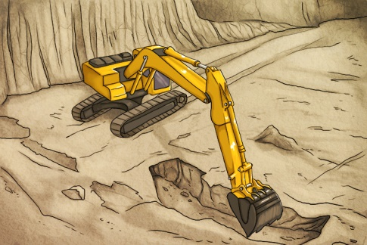
GUIDENOTES
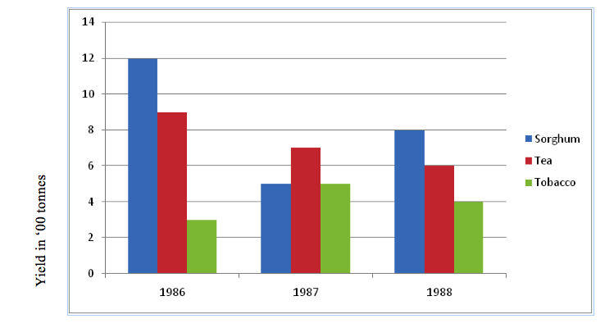



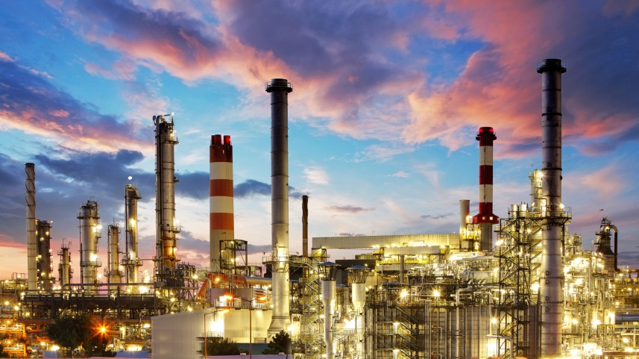


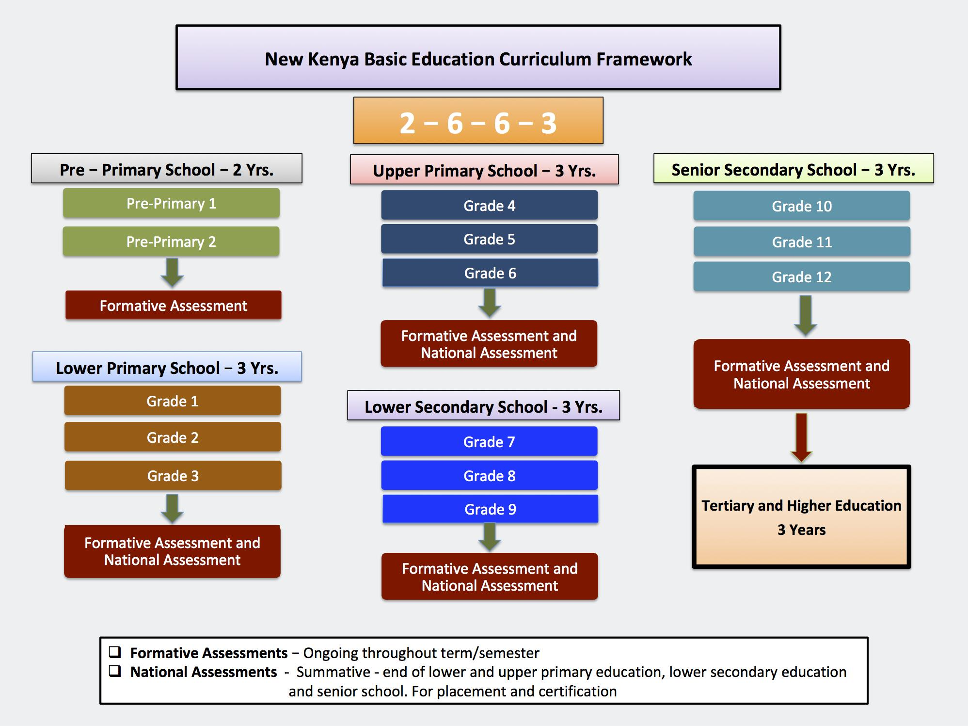


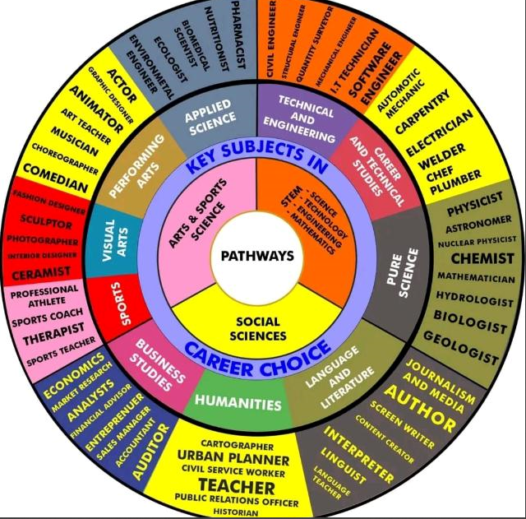

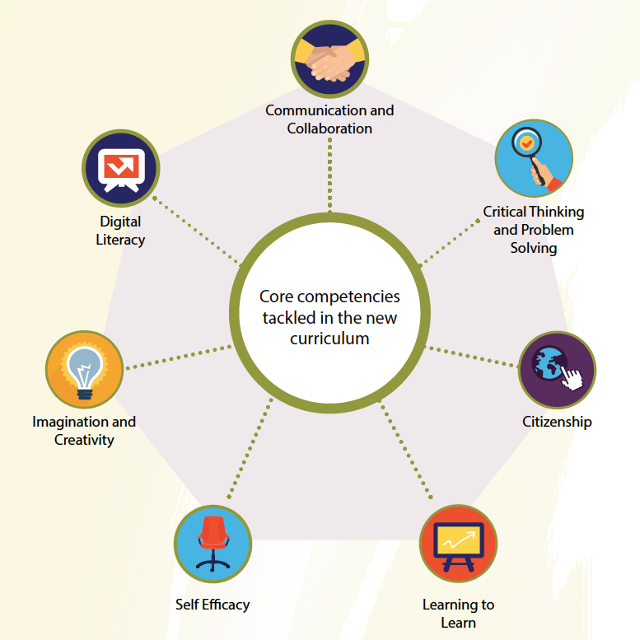

NATIONAL GOALS OF EDUCATION
Education in Kenya should:
1. Foster nationalism and patriotism and promote national unity
Kenya’s people belong to different communities, races and religions, but these differences need not divide them. They must be able to live and interact as Kenyans. It is a paramount duty of education to help young people acquire this sense of nationhood by removing conflicts and promoting positive attitudes of mutual respect which enable them to live together in harmony and foster patriotism in order to make a positive contribution to the life of the nation.
2. Promote the social, economic, technological and industrial needs for national development
Education should prepare the youth of the country to play an effective and productive role in the life of the nation.
a) Social Needs
Education in Kenya must prepare children for changes in attitudes and relationships which are necessary for the smooth progress of a rapidly developing modern economy. There is bound to be a silent social revolution following in the wake of rapid modernization. Education should assist our youth to adapt to this change.
b) Economic Needs
Education in Kenya should produce citizens with the skills, knowledge, expertise and personal qualities that are required to support a growing economy. Kenya is building up a modern and independent economy which is in need of an adequate and relevant domestic workforce.
c) Technological and Industrial Needs
Education in Kenya should provide learners with the necessary skills and attitudes for industrial development. Kenya recognizes the rapid industrial and technological changes taking place, especially in the developed world. We can only be part of this development if our education system is deliberately focused on the knowledge, skills and attitudes that will prepare our young people for these changing global trends.

3. Promote individual development and self-fulfilment
Education should provide opportunities for the fullest development of individual talents and personality. It should help children to develop their potential interests and abilities. A vital aspect of individual development is the building of character.
4. Promote sound moral and religious values
Education should provide for the development of knowledge, skills and attitudes that will enhance the acquisition of sound moral values and help children to grow up into self-disciplined, self-reliant and integrated citizens.
5. Promote social equity and responsibility
Education should promote social equality and foster a sense of social responsibility within an education system which provides equal educational opportunities for all. It should give all children varied and challenging opportunities for collective activities and corporate social service irrespective of gender, ability or geographical environment.
6. Promote respect for and development of Kenya’s rich and varied cultures
Education should instill in the youth of Kenya an understanding of past and present cultures and their valid place in contemporary society. Children should be able to blend the best of traditional values with the changing requirements that must follow rapid development in order to build a stable and modern society.
7. Promote international consciousness and foster positive attitudes towards other nations
Kenya is part of the international community. It is part of the complicated and interdependent network of peoples and nations. Education should therefore lead the youth of the country to accept membership of this international community with all the obligations and responsibilities, rights and benefits that this membership entails.
8. Promote positive attitudes towards good health and environmental protection
Education should inculcate in young people the value of good health in order for them to avoid indulging in activities that will lead to physical or mental ill health. It should foster positive attitudes towards environmental development and conservation. It should lead the youth of Kenya to appreciate the need for a healthy environment.
LEARNING OUTCOMES FOR SENIOR SCHOOL
By the end of senior school, the learner should be able to:
1. Communicate effectively and utilize information and communication technology across varied contexts,
2. Apply mathematical, logical and critical thinking skills for problem solving,
3. Apply basic research and scientific skills to manipulate the environment and solve problems,
4. Exploit individual talents for leisure, self-fulfillment, career growth, further education and training,
5. Uphold national, moral and religious values and apply them in day-to-day life,
6. Apply and promote health care strategies in day-to-day life,
7. Protect, preserve and improve the environment for sustainability,
8. Demonstrate active local and global citizenship for harmonious co-existence,
9. Demonstrate appreciation of diversity in people and cultures,
10. Manage pertinent and contemporary issues responsibly.

THE SENIOR SCHOOL IN THE COMPETENCY BASED CURRICULUM (CBC)
Senior School is the forth level of Basic Education in the Competency Based Curriculum (CBC) that learners shall come to after the Pre-Primary, Primary and Junior School (JS). The essence of Senior School is to offer learners a Pre- University/ Pre- career experience where the learners have an opportunity to choose pathways where they have demonstrated interest and/or potential at the earlier levels. Senior school comprises three years of education for learners in the age bracket of 15 to 18 years and lays the foundation for further education and training at the tertiary level and the world of work. In the CBC vision, learners exiting this level are expected to be engaged, empowered and ethical citizens ready to participate in the socio-economic development of the nation.
At this level, learners shall take SEVEN (07) learning areas (LAs) as recommended by the Presidential Working Party on Educational Reforms (PWPER). These shall comprise Four Compulsory learning areas, and Three learning areas opted for by the learner according to their choses Pathway. While English and Kiswahili are indicated as Compulsory, the learners who opt for these learning areas as their subjects of specialization shall go through a differentiated curriculum in terms of scope, experiences and assessment. Such learners shall; therefore, take Advanced English or Kiswahili Kipevu with additional two lessons. It is recommended that AT LEAST TWO learning areas should be from chosen Pathway. In exceptional cases, some learners may opt for ONE learning area from the chosen Pathway and a maximum of TWO learning areas from any of the three pathways; depending.

LIST OF LEARNING AREAS AT SENIOR SCHOOL
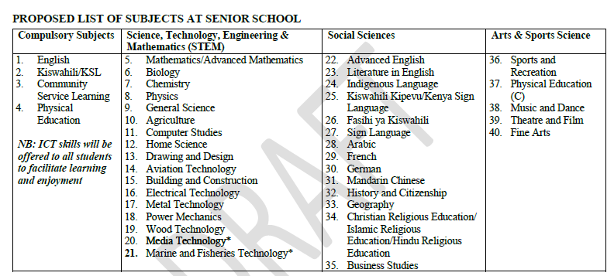

LESSON DISTRIBUTION AT SENIOR SCHOOL
The number of lessons in each of the compulsory learning areas shall be 4; while the optional areas shall be 6 lessons each. A lesson shall be 40 minutes. The "free" lessons shall be used for development of ICT skills, Pastoral Instruction Programme (PPI), projects, collaborative study and further reading.

ESSENCE STATEMENT
Geography is the study of the Earth, people and their inter-relationships in the context of place, space, environment and time. It draws content from a wide range of disciplines such as Computer Science, Economics, Engineering, Mathematics, Cartography and History. The content is organized around the themes of human-environment interactions, location, place, movement and region. There are two main branches of Geography namely; Physical and Human Geography. The practical components of Map work, Fieldwork, Photograph work, Geographic Information Systems (GIS), Elementary Surveying and Statistics cut across the Physical and Human Geography.
Geography incorporates distinctive knowledge that equips the learner with the 21st Century competencies in order to cope with environmental and societal challenges at local, national, regional and global levels. To enrich the content, therefore, the Pertinent and Contemporary Issues are infused and integrated in the curriculum. Further, the subject is fundamental in the attainment of the National Goals of Education and global aspirations on sustainable development. It also lays a strong foundation for further education and career development.
The study of Geography adopts the Learning Styles Models that emphasize on creation of knowledge through transformative experiences for lifelong learning and in-depth understanding of the environment. |Learning of Geography therefore, should be practical and culturally responsive to the natural and human phenomena in the local and extended environments. In addition, the subject should engage the learner in meaningful and relevant activities which allow application of concepts learnt and foster positive attitude towards the environment.

SUBJECT GENERAL LEARNING OUTCOMES
By the end of Senior Secondary, the learner should be able to:
1. Demonstrate an understanding of the relationship between Geography and other disciplines for career development
2. Apply appropriate geographical knowledge, skills, values and attitudes as a basis for technological and industrial development
3. Manage and conserve the physical and human environments for socio-economic development
4. Appreciate the interdependence between the Earth’s systems and processes for environmental sustainability
5. Use individual talents and geographical skills for self-reliance and spatial interactions at local, national, regional and global levels

SUMMARY OF STRANDS AND SUB STRANDS
1.0 PRACTICAL GEOGRAPHY INTRODUCTION TO GEOGRAPHY
1.1 Map Reading and Interpretation
1.2 Statistical Methods
1.3 Geographic Information System
2.0 NATURAL SYSTEMS AND PROCESSES ROCKS
2.1 Earth Movements
2.2 Folding
2.3 Vulcanicity
2.4 Earthquakes
3.0 HUMAN AND ECONOMIC ACTIVITIES AGRICULTURE
3.1 Mining
3.2 Energy
3.3 Industry

STRAND 1: PRACTICAL GEOGRAPHY

Introduction to Geography
- It is defined as the scientific study of the earth as a home of man.
- Study of interrelationship on natural and human phenomena on the earth's surface.

Branches of Geography

Physical Geography
It Deals with the study of natural physical environment of human kind.
Covers:
- Geology- study of the origin, structure and composition of the earth. It includes study of rocks.
- Geomorphology- the study of internal and external land forming processes and landforms.
- Climatology- the study of climate and weather
- Pedology- the study of soils
- Biogeography- the study of soils, vegetation and animals.
- Hydrology- the study of water bodies
- Spatial geography- study of space
Human and Economic Geography
- Study of people and their activities on the earth's surface. It covers:
- Mining
- Forestry
- Agriculture
- Fishing
- Wildlife and tourism
- Industry
- Energy etc.

Practical Geography
-A smaller branch which equips the learner with practical skills that enhance their understanding and interpretation of human and physical geographical information. It covers:
- Statistical methods
- Map work
- Field work
- Photograph work

Importance of Learning Geography
- Facilitates good relationship among nations by studying geography of other regions of the world.
- It's a career subject in that it enables one to go for advanced studies in specialized fields e.g. geography teachers, meteorology, surveying etc.
- Enables us to appreciate other people's way of life by learning economic activities of different communities within our country and other parts of the world.
- Enables us to conserve our environment when we learn negative and positive effects of human activities on the environment.
- Enables us to conserve our resources when we learn wise use of resources in conservation and management of resources e.g. wildlife, forests, energy, etc.
- Inculcates in us virtues of cooperation and patience as we work in groups.
- Makes us to appreciate manual work as we are involved in practical geography which may lead to self employment.
- Promotion of industry such as tourism by guiding tourists to places of interest by using maps, calculations of distances etc

Relationship between Geography and Other Subjects
- Mathematics- mathematical techniques are used in drawing graphs and pie charts and mathematical formulae are used in geography to calculate distances, areas, population density, population densities, etc.
- History- history uses geographical tools like maps, charts and graphs to show where past events took place e.g. the movement of people in the past.
- Meteorology- geography uses meteorological information in the study of weather and in classifying climatic regions and mapping them.
- Physics- geography uses physics principles and formulae to calculate and describe aspects such as magnetic field, gravity, vibrations of the earth etc.
- Chemistry- geography applies chemistry in studying chemical composition and chemical changes which take place in soils and rocks.
- Geology- geography studies rocks.
- Agriculture- geography studies farming systems, their distribution and factors affecting farming activities.
- Biology- Geography explains the distribution of organisms and factors influencing their distribution on the earth's surface.
- Economics- Useful in studying trade patterns, resource distribution, and economic geography.
- Computer Studies (GIS & Remote Sensing)- Modern geographical studies use tech tools for mapping and spatial analysis

d) Careers Related to Geography

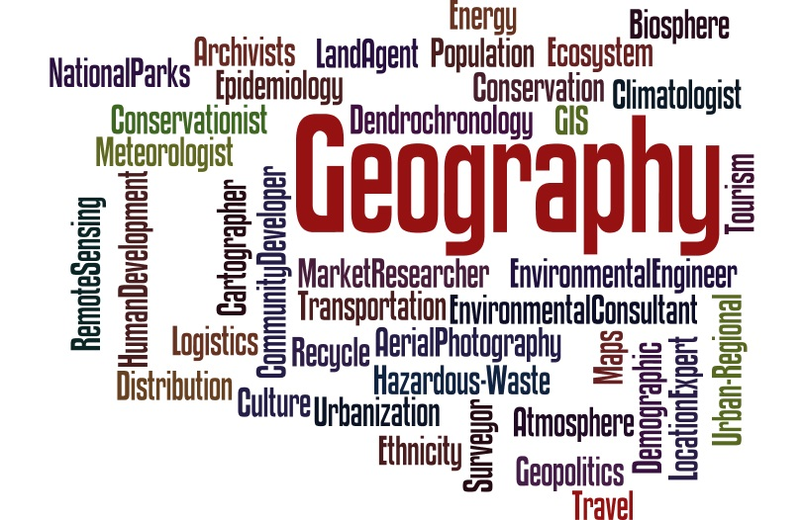
Geography provides pathways to many careers, such as:
Branch | Possible Careers
Physical Geography | Meteorologist, Geologist, Environmental Scientist
Human Geography | Urban Planner, Development Officer, Demographer
Environmental Geography | Environmental Consultant, Ecologist, Conservationist
Cartography | Cartographer, GIS Specialist, Remote Sensing Analyst
Tourism | Tour Guide, Travel Consultant, Tourism Manager
Transport | Traffic Planner, Logistics Officer
Education | Geography Teacher, University Lecturer
Aviation | Pilot, air traffic control, etc

e) Significance of Geography in Day-to-Day Life
Geography helps individuals:
- Understand weather forecasts – To plan farming, travel, and dressing.
- Read and use maps – For navigation and exploration.
- Make informed environmental choices – Recycling, conservation, waste management.
- Plan travel and transport routes – Understanding distance, terrain, and direction.
- Prepare for natural disasters – Awareness and response planning.
- Understand global issues – Like climate change, urbanization, and resource use.

Sub strand 1.2 map Work
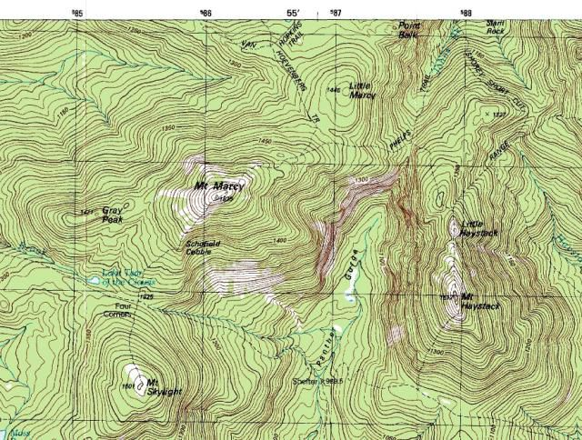

Description of Relief

Gentle Slope
- Slope is the gradient of land surface.
- Gentle slope is one in which land doesn't rise or fall steeply.
- Contours are wide apart
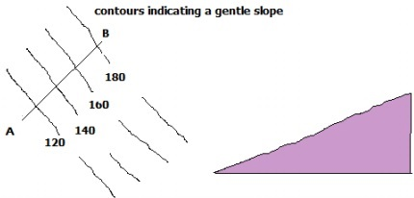

Steep Slopes
- Where land rises or falls sharply
- Contours are close to each other
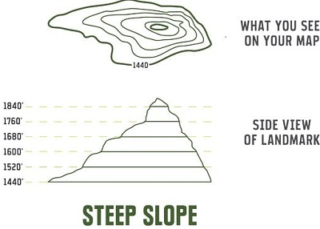
Even Slopes
- Shown by contours which are evenly spaced.
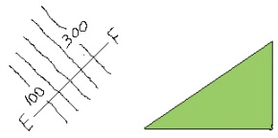
Uneven Slopes
- Indicated by unevenly spaced contours.
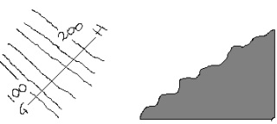
Convex Slopes
- One curved outwards
- Indicated by contours which are close together at the bottom and widely spaced together at the top.
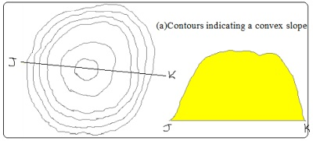

Concave Slopes
- One curved inwards.
- Contours are close together at the top and widely spaced at the bottom.
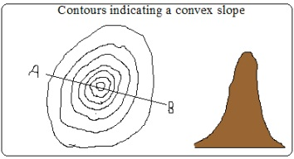

A Valley
- A low area between higher grounds.
- Indicated by U-shaped contours pointing towards a higher ground.
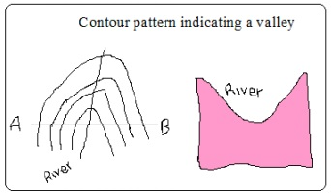

A Spur
A Spur is:
- a land which is projected from high to low ground.
- indicated by U-shaped contours bulging towards lower ground.

Interlocking Spurs
-Spurs which appear as if to fit together.
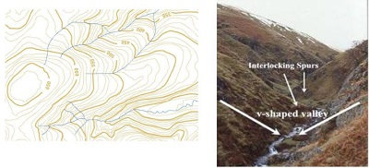

Truncated Spurs
- Spurs in glaciated highlands whose tips have been eroded and straightened.
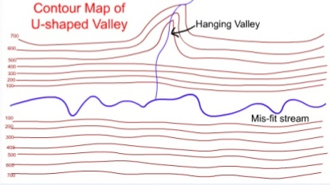

Conical Hills
- Hills are uplands which rise above relatively lower ground
- Conical hills are small rounded hills
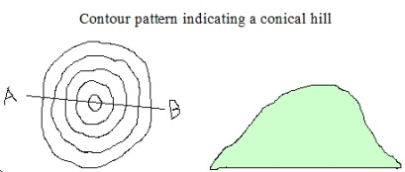

Irregular Shaped Hills
-A hill with some sides with uneven gentle and others with uneven steep slopes
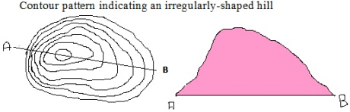

Ridges
- A range of hills with steep slopes on all sides.
- A ridge can contain hills, cols, passes or water shed
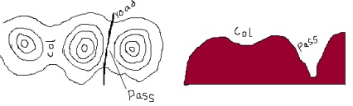

A Col

A low area which occurs between two hills
A Pass
- A narrow steep sided gap in a highland

A Water Shed
- The boundary separating drainage systems which drains into different directions
- Escarpment and ridges often form water sheds.
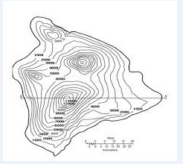

Escarpment
- A relatively continuous line of steep slopes facing the same direction
- Has two slopes: a long gentle slope (dip slope) and short steep slope (scarp slope).
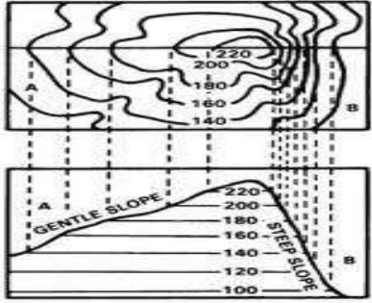

A Plateau
- A high flat land bound by steep slopes.
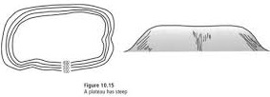

Description of Vegetation
- Natural vegetation is classified as: woodlands, thickets, scrubs or grasslands.
- Symbols are given as pictures of vegetation.
- Types present
- Distribution
- Reasons for distribution e.g. seasonal streams, scrub or grassland due to low rainfall.
a) Forests
Likely indications of the following in the area:
- Heavy rainfall
- Fertile rainfall
- Cool temperature depending on altitude
b) Thickets and shrubs
- Seasonal rainfall
- Poor soil
- High temperature
c) Riverine trees
High moisture content in the river valley

Describing Drainage
- Identify drainage features present. Natural drainage features include lakes, rivers, swamps, sea, rapids, water falls, cataracts, springs, deltas, fjords, sand or mud, and bays. Artificial features include ponds, wells, boreholes, water holes, cattle dips, cattle troughs, canals, reservoirs, irrigation channels, aqueducts, water treatment plants and man made lakes.
- Identify main rivers by name
- Size of rivers-big or small-shown by thickness of blue lines.
- Give the general direction of flow.
- Location of water shed if any
- Characteristic of each feature

a) Permanent Rivers
- Which flow throughout the year
- Shown by continuous blue lines

Likely indication of:
- Heavy rainfall
- Impermeable rocks

b) Seasonal Rivers
- Which flow seasonally or during the rain season
- Shown by broken blue lines

Likely indication of:
- Low rainfall
- River doesn't have a rich catchment area

c) Disappearing Rivers
- Blue lines ending abruptly

Likely indication of:
- Permeable rocks
- Very low rainfall
- Underground drainage

Drainage patterns and description
- Drainage pattern is the layout of a river and its tributaries on the landscape.

a) Dendritic
- Resembles a tree trunk and branches or veins of a leaf.
- Tributaries join the main river at acute angles.

b) Trellis
- Tributaries join the main river and other tributaries at right angles of hard and soft rocks)
- Common in folded areas where rivers flow downwards separated by vertical uplands.

c) Rectangular Pattern
- Looks like a large block of rectangles.
- Tributaries tend to take sharp angular bends along their course.
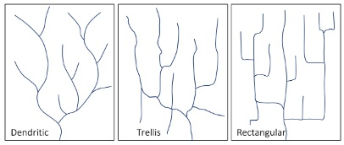

d) Parallel Pattern
- Rivers and tributaries flow virtually parallel to each other Influenced by slope
- Common on slopes of high mountain ranges


e) Centripetal Pattern
- Rivers flow from many directions into a central depression such as a lake, sea or swamp.
- Examples are rivers flowing into some of the Rift Valley lakes such as Nakuru and Bogoria.


f) Annular Pattern
- Streams (rivers which are small in size) are arranged in series of curves about a basin or crater
- It's controlled by the slope.

g) Radial
- Resembles the spikes of a bicycle
- Formed by rivers which flow downwards from a central point in all directions such as on a volcanic cone e.g. on Mt. Kenya, Elgon and Kilimanjaro.
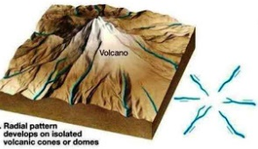

h) Fault – Guided Pattern
- Flow of river is guided by direction of fault lines
Description of Human Activities
- Identify types
- Evidence –man made features
- Reasons e.g. tea-cool temps and heavy rainfall
Agriculture
a) Plantation farming
Evidenced by presence of:
- "C"-coffee
- Named estates e.g. Kaimosi tea estate
b) Small scale crop farming
- Cotton ginnery or sheds
- Coffee hullerlies
- Posho mills for maize, millet, sorghum
- Tea factory/store
(c)Livestock Farming
- Dairy farms
- Veterinary stations
- Cattle dips
- Creameries
- Water holes
- Dams
- Butcheries
- Slaughter houses
(d)Mining
- Symbol for a mine/mineral works
- Name of the mine
- Particular mineral e.g. soda ash
- Quarry symbol
- Processing plant of a mineral e.g. cement indicates cement is mined in that area
(e)Forestry/Lumbering
- Saw mills
- Forest reserves
- Forest station
- Forest guard post
- Roads ending abruptly into a forest estate used to transport logs to saw mills
(f)Fishing
- Fish traps
- Fishing co-operative society
- Fish ponds
- Fish hatcheries
- Fisheries department
- Fish landing grounds(banda)

Manufacturing/Processing Industry
- Saw mills for lumber products
- Gunnery for cotton processing
- Mill for maize, millet, wheat processing
- Creameries for milk processing
- Factory for manufacturing or processing a known commodity.

Services
a) Trade
- Shops
- Markets
- Stores
- Trading centres
b) Transport
i) Land
- Roads
a. All weather roads- which are used all year round i.e. tarmac and murrum roads.
b. Dry weather roads- which are used reliably during dry seasons.
c. Motorable trucks- rough roads which are used by people on foot and by vehicles on dry season.
- Other trucks and foot paths
- Railways, station, sliding, level crossing lines and railways light
ii) Air
- Air fields
- Airports
- Air strips
iii) Water
- Ferries
- Bridges
c) Communication
- Post offices(P.O.)
- Telegraph(T.G.)
- Telephone lines(T)
d) Tourism
- Camping sites
- Tourist class hotels and restaurants
- National parks
- Game reserves
- Curio shops
- Museums
- Historical monuments
e) Administration
- DO, DC, PC, police post, chiefs camp
d) Recreational Services
- Golf clubs/courses
- Stadiums

Description of Settlement
A settlement is a place with housing units where people live together
- Densely distributed settlements- high concentration of settlements(black dots)
- Moderately distributed settlements- settlements moderate in quantity
- Sparsely distributed settlements-few settlements spread over a large area.
- Very sparse if very few
- Identify type of settlement patterns present
- Type of Settlements
a) Rural settlements
Consist of villages and homesteads and homesteads in which people are involved in subsistence agriculture and traditional activities such as pottery weaving, curving, etc.
b) Urban settlement
Consist of dense permanent and sometimes high buildings and population engaged in non agricultural activities such as industrial activities.

Factors Influencing Settlement
1. Physical Factors
a) Climate
Areas with moderate temps and adequate rainfall are densely settled while those with extremely low or high temps have fewer settlements.
b) Relief
Terrain: Steep slopes are less settled due to thin soils and difficulty to erect buildings.
Aspect: Slopes facing away from the sun in high latitudes are less settled than those facing the sun. Wind ward slopes of mountains on the path of rain bearing winds are more settled due to heavy rainfall making them ideal for agriculture.
c) Drainage
Rivers and springs attract settlements because they provide clean water.
Areas with drainage swamps are less settled because it‟s difficult to erect buildings and they also harbour mosquitoes and snails which cause diseases.
d) Vegetation
Dense forests discourage settlements because of wild animals and also harbour disease vectors such as tsetse flies e.g. Miombo woodland of Tanzania and Lambwe valley in Kenya.
e) Pests and diseases
Areas prone to pests and diseases are less settled because people like to live in healthy environment.
f) Natural resources
Settlements start where there is mineral extraction. e.g. Magadi Lakes with abundant fish may also attract settlement.
g) Human Factors
i) Political factors
- 1967 TZ settled peoples in villages and the rest of land was left for farming (Ujamaa villages)
- After independence Kenya settled its landless in settlement schemes e.g. Mwea, Laikipia, Nyandarua.
- Settlement of refugees in refugee camps due to political upheavals
ii) Historical factors
- Weaker communities were forced to move elsewhere by wars.
- Settlement of communities in strategic sites such as hilltops or plateaus to see approaching enemies e.g. Fulani of Nigeria in Jos plateau.
iii) Cultural factors
- Farming communities settled in agriculturally productive areas.
- Pastoralists settle in areas with enough land to provide pasture for their animals at ease.
iii) Economic factors
- Rural to urban migration for employment and trading.
- Mining activities may lead to development of settlements e.g. Magadi due to trona mining.

Types of Settlements Patterns
a) Nucleated/Clustered Settlement Pattern
- Buildings are close to each other
Factors
- Availability of social amenities such as schools and health care
- Shortage of building land
- Favourable climate leading to high agricultural potential e.g. Kenya highlands.
- Fertile soils.
- Presence of natural resources e.g. minerals in Magadi, Mwadui, Kimberly.
- Security concern especially in banditry prone areas
b) Linear Settlement
- Buildings are arranged in a line
- Presence of a transport line e.g. road or railway.
- Presence of a river or a spring to provide water for domestic or commercial use
- Presence of a coast line which has a favourable fishing ground e.g. shore of E. African coast.
- Suitable terrain for cultivation of crops such as at the foot of a scarp
c) Dispersed/Scattered Settlement
- Buildings are scattered
- Plenty of land to build whenever they want
- Avoidance of harsh climate e.g. arid and semi-arid areas.
- Poor infertile soils.
- Pests and diseases.
- Physical features such as ridges, valleys which separate houses
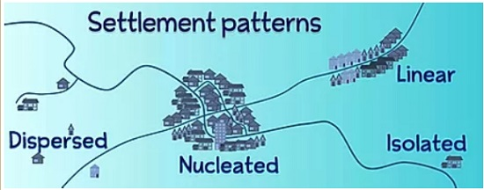

Enlargement and Reduction of Maps
Steps
1. Identify the area requiring to be enlarged
2. Measure its length and width
3. Multiply (E) or divide (R) the by the number of times given. The scale also changes
e.g.1:50000/2(enlarged)×2(reduced)
4. Draw the new frame with new dimensions
5. Insert the grid squares e.g. 2×2cm, 2/2, etc.
6. Draw diagonals on the frame
7. Transfer features exactly where they were

Drawing a Cross Section/Profile
-Line drawn on a piece of paper showing the nature of relief of a particular area.
Steps
1. Identify the given points and name them A and B
2. Joint point A and B using a pencil
3. Take a piece of paper and fold it into two parts
4. Place the papers edge along the line joining A and B
5. Mark all contours and their heights
6. Mark features along A-B e.g. R- river, H- hill, M- mountain
7. Determine the highest and lowest contour height to determine the appropriate vertical scale
8. Draw horizontal axis and mark it A-B
9. Draw vertical axis from A to B
10. Place the edge of folded paper along horizontal axis
11. Use values along vertical axis to plot contour heights. Remember to show features marked along A-B
12. Join plotted points using smooth curve (cross Section)
13. Include title on top vertical and horizontal map scale

Calculation and Interpretation of Vertical Exaggeration and Gradient
Vertical Exaggeration
Number of times that the vertical scale is larger than horizontal scale
V.E. =Denominator of H.S. /D. of V.S. (cross section scale.
e.g. V.S. =1:20M
H.S=1:50000
V.E.=50000/20×100 (To convert into cm) =25
Interpretation
The vertical height has been exaggerated 25 times compared to the horizontal distance
Intervisibility
Ability of one place to be seen from another
Steps
- Draw cross section
- Join points A-B using visibility line
- If the visibility line is above the cross section, the two points are intervisible. If below they are not intervisible.
Gradient
Degree of steepness of a slope between two given points
STEPS
1. Identify the two points
2. Calculate difference in height between the two points(Vertical Interval) e.g. 500m
3. Joint them with a light line
4. Measure ground distance between the two points(Horizontal Equivalent)e.g.12 cm
G=V.I./H.E.
=500×100/12×50000=50000/600000=1/12=1:12
interpretation
For every 12 m travelled on the Ground, there is a vertical rise of 1m

Sub strand 1.3 STATISTICS IN GEOGRAPHY

a) Importance of Statistics in Geography
Statistics refers to the collection, analysis, interpretation, and presentation of numerical data. In Geography, statistics are essential for:
- Simplifying complex data – Large amounts of geographical data can be organized into tables, graphs, and charts.
- Making comparisons – Helps compare different regions, e.g., population, rainfall, or crop yields.
- Identifying patterns and trends – Shows changes over time (e.g., climate change, population growth).
- Enhancing accuracy – Provides factual support to geographical observations and arguments.
- Supporting decision-making – Planners use statistical data to make informed choices in areas like agriculture, urban planning, and resource management.

b) Limitations of Statistics in Explaining Geographical Facts
Despite its importance, statistics has some limitations in Geography:
- May not explain causes – While statistics show patterns, they do not always explain why a phenomenon occurs.
- Can be misinterpreted – Poor interpretation may lead to wrong conclusions.
- Data may be outdated or incomplete – Especially in developing areas where record-keeping is poor.
- Ignores qualitative data – Statistics focus on numbers, not feelings, experiences, or historical context.
- Affected by bias – If data collection is biased, the statistical results will also be misleading.

c) Methods of Data Collection, Analysis, and Presentation in Geographical Studies

i. Data Collection Methods:
- Observation – Watching and recording geographical events.
- Interviews – Asking people questions directly.
- Questionnaires – Written questions given to respondents.
- Measurements – Using tools to record data (e.g., rain gauges, thermometers).
- Photography – Capturing visual data of phenomena.
- Secondary sources – Using existing data from books, reports, censuses, etc.

ii. Data Analysis Methods:
- Calculating averages, percentages, ratios, etc.
- Looking for correlations and trends in the data.
- Classifying data into categories or groups.

iii. Data Presentation Methods:
- Tables
- Bar graphs
- Cumulative bar graph
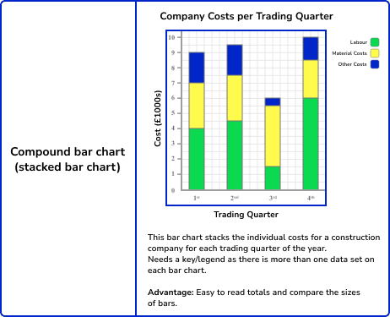
Creating a bar chart is relatively simple. In this example, we are going to produce a bar chart to show the results of a traffic count. Learners have collected raw data that shows the type and number of vehicles that pass them within 15 minutes:
- buses – 2
- cars- 24
- lorries – 3
- motorbikes – 6
- bicycles- 2
1. Step one, set the cumulative total of each year.
2. Draw vertical axis(Y) to represent dependent variable
3. Draw horizontal axis(x) to represent independent variable
4. Label both axis using suitable scale
5. Plot the cumulative values for each year
6. Use values for components to subdivide the cumulative bar
7. The subdivisions are placed in descending order with the longest at the bottom(coffee)
8. Shade each component differently
9. Put title and key
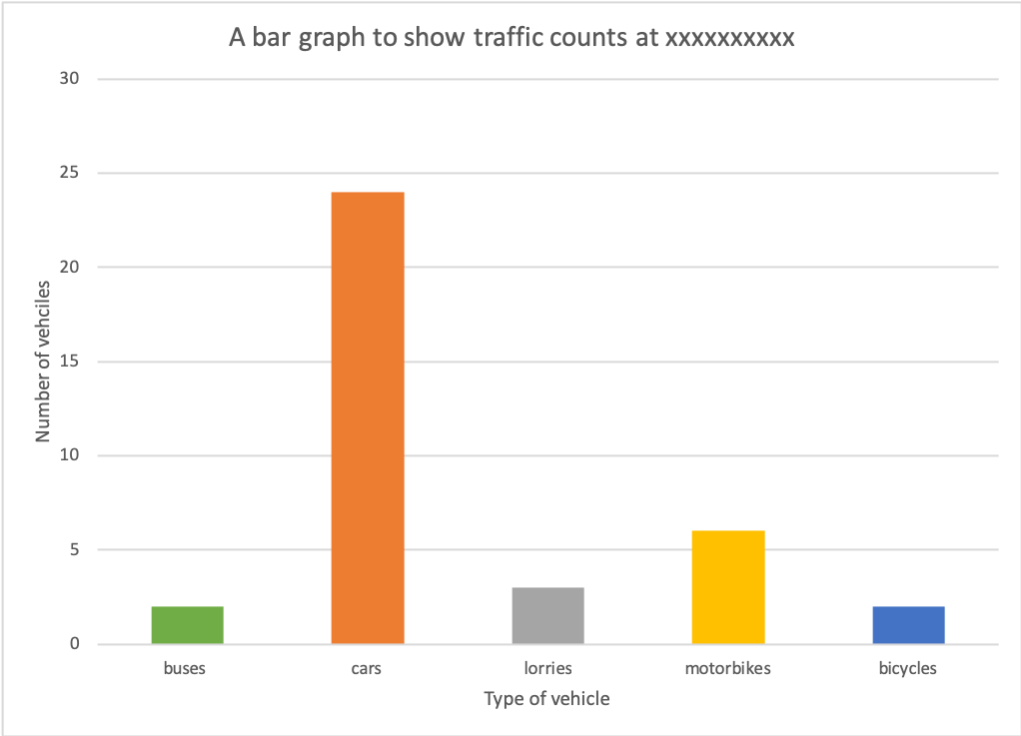
Advantages
1. Its easy to construct
2. It has good visual impression
3. There is easy comparison for the same component in different bars because of uniform shading
4. Easy to interpret because bars are shaded differently
5. Total value of the bar can be identified easily
Disadvantages
1. It doesn't show the trend of components (change over time).
2. Cant be used to show many components as there is limited space upwards
3. Tedious as there is a lot of calculation work involved.
4. Not easy to trace individual contribution made by members of the same bar
5. Poor choice of vertical scale causes exaggeration of bars length leading to wrong conclusions
- Line graphs
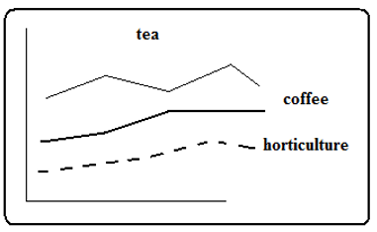
Advantages
- Simple to construct
- Suitable when comparing trends or movements
- Comparison of items is easy because the graphs are drawn using common axis
- It’s easy to read exact values from each graph
Disadvantages
- Number of items which can be represented are limited
- Crossing of lines may make interpretation and comparison difficult and confusing.
- Total amount of variable can’t be established at a glance.

- Pie charts

Pie-chart / Divided circles / Circle charts
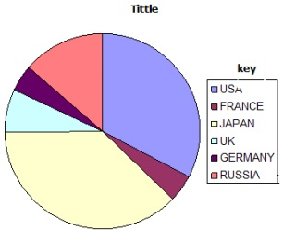
Steps
- Convert components into degrees
USA 1800×360/5480=118.2°
FRANCE 240×360/5480=15.8°
JAPAN 2050×360/5480=134.7°
UK 400×360/5480=26.3°
GERMANY 240×360/5480=15.8°
RUSSIA 750×360/5480=49.3°
- Draw a circle of convenient size using a pair of compasses.
- From the centre of the circle mark out each calculated angle using a protractor
- Shade the sectors differently and provide the key for various shadings.
Advantages
1. Gives a good/clear visual impression
2. Easy to draw.
3. Can be used to present varying types of data e.g. minerals, population, etc.
4. Easy to read and interpret as segments are arranged in descending order and are also well shaded.
5. Easy to compare individual segments.
Disadvantages
1. Difficult to interpret if segments are many.
2. Tedious due to a lot of mathematical calculations and marking out of angles involved.
3. Can't be used to show trend/change over a certain period.
4. Small quantities or decimals may not be easily represented.
- Histograms
A histogram appears similar to a bar chart. However, there are key differences between the two. Histograms are used to present continuous data (a bar chart is used to present discrete data).
Histograms are ideal for presenting continuous data. Continuous data is data that falls in a continuous sequence e.g. time, distance and temperature. An example of this would be after counting pedestrians at 15-minute intervals over 2 hours, a histogram could be used to present the results.
Creating a histogram is relatively simple. In this example, we are going to produce a histogram to show the results of a pedestrian count completed at 15-minute intervals over a continuous period of time. Learners have collected raw data that shows the number of pedestrians that passed them during 15-minute intervals over two hours.
- 8-8.15 am – 120
- 8.15-8.30 am – 156
- 8.30-8.45 am – 176
- 8.45-9 am – 167
- 9-9.15 am – 101
- 9.15-9.30 am – 134
- 9.30-9.45 am – 123
- 9.45-10 am – 132
Step 1 – Decide on the scale of the X-axis
Decide on an appropriate scale on the X-axis for the bars. The bars should be the same width and there should be no gaps between the bars.
Step 2 – Decide on the scale of the Y-axis
Decide on a suitable scale for the Y-axis for the number of pedestrians. The scale should be spaced evenly and allow for the highest number in the data set to be included.
Step 3 – Create the histogram
Accurately draw the bars for each piece of data. As the data is continuous, each bar should be shaded in the same colour
Step 4 – Finish your graph
Include a title and label each axis.
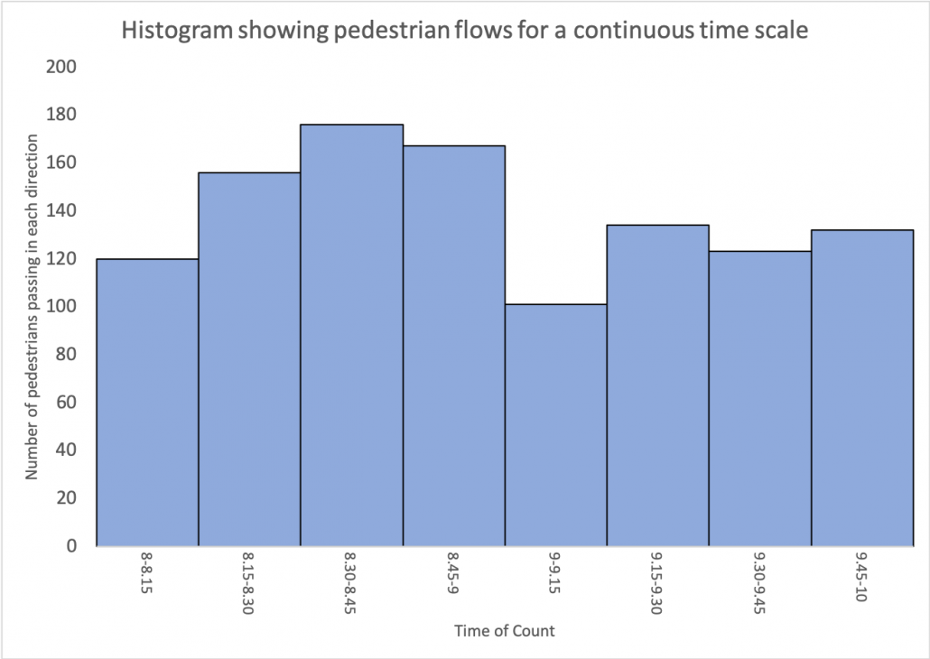

Reading a histogram
To read a bar chart, read along the x-axis (bottom) to find the bar you want to read. Go to the top of the bar and read across to the scale on the y-axis to work out the value. Using a ruler can help with this.
Advantages:
- Easy to understand:
Histograms are simple to interpret, making them accessible for visualizing data distributions to a wider audience.
- Effective for large datasets:
They can effectively show the distribution of large datasets, highlighting key features and trends.
- Reveals patterns and trends:
Histograms help identify patterns, outliers, and overall trends in data, aiding in analysis and interpretation.
- Visual representation of statistical measures:
They allow for a quick estimation of key statistical measures like mean and median based on the graph's shape and central tendency.
- Consistency in data presentation:
Histograms organize data into uniform intervals, ensuring accuracy and reliability when displaying data distributions.
Disadvantages:
- Loss of precision:
The binning process in histograms can lead to a loss of precision, making it difficult to pinpoint exact values.
- Difficulty in comparing individual data points:
They are less suitable for comparing individual data points due to the grouping of data into ranges.
- Binning can influence interpretation:
The choice of bins can significantly affect the appearance and interpretation of the histogram, potentially masking important features or creating misleading patterns.
- Not suitable for comparing two datasets:
Histograms are not ideal for directly comparing two different datasets, as they focus on the distribution within each set.
- Requires sufficient data:
Histograms work best with datasets that contain a reasonable amount of data points to provide a meaningful representation of the distribution.
- Pictograms
A pictogram is an appropriate method of presenting discrete data when accuracy is not particularly important.
Follow the steps below to create a pictogram.

Step 1 – Decide on the symbols
Decide on an appropriate symbol to represent your data. In this example, we will create a pictogram presenting the rainfall data below:
Monday – 3 mm
Tuesday – 4 mm
Wednesday – 8 mm
Thursday – 1 mm
Friday – 2 mm
Saturday – 4 mm
Sunday – 2 mm
In this case, we can use the shape of a water droplet.
Step 2 – Scale
Decide on the scale you will use for the symbols. In this case, we will use one droplet per 1 mm of rainfall.
Step 3 – Plotting your data
When creating a pictogram dates etc. do not have to be continuous. Draw the symbols. Sometimes the symbols will not be full-size if they represent a proportion of a unit. Remember to add a key, title and label the axis.

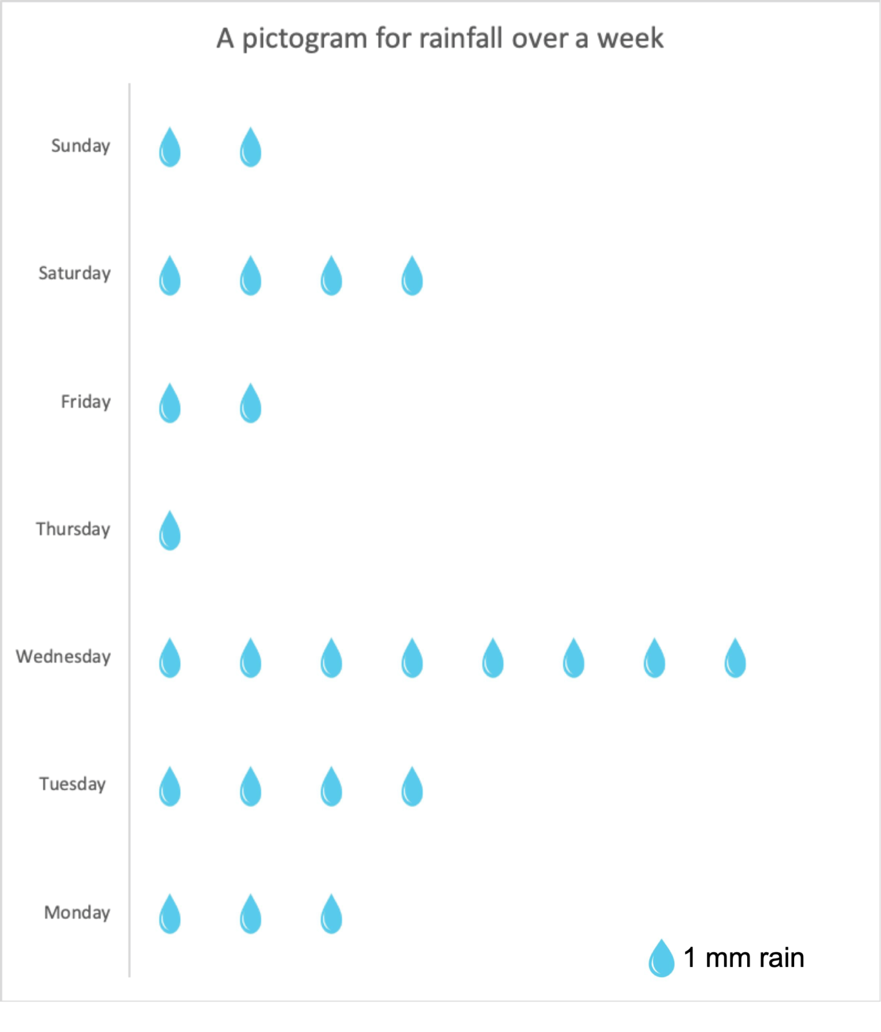
- Maps (e.g., choropleth, dot maps)

d) Collect, Analyse, Interpret, and Present Statistical Data on a Geographical Phenomenon

Example: Rainfall in Nairobi (Jan–Dec 2024)
Month | Rainfall (mm)
Jan | 50
Feb | 40
Mar | 80
Apr | 120
May | 100
Jun | 60
Jul | 30
Aug | 40
Sep | 50
Oct | 90
Nov | 130
Dec | 110

Analysis:
- Highest rainfall: November (130 mm)
- Lowest rainfall: July (30 mm)
- Two main rainy seasons: March–May and October–December

Interpretation:
- Nairobi experiences bimodal rainfall.
- Rainfall is suitable for agriculture during rainy seasons.

Presentation:
- Can be presented using a bar graph or line graph.

e) Importance of Statistics in Day-to-Day Life
- Budgeting and planning – Helps individuals and governments manage finances and resources.
- Weather forecasting – Uses statistical models to predict future weather.
- Business decisions – Companies use data to understand markets and improve performance.
- Education – Analyzing performance and enrolment trends.
- Healthcare – Understanding disease patterns, vaccination rates, etc.

Sub strand 1.4: GEOSPATIAL TECHNOLOGIES: GIS, GPS, and Remote Sensing

a) Explanation of GIS, GPS, and Remote Sensing (RS) as Geospatial Technologies
- Geographic Information Systems (GIS):
  - Definition: GIS is a technology used to capture, store, analyze, manage, and display geographical data.
  - How It Works: GIS integrates various data types (e.g., maps, satellite imagery, demographic data) to enable analysis of spatial patterns and relationships.
  - Key Functions:
    - Mapping of land use, population density, transportation networks, and more.
    - Helps in making informed decisions for urban planning, environmental management, disaster response, etc.
- Captures Data: GIS can take information from various sources, like GPS coordinates, satellite imagery, aerial photos, surveys, and even spreadsheets with location data.
- Stores Data: It organizes this data in a way that links it to specific geographic locations. This allows for efficient retrieval and analysis.
- Analyzes Data: This is where the real power of GIS comes in. It can perform spatial analysis to identify patterns, relationships, and solve problems. For example, it can determine the best route for a delivery truck, identify areas at high risk for flooding, or analyze the spread of a disease.
- Displays Data: GIS presents information visually through maps, charts, graphs, and reports, making complex data easier to understand and communicate.

- Global Positioning System (GPS):
  - Definition: GPS is a satellite-based navigation system that provides location data (latitude, longitude, and altitude) anywhere on Earth.
  - How It Works: GPS uses a network of satellites that send signals to GPS receivers, which calculate the exact location based on the time it takes for signals to travel.
  - Applications:
    - Navigation (e.g., driving, hiking)
    - Surveying
    - Mapping and positioning in GIS
- Remote Sensing (RS):
  - Definition: Remote sensing is the process of collecting data about Earth's surface from a distance, typically using satellites or drones.
  - How It Works: Sensors on satellites or aircraft capture images and data based on electromagnetic radiation reflected from the Earth's surface.
  - Applications:
    - Environmental monitoring (e.g., deforestation, urban sprawl)
    - Disaster management (e.g., detecting floods or fires)
    - Agricultural monitoring (e.g., crop health, soil moisture)

b) Components of GIS Used in Geo-Referencing Information
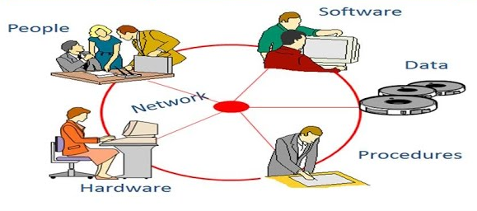
Geo-referencing is the process of assigning real-world coordinates (latitude and longitude) to map features. The components of GIS that help in geo-referencing are:
Key Components of a GIS:
- Hardware: The computers, servers, and other physical equipment used to run the GIS software.
- Software: The programs that provide the tools for data input, storage, analysis, and output (e.g., Esri's ArcGIS, QGIS).
- Data: The geographically referenced information, which can be in various formats (e.g., points, lines, polygons, raster images).
- People: The trained professionals who manage the system and perform the analyses.
- Methods: The procedures and techniques used to analyze and interpret the geographic data.

c) Importance of GIS in Geographical Studies
GIS has revolutionized the way geographers study and understand the Earth and human-environment interactions. Its importance in geographical studies includes:
- Spatial Data Management: GIS provides efficient tools for organizing, storing, and retrieving large volumes of spatial and attribute data, making it easier to manage complex geographical datasets.
- Spatial Analysis: GIS enables powerful analytical capabilities to identify patterns, relationships, and trends in geographic data. This includes:
  - Proximity Analysis: Determining features that are close to each other.
  - Overlay Analysis: Combining different layers of spatial data to identify areas with specific characteristics.
  - Network Analysis: Analyzing linear features like roads and rivers to find optimal routes or understand connectivity.
  - Spatial Statistics: Applying statistical methods to analyze spatial patterns.
- Visualization and Mapping: GIS allows for the creation of high-quality maps and other visual representations of geographic information, making it easier to communicate spatial patterns and insights. Different thematic maps can be created to highlight specific attributes.
- Decision Making: By providing spatial insights and analytical results, GIS supports informed decision-making in various geographical applications, such as urban planning, environmental management, and resource allocation.
- Environmental Monitoring: GIS is crucial for monitoring environmental changes, such as deforestation, land degradation, pollution spread, and the impacts of climate change. Satellite imagery (from Remote Sensing) integrated with GIS allows for temporal analysis of these changes.
- Resource Management: GIS helps in the efficient management of natural resources like forests, water, and minerals by providing information on their location, extent, and condition.
- Urban and Regional Planning: GIS is used to analyze population distribution, infrastructure, land use, and other factors to support sustainable urban and regional development.
- Disaster Management: GIS plays a vital role in disaster preparedness, response, and recovery by providing tools for risk assessment, mapping affected areas, and coordinating relief efforts.
- Understanding Human-Environment Interactions: GIS allows geographers to analyze the complex relationships between human activities and the natural environment by integrating social, economic, and environmental data with spatial information.

d) Application of GIS in Locating Key Features in the Locality
GIS can be applied in your locality in the following ways:
- Mapping Public Facilities:
  - Locating schools, hospitals, government offices, and other important facilities.
- Road Network Analysis:
  - Identifying road networks, traffic conditions, and planning new roads.
- Population Distribution:
  - Analyzing population density and planning for resources like water supply, electricity, and health services.
- Environmental Monitoring:
  - Locating areas prone to floods, droughts, or other natural disasters and planning preventive measures.
- Agriculture:
  - Identifying fertile agricultural lands, water sources, and analyzing crop patterns.
- Data Collection: Identifying and gathering spatial data about the features of interest. This could involve:
  - Using GPS devices or smartphone apps to record the coordinates (latitude and longitude) of specific locations (e.g., schools, markets, health centers, rivers, hills).
  - Obtaining existing maps (both paper and digital) of the locality.
  - Using online mapping platforms like Google Maps or OpenStreetMap to identify and extract location information.
- Data Input: Entering the collected data into a GIS software or a mapping application. This might involve:
  - Manually entering coordinates.
  - Importing GPS data files.
  - Digitizing features from scanned maps.
  - Using online map editing tools.
- Geo-referencing: If using scanned maps or other imagery, geo-referencing involves assigning real-world coordinates to the features on the map so they align correctly with other spatial data.
- Visualization and Mapping: Displaying the located features on a map. GIS software allows you to customize the appearance of these features (e.g., different symbols for different types of features).
- Analysis (Optional): Performing basic spatial analysis, such as measuring distances between features or identifying features within a certain proximity of each other.
Example Activities:
- Using a GPS-enabled smartphone to record the locations of important places around your school or home.
- Creating a simple map showing the distribution of different types of land use in your locality using online mapping tools.
- Identifying the nearest health center or police station to a specific point using a GIS application.

e) Acknowledging the Importance of GIS in Day-to-Day Life
- Navigation and Travel:
  - GPS in smartphones, cars, and navigational devices helps in guiding people to their destinations.
- Urban Planning:
  - GIS aids city planners in designing efficient public transport systems, waste management, and infrastructure development.
- Emergency Services:
  - GIS helps emergency responders find the quickest routes and identify danger zones during fires, accidents, or medical emergencies.
- Agriculture:
  - Farmers use GIS to monitor crop health, soil moisture, and other factors to improve productivity.
- Environmental Protection:
  - GIS is used to monitor and prevent illegal logging, track wildlife habitats, and manage protected areas.
- Weather Forecasting and Disaster Management:
  - GIS and remote sensing help track weather patterns and predict natural disasters, allowing for timely alerts and responses.
- Location-Based Services (LBS): Many smartphone apps use your location (determined by GPS and other technologies integrated with GIS) to provide relevant information and services, such as finding nearby restaurants, shops, or ATMs.
- Emergency Services: GIS helps emergency responders (police, fire, ambulance) to quickly locate incidents, plan efficient routes, and allocate resources effectively.
- Delivery Services: Companies like courier services and food delivery platforms use GIS to optimize delivery routes and track the location of their personnel.
- Agriculture: Precision agriculture uses GIS and GPS to analyze soil conditions, manage irrigation, and optimize fertilizer application, leading to increased efficiency and yields.
- Environmental Management: GIS is used by environmental agencies to monitor pollution, track wildlife, manage protected areas, and respond to environmental disasters.
- Public Health: GIS helps in tracking the spread of diseases, identifying at-risk populations, and planning public health interventions.
- Urban Planning and Development: Governments and urban planners use GIS to analyze population growth, infrastructure needs, and land use patterns to plan for sustainable development.
- Real Estate: GIS is used to analyze property values, assess neighborhood amenities, and match buyers with suitable properties.
- Marketing and Business: Businesses use GIS to understand customer distribution, identify potential markets, and optimize advertising campaigns based on location.

Example of GIS Application in Day-to-Day Life:
Example: In a flood-prone area, GIS can help by identifying flood zones, mapping out evacuation routes, and finding the location of relief centers. This enables quick action during flood events, minimizing damage and loss of life.

SUMMARY SECTION ON GIS

Components of GIS:
- Hardware – Computers, GPS devices, scanners, and printers.
- Software – Programs like ArcGIS, QGIS, and Google Earth used to process data.
- Data – Geographic data (maps, satellite images) and attribute data (names, statistics).
- People – GIS users such as cartographers, planners, researchers.
- Methods – Techniques and procedures used to analyze spatial information.

Types of Data in GIS:
- Spatial Data – Information about the location and shape of features (e.g. rivers, roads).
- Attribute Data – Descriptive data about a place or feature (e.g. name, population, temperature).

Sources of GIS Data:
- Satellite images
- Aerial photographs
- Field surveys
- Maps
- GPS devices

Functions of GIS:
- Data Collection – Gathering information from the field or secondary sources.
- Data Storage – Saving information for future reference and analysis.
- Data Analysis – Studying patterns, trends, and relationships.
- Data Display – Showing data using maps, graphs, and charts.
- Data Management – Organizing and updating data in a database.

Applications of GIS:
- Urban and rural planning
- Disaster management and mitigation
- Environmental monitoring (deforestation, pollution)
- Natural resource management
- Transport and infrastructure planning
- Health (e.g. mapping disease outbreaks)
- Agriculture (e.g. analyzing soil and crop patterns)

Advantages of GIS:
- Accurate and up-to-date information
- Helps in better decision-making
- Easy to store and retrieve large amounts of data
- Can analyze data from different sources
- Creates easy-to-understand maps and visualizations

Limitations of GIS:
- Expensive to set up and maintain
- Requires skilled personnel
- Needs constant updating
- Limited in areas with poor technological infrastructure

STRAND 2: NATURAL SYSTEMS AND PROCESSES

Sub strand 2.1: Rocks
- A consolidated material composed of grains of one or more minerals.
Classification of Rocks

1. Igneous Rocks
-Rocks formed when molten material from the earth's interior cools and solidifies on or beneath the earth's surface.
Types of Igneous Rocks

a) Intrusive Igneous Rocks
- Rocks formed when magma cools and solidifies below the earth's surface e.g. granite, diorite, gabbro, peridotite.
- Have coarse texture as a result of slow cooling giving minerals more time to form large crystals.
- Are classified further into two:
- Hypabyssal rocks - intrusive igneous rocks which are near the earth's surface.
- Plutonic rocks - intrusive igneous rocks which are deep below the surface.

(b) Extrusive Igneous Rocks
-Rocks formed when lava solidifies on the earth's surface.
-Have fine texture due to fast cooling giving minerals less time to collect together to form larger crystals.
They are of two types namely:
- Volcanic Ejecta
-Extrusive igneous rocks are formed When ash and lava ejected from underground as they fall on the earth's surface e.g. pumice. When dust and ash ejected settle on the ground and get compressed to form a rock e.g. tuff.
- Lava Flows
-Extrusive igneous rocks formed when basic lava flows over a considerable distance then cools and solidifies e.g. basalt and obsidian.

2. Sedimentary Rocks
-Rocks formed when particles of other rocks are laid down and compressed into layers or when plant and animal remains are buried and compressed and compacted.
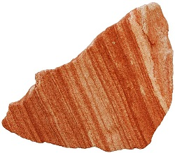
A Sandstone- Type of a Sedimentary Rock (Picture Courtesy)
- When they are laid down a layer is formed.
- As deposition continues additional layers are formed which compress the lower layers into a hard mass.

Types of Sedimentary Rocks
a) Mechanically Formed Sedimentary Rocks
-Sedimentary rocks formed when weathered igneous or metamorphic rocks are deposited and compacted e.g. sandstone and shale.
b) Organically formed Sedimentary Rocks
-Sedimentary rocks formed when animal and plant or animal remains are buried, compressed and compacted.
- Organically formed sedimentary rocks can be classified into:
- Calcareous rocks - rich in calcium carbonate e.g. chalk and limestone.
Coral rocks are formed from remains of sea polyps which extract lime from the sea, build shells for protection, attach themselves to each other and rocks to live in colonies, then die and shells to form coral rocks.
- Ferruginous Rocks - rich in iron e.g. ironstone.
- Siliceous Rocks - rich in silica e.g. diatomite.
- Carbonaceous Rocks - rich in carbon e.g. coal.
c) Chemically formed Sedimentary Rocks
-Sedimentary rocks formed when materials dissolved in water chemically react forming new substances then water evaporated leaving layers of those salts.
Chemically formed sedimentary rocks can be classified into:
- Carbonates e.g. trona and dolomite
- Sulphates - sulphate compounds
- Chlorides e.g. halite
- Silicates e.g. flint
- Iron stones e.g. haematite and limonite

3. Metamorphic Rocks
- Rocks which have changed their physical appearance and chemical properties as a result of subjection to great heat and pressure e.g
- Gneiss from granite
- Slate from clay
- Marble from limestone
- Quartzite from sandstones
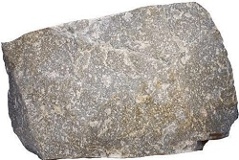
A Quartzite rock - A Chemically Formed Rock (Picture Courtesy)
2.1.2 Classification of Rocks According to Age
The age of rocks is crucial for understanding Earth's history. Rocks are broadly categorized based on their geological age:
- Precambrian Rocks: These are the oldest rocks, formed before the start of the Cambrian period (over 541 million years ago). They often form the ancient cores of continents (shields) and are typically metamorphic and igneous rocks. In Kenya, parts of the basement system are Precambrian.
- Paleozoic Rocks: Formed during the Paleozoic Era (approximately 541 to 252 million years ago). This era saw the diversification of early life. Sedimentary rocks are common in this age, often containing fossils.
- Mesozoic Rocks: Formed during the Mesozoic Era (approximately 252 to 66 million years ago), often referred to as the "Age of Reptiles." Sedimentary rocks formed during this time can contain dinosaur fossils.
- Cenozoic Rocks: These are the youngest rocks, formed during the Cenozoic Era (66 million years ago to the present). This era is known as the "Age of Mammals." A wide variety of igneous and sedimentary rocks formed during this time, including volcanic rocks associated with the East African Rift Valley.
Note: Determining the absolute age of rocks often involves radiometric dating techniques, which measure the decay of radioactive isotopes within the rock minerals. Relative dating methods, like superposition (older rocks are generally found below younger rocks), help to establish the sequence of rock formation.
2.1.3 Distribution of Rocks in Kenya
Kenya's geology is diverse, with a variety of rock types distributed across the country:
- Basement System Rocks: These are ancient Precambrian metamorphic and igneous rocks that form the foundation of much of Kenya. They are exposed in areas like:
  - The highlands of central Kenya (e.g., around Machakos, Kitui).
  - Parts of western Kenya (e.g., Kakamega, Kisii).
  - The coastal region (e.g., the hinterland of Mombasa).
  - Northern Kenya. These rocks are often highly metamorphosed, including gneisses, schists, and marbles, and contain intrusions of granitic rocks.
- Volcanic Rocks: Associated with the East African Rift Valley, these are primarily Cenozoic extrusive igneous rocks. They are found extensively along the Rift Valley and surrounding highlands, including:
  - The Aberdare Ranges.
  - Mount Kenya.
  - The Mau Escarpment.
  - The Chyulu Hills. Common volcanic rocks include basalt, trachyte, phonolite, and volcanic ash deposits.
- Sedimentary Rocks: These are found in various parts of Kenya, often in basins and coastal areas:
  - Coastal Sedimentary Rocks: Mesozoic and Cenozoic sedimentary rocks are prominent along the coast, including sandstones, shales, limestones, and coral reefs. These were formed from marine deposits.
  - Tertiary Sediments: Found in the Lake Victoria basin and parts of the Rift Valley, these include clays, sands, and diatomites.
  - Karoo Supergroup Sediments: Paleozoic to Mesozoic sedimentary rocks found in isolated basins, such as the Maji ya Chumvi area near Mombasa. These include sandstones, shales, and conglomerates.
- Plutonic Intrusive Rocks: These are igneous rocks that cooled slowly beneath the surface and are exposed in some areas due to erosion. Granite is a common example found intruding into the Basement System rocks.
Sketch Map of Kenya Showing Rock Distribution (Learners should draw this):
A sketch map should roughly indicate the major areas where these rock types are dominant. Key regions to highlight would be:
- Large areas marked for the Precambrian Basement System covering central, western, and parts of northern and coastal hinterland.
- A zone along the Rift Valley and surrounding highlands marked for Volcanic Rocks.
- A coastal strip marked for Sedimentary Rocks.
- Smaller, localized areas for Tertiary and Karoo sediments.
2.1.4 Significance of Rocks in Kenya
Rocks play a vital role in Kenya's environment, economy, and human activities:
- Building and Construction Materials: Rocks are a primary source of materials for construction.
  - Granite and Basalt: Used for road construction, bridges, and building foundations.
  - Sandstone and Limestone: Used as building blocks and for producing cement.
  - Clay (from weathered sedimentary rocks): Used for making bricks and tiles.
  - Gravel (from weathered rocks): Used in concrete and road construction.
- Mineral Resources: Rocks host various valuable mineral deposits.
  - Gold: Found in metamorphic and volcanic rocks in areas like western Kenya.
  - Soda Ash: Extracted from alkaline volcanic lakes like Lake Magadi.
  - Fluorspar: Found in the Kerio Valley associated with faulting and volcanic activity.
  - Limestone: Essential for the production of cement, a crucial component of the construction industry.
  - Titanium: Found in coastal sands derived from weathered igneous rocks.
- Agriculture: Weathering of rocks contributes to the formation of soil, which is essential for agriculture. Different rock types weather to produce soils with varying fertility and drainage characteristics. Volcanic soils, for example, are often very fertile.
- Water Resources: The type and structure of rocks influence groundwater storage and movement. Permeable rocks like sandstone can act as aquifers, storing significant amounts of groundwater. Impermeable rocks can form barriers, influencing surface water flow.
- Tourism: Unique rock formations and landscapes, such as those found in the Rift Valley (e.g., volcanic craters, hot springs), attract tourists and contribute to the tourism industry. Inselbergs (isolated rock hills) found in some parts of the Basement System also offer scenic attractions.
- Energy Resources: Geothermal energy, a renewable energy source, is harnessed in areas with volcanic activity, where hot rocks heat underground water.
- Historical and Cultural Significance: Some rock formations have historical or cultural significance for local communities. Caves and rock shelters have been used by humans for millennia and may contain archaeological sites.
- Understanding Earth's History: Studying rocks provides valuable insights into Kenya's geological past, including volcanic activity, tectonic movements, and changes in climate and environment over millions of years. Fossils found in sedimentary rocks tell the story of past life.
2.1.5 Sampling Rock Types in Your Locality
Conducting a field study in your local environment is a hands-on way to learn about rocks.
Procedure:
- Preparation:
  - Obtain permission from relevant authorities if necessary.
  - Gather necessary equipment: geological hammer, chisel, hand lens, sample bags or containers, notebook, pen, marker, safety goggles, and a local guide if possible.
- Fieldwork:
  - Identify different rock outcrops, loose rocks, or quarries in your locality.
  - Observe the color, texture (grain size), and any visible features (layers, crystals, fossils) of the rocks.
  - Carefully collect small samples of different-looking rocks, ensuring you note the location where each sample was found. Use the hammer and chisel to break off small, representative pieces if necessary (wear safety goggles!).
  - Record detailed observations about each sample in your notebook, including the location, color, texture, and any other notable characteristics.
  - If possible, take photographs of the rock outcrops and the surrounding environment.
- Classification (Back in the classroom):
  - Clean and label each rock sample clearly with its collection location.
  - Using your observations, reference materials (textbooks, online resources), and possibly with the help of your teacher, try to classify each sample as igneous, sedimentary, or metamorphic.
  - Further attempt to identify specific rock types within each category (e.g., granite, basalt, sandstone, shale, marble). Use the hand lens to examine the mineral grains.
  - Discuss your findings and classifications with your classmates and teacher.
- Display:
  - Arrange the collected and classified rock samples in an organized manner for display in the classroom, along with labels indicating their type and collection location.
Significance of Rocks
- Rocks weather to form soil which is important in agriculture
- Form aquifers which store ground water which forms springs which form rivers and wells which provide water for domestic and industrial use
- Some rocks are sources of building materials e.g. igneous rocks are used to make ballast and limestone rocks are used as building blocks and raw material in cement manufacturing
- Phosphate and nitrate rocks are used to make fertilizer used in agriculture
- Granitic tors of W. Kenya and high volcanic peaks such as those of Mt.
Kenya are a tourist attraction which brings foreign exchange
- Pumice is used as a scrubbing stone
- A rock such as coal is used as fuel for heating, smelting of iron and thermal electricity generation
- Source of minerals e.g. oil and coal is associated with sedimentary rocks
Earth Movements
There are several types of earth movements, primarily classified based on their direction and the forces involved:
- Endogenic Movements: These are caused by forces originating from within the Earth. They are further divided into:
  - Vertical Movements (Diastrophism): These movements cause uplift or subsidence of the Earth's crust.
    - Uplift: Raises landmasses, e.g., formation of plateaus and coastal emergence.
    - Subsidence: Lowers landmasses, e.g., formation of basins and coastal submergence.
  - Horizontal Movements (Orogenesis): These movements cause the folding and faulting of the Earth's crust, leading to mountain building.
    - Folding: Bending of rock layers due to compressional forces.
    - Faulting: Fracturing of the rock layers due to tensional or compressional forces.
- Exogenic Movements: These are caused by forces originating from outside the Earth, primarily driven by gravity, water, wind, and ice. They are also known as denudation processes.
  - Weathering: The breakdown of rocks in situ (in their original place).
  - Erosion: The wearing away and removal of weathered material by agents like water, wind, and ice.
  - Mass Wasting: The downslope movement of rock and soil material due to gravity.
  - Deposition: The laying down of eroded material in a new location.
Causes of Earth Movements
The primary driving forces behind earth movements are:
- Tectonic Forces: These forces originate from within the Earth and are associated with the movement of tectonic plates.
  - Convection currents in the mantle: The slow movement of molten rock in the Earth's mantle creates drag on the tectonic plates, causing them to move.
  - Ridge push: At mid-ocean ridges, new crust is formed and pushes older crust away.
  - Slab pull: At subduction zones, the denser oceanic plate sinks into the mantle, pulling the rest of the plate with it.
- Gravity: Gravity plays a significant role in exogenic processes like mass wasting, erosion, and deposition.
- Energy from the Sun: Solar energy drives the water cycle and wind patterns, which are the primary agents of exogenic processes.
- Human Activities: Activities such as mining, dam construction, and deforestation can also trigger earth movements like landslides and subsidence.
Features Resulting from Earth Movements
Earth movements create a variety of geological features:
- Features from Endogenic Movements:
  - Mountains: Formed by folding (e.g., the Himalayas) or faulting (e.g., the Sierra Nevada).
  - Rift valleys: Formed by faulting (e.g., the East African Rift Valley).
  - Plateaus: Elevated flatlands formed by uplift (e.g., the Tibetan Plateau).
  - Volcanoes: Formed by the eruption of magma from the Earth's interior.
  - Earthquakes: Caused by the sudden release of energy in the Earth's crust.
- Features from Exogenic Movements:
  - Valleys: Formed by river erosion (e.g., V-shaped valleys, U-shaped valleys).
  - Canyons: Deep valleys with steep sides, formed by river erosion in arid regions (e.g., the Grand Canyon).
  - Floodplains: Flat areas adjacent to rivers, formed by deposition.
  - Deltas: Formed by river deposition at the mouth of a river.
  - Beaches: Formed by wave deposition.
  - Sand dunes: Formed by wind deposition.
  - Moraines: Formed by glacial deposition.
  - Cliffs: Formed by coastal erosion.
  - Arches and stacks: Formed by coastal erosion.

Folding
Process in which crustal rocks are distorted by compressional forces by being caused to bend upwards and downwards.
It occurs on fairly young sedimentary rocks.
Types of Folds Resulting from Tectonic Forces
Folding occurs when compressional tectonic forces cause rock layers to bend or buckle. The characteristics of the folds depend on the intensity and direction of the forces, the type and thickness of the rock layers, and the presence of any weaknesses. The main types of folds include:
- Anticline: An upward-arching fold where the oldest rock layers are at the core and the younger layers dip away from the center. Imagine the shape of an "A".
- Syncline: A downward-arching fold where the youngest rock layers are at the core and the older layers dip towards the center. Imagine the shape of a "U" or a trough.
- Symmetrical Fold: A fold where the limbs (sides) dip at approximately the same angle away from the axial plane (an imaginary plane that divides the fold as symmetrically as possible).
- Asymmetrical Fold: A fold where the limbs dip at different angles from the axial plane. One limb is steeper than the other.
- Overturned Fold: An asymmetrical fold where one limb has been tilted beyond the vertical, and the axial plane is inclined. The younger rocks may lie beneath older rocks in this case.
- Recumbent Fold: An extreme type of overturned fold where the axial plane is nearly horizontal. The limbs are essentially lying on top of each other.
- Isoclinal Fold: A fold where the limbs are parallel to each other and dip in the same direction at the same angle. The axial planes are also parallel.
- Monocline: A simple, step-like bend in otherwise horizontal or gently dipping rock layers. It has one limb that is significantly steeper than the surrounding layers.
- Plunging Fold: A fold where the hinge line (the line formed by the intersection of the axial plane with the top or bottom surface of a folded layer) is not horizontal. Anticlines and synclines can be plunging.

Parts of a Fold
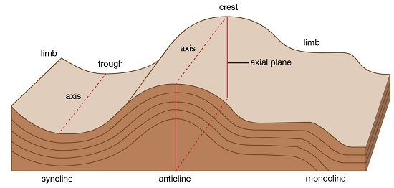
(a) Anticlines (upfolds)-parts of the earths surface which bend upwards when folding occurs.
(b) Synclines (down folds)-Parts of the earths surface which bend downwards when folding occurs.
(c) Crest-upper most part of Anticline.
(d) Trough-lowest part of a syncline
(e) Limb-rock layers sloping on both sides of a fold
(f) Axis-imaginary line drawn vertically through the centre of the anticline.

Types of a Fold
1. Simple Symmetrical Folds
-Which are symmetrical about the anticline.
-Formed by 2 compressional forces of equal magnitude.
2. Asymmetrical Folds
-Which are asymmetrical about the anticlines axis or in which one limp is steeper than the other.
-Formed by two compressional forces of unequal magnitude in which one is stronger than the other.
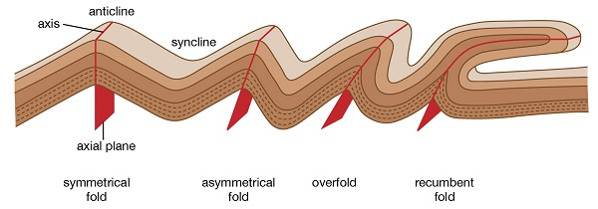
3. Over Folds
In which anticline of one fold is pushed over the limp of the other.
4. Isoclinal Folds
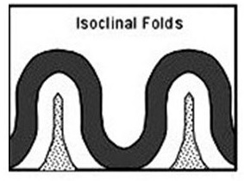
- Which are packed closely together and with limps almost parallel to each other.
- Vertical Isoclinal folds are formed by compressional forces of equal magnitude while inclined Isoclinal folds are formed by forces of unequal magnitude.
5. Recumbent Folds
Which lie in a horizontal manner.
Formed by two compressional forces one of which is very strong.
6. Nappe/Overthrust Fold
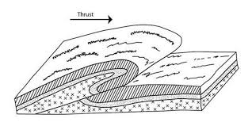
In which one limp is pushed over the other limp.
The forces are very strong and they cause a fracture/fault to develop.
7. Anticlinorium and Synclinorium Complex
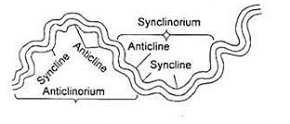
Folds characterised by minor upfolds and minor downfolds.
- Land is first subjected to weak compressional forces resulting into minor folds.
- Later the land is subjected to much greater compressional forces resulting into new upfolds with minor folds (Anticlinorium) and new down folds with minor folds (Synclinorium).

Resultant Features Due To Folding
1. Fold Mountains and Their Distribution
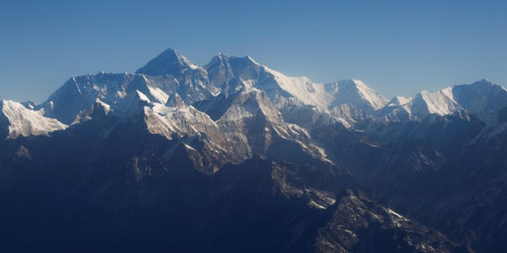
The Himalayas Mountain range in Asia
Worlds highest and most impressive mountains and the most conspicuous feature of folding.
- Himalayas - Asia
- Everest - Nepal-Tibet border highest point.
- Andes - Peru in S. America
- Alps - South Central Europe
- Rockies - America
- Atlas - Africa.
- Appalachian - America
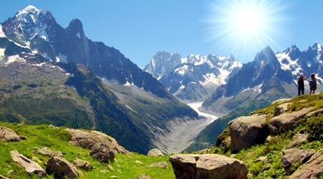
Theories of Origin of Fold Mountains
  - Contraction Theory
- During the earth’s formation surface rocks cooled faster and wrinkled to form Fold Mountains.
b. Convectional Currents Theory
- Horizontal convectional currents in the mantle exerted frictional pull on crustal rocks.
- Continental crusts were pulled towards each other.
- Sediments between them were squeezed into folds.
c. Continental Drift Theory
- During break of Gondwanaland India drifted northwards and collided with Eurasia.
- Sediments between were squeezed to form fold mountains e.g. Himalayas and Everest.
d. Plate Tectonics Theory
- When an oceanic plate meets another or it meets a continental plate, the sediments under the sea are compressed to form Fold Mountains.
- When two continental plates meet the sial layer is compressed to form fold mountains
- E.g. Alps was formed when Africa plate pushed against the rigid European plate
2. Escarpments
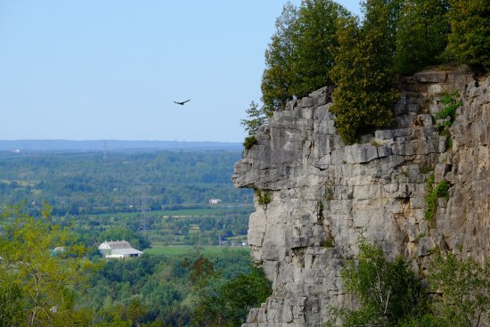
- A relatively continuous line of steep slopes facing the same direction.
- Formed one compressional force causes folding resulting in one steep limp of the anticline which forms the escarpment.
3. Depressions
Formed when not very strong forces cause folding causing some parts of the earths surface to form synclines forming basins.
4. Ridges and Valleys
- When folding occurs anticlines form uplands/ridges/hills while synclines form valleys.
5. Rolling Plains
- A high fairly level land between mountains.
- Formed when rocks at the edges of a region become intensely folded and the middle parts resist folding resulting into mountains which enclose a high fairly level land.
7.Inter-montane basins
-Formed when some parts of inter-montane plateau sink more to form basins.

Significance of Folding To Human Activities/Economic significance
Positive/Advantages
1. Fold Mountains are a tourist attraction which brings foreign exchange.
2. Fold Mountains are water catchment areas and sources of rivers.
3. Some fold mountains have valuable mineral deposits such as coal and petroleum.
4. Fold Mountains act as protective barriers during war.
5. Some fold mountains on the path of rain bearing rainfall influence rainfall causing the windward slopes to receive heavier rainfall.
6. Folding can lead to formation of valuable minerals due to metamorphism.
7. Folding brings valuable minerals to the surface making them easily available.
Negative/disadvantages
1. Fold Mountains on the path of rain winds cause the leeward slopes to receive less rainfall.
2. Fold Mountains discourage settlement due to cold temperatures and rugged terrain
3.Folding can lead to burying of minerals.
4.Fold Mountains are a barrier to road and railway where there are no passes and where there are passes they may be covered by snow.
Orographic fog hinders pilot’s visibility.
To Physical Environment
1. Folding can result in submerged coastal zones which are used as harbours.
2. Can lead to metamorphism of rocks changing their original state and making them more resistant to erosion.
3. Depressions formed by folding turn into wet land important for water purification.
4. Folding leads to faulting and magma may escape through faults leading to Vulcanicity and earth quakes.
Resultant Features of Folding on the Earth’s Surface
Folding of the Earth's crust creates a variety of distinctive landforms:
- Fold Mountains: These are large mountain ranges formed by the folding of the Earth's crust along convergent plate boundaries. Intense compressional forces cause extensive folding and faulting, resulting in high peaks and deep valleys. Examples include the Himalayas, the Alps, the Andes, and the Rockies.
- Ridges and Valleys in Folded Terrain: In areas with less intense folding, alternating anticlines and synclines can create a landscape of parallel ridges (formed by resistant anticlines) and valleys (formed by less resistant synclines).
- Upwarped Plains and Plateaus: Broad, gentle folding can uplift large areas, forming extensive plains or plateaus that may be slightly warped.
- Basins: Large, bowl-shaped depressions formed by the downwarping of rock layers. These basins can accumulate sediments over time.
- Hogbacks and Cuestas: These are asymmetrical ridges formed by the erosion of steeply dipping sedimentary rock layers. A hogback has a sharp, narrow crest and steeply sloping sides, while a cuesta has a gentler slope on one side and a steeper scarp on the other.
- Structural Domes and Basins: Large, roughly circular or elliptical upwarps (domes) and downwarps (basins) in rock layers. Erosion of a dome exposes older rocks at the center, while erosion of a basin exposes younger rocks at the center.
Sketches of Resultant Features (Learners should draw these):
- Fold Mountains: A cross-section showing multiple anticlines and synclines forming high peaks and valleys.
- Ridges and Valleys: A block diagram illustrating parallel ridges (anticlines) and valleys (synclines).
- Hogback and Cuesta: Cross-sections showing the asymmetrical nature of these ridges formed from dipping rock layers.
- Structural Dome and Basin: A map view showing concentric rings of rock layers, with the oldest at the center of a dome and the youngest at the center of a basin.
Modelling Resultant Features (Learners can create these):
- Using layers of different colored clay or playdough to demonstrate the bending and buckling of rock layers into anticlines and synclines.
- Using stacked pieces of paper or fabric to show how compression can create folds of varying shapes and intensities.
- Creating a model of a fold mountain range using cardboard or other materials.
- Demonstrating a monocline by bending a stack of layers in a step-like fashion.
Significance of Folding and the Resultant Features
Folding and the landforms it creates have significant impacts:
- Formation of Mountain Ranges: Fold mountains are major barriers, influencing climate patterns (creating rain shadows), river systems (acting as water divides and sources of rivers), and human migration and settlement.
- Economic Mineral Deposits: Folding can concentrate valuable mineral deposits. For example, ore veins can be formed along fault lines associated with folding. Sedimentary basins formed by folding can accumulate fossil fuels like oil and natural gas.
- Water Resources: Fold mountains often receive high amounts of precipitation, acting as important water towers that supply rivers and groundwater to surrounding areas. Synclinal valleys can sometimes hold underground water.
- Soil Formation: The weathering and erosion of folded rocks contribute to the formation of various soil types in mountainous and hilly regions.
- Tourism and Recreation: Fold mountain landscapes are often scenic and attract tourists for activities like hiking, skiing, and mountaineering. Hilly and ridged terrain also offers opportunities for adventure sports.
- Agriculture: While steep slopes of fold mountains may limit agriculture, terracing can allow for cultivation. Valleys between folds often have fertile soils due to deposition.
- Settlement Patterns: Fold mountains can act as barriers to human settlement and transportation, leading to dispersed populations and influencing the development of infrastructure like roads and railways. Valleys, on the other hand, may provide favorable sites for settlement.
- Climate: Fold mountains can create orographic rainfall as moist air is forced to rise and condense over them. They can also create rain shadow effects on the leeward side, leading to drier conditions.
Distribution of Fold Mountains in the World
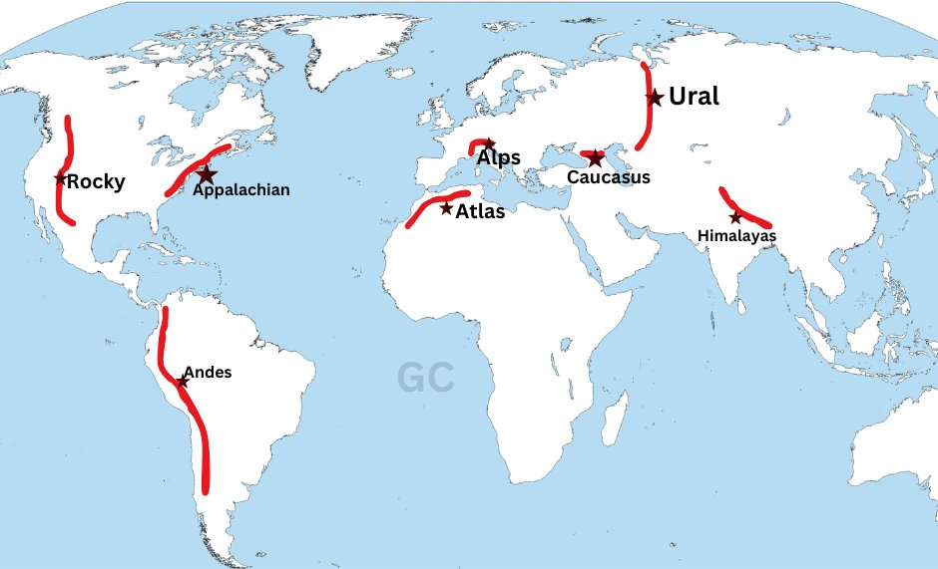Fold mountains are primarily located along convergent plate boundaries where continental plates collide. Major fold mountain systems include:
- The Himalayas: Formed by the collision of the Indian and Eurasian plates. They are the highest mountain range in the world, containing peaks like Mount Everest.
- The Alps: Formed by the collision of the African and Eurasian plates. They stretch across central Europe.
- The Andes: Formed by the subduction of the Nazca Plate beneath the South American Plate along the western coast of South America. They are the longest continental mountain range.
- The Rockies: Formed by the collision of the North American and Pacific plates (complex subduction and compression) in western North America.
- The Appalachians: Older fold mountains in eastern North America, formed by ancient continental collisions. They are now heavily eroded and less dramatic in height than the younger ranges.
- The Urals: A mountain range in Russia that forms the traditional boundary between Europe and Asia, formed by ancient continental collisions.
- The Atlas Mountains: Located in northwestern Africa, formed by the collision of the African and Eurasian plates.
- The Great Dividing Range: Located in eastern Australia, formed by ancient tectonic activity.
World Map Showing Distribution of Fold Mountains (Learners should draw this):
A world map should be drawn, highlighting the locations of these major fold mountain systems along the edges of continents where plate collisions have occurred. Key continents to show are Asia (Himalayas, Urals), Europe (Alps), North America (Rockies, Appalachians), South America (Andes), Africa (Atlas), and Australia (Great Dividing Range).
Influence of Folding and the Resultant Features on Human Activities
Folding and the landforms it creates have a profound influence on various human activities:
- Agriculture: Mountainous terrain can limit arable land, but terracing allows for farming on slopes. Valleys often provide fertile ground for cultivation. The climate influenced by mountains (rainfall, temperature) also affects agricultural practices.
- Settlement: Steep slopes and rugged terrain of fold mountains can hinder settlement and infrastructure development. Valleys and lower-lying areas between folds tend to be more densely populated.
- Transportation: Mountain ranges act as significant barriers to transportation, requiring the construction of passes, tunnels, and winding roads. This can impact trade, communication, and accessibility.
- Resource Exploitation: Fold mountains are often rich in mineral resources, leading to mining activities. They also serve as sources of timber and hydroelectric power due to high rainfall and steep slopes.
- Tourism and Recreation: Fold mountain landscapes provide opportunities for various recreational activities, supporting local economies through tourism.
- Water Supply: Mountains are crucial water sources, supplying rivers and groundwater used for domestic, agricultural, and industrial purposes. The pattern of folding can influence the availability and distribution of water resources.
- Energy Production: Hydroelectric power generation is common in mountainous regions with high river discharge. Geothermal energy can also be harnessed in areas with tectonic activity associated with folding.
- Cultural Development: Mountainous regions can sometimes lead to the isolation of communities, fostering unique cultures and traditions.
VULCANICITY
-Process in which solid, liquid or gaseous materials are forced out of the interior of the earth into the earth’s crust or onto the earth’s surface.
These materials are magma, lava, gases, dust, ash and cinder.

Causes of Vulcanicity in the Earth
Vulcanicity refers to the processes and phenomena associated with the eruption of molten rock (magma) onto the Earth's surface. The primary causes of vulcanicity are related to the Earth's internal heat and tectonic plate movements:
- Plate Tectonics: The Earth's lithosphere is broken into several large and small plates that are constantly moving. The movement of these plates is the main driving force behind vulcanicity.
  - Divergent Plate Boundaries: At divergent boundaries, plates move apart, allowing magma from the asthenosphere (the upper layer of the Earth's mantle) to rise and fill the gap. This process leads to the formation of volcanic activity, such as mid-ocean ridges (e.g., the Mid-Atlantic Ridge) and rift valleys (e.g., the East African Rift Valley).
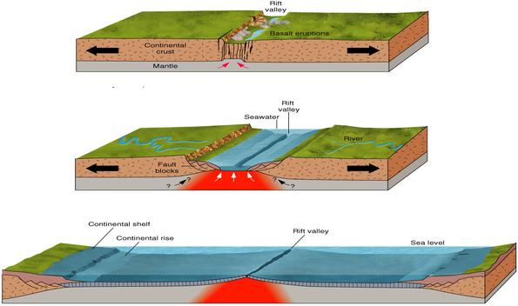

  - Convergent Plate Boundaries: At convergent boundaries, plates collide. There are two main scenarios:
    - Subduction Zones: When an oceanic plate collides with a continental plate or another oceanic plate, the denser plate is forced beneath the less dense plate in a process called subduction. As the subducting plate descends into the mantle, it heats up and releases water. This water lowers the melting point of the surrounding mantle rock, causing it to melt and form magma. This magma rises to the surface, leading to the formation of volcanic arcs (e.g., the Andes Mountains, the Japanese Islands).

    - Continental Collision: When two continental plates collide, neither plate subducts. Instead, they crumple and fold, forming large mountain ranges (e.g., the Himalayas). While this process doesn't directly cause widespread vulcanism, some localized melting can occur due to the intense pressure and friction. 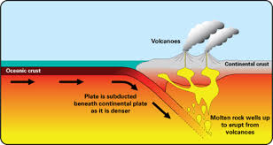

  - Hot Spots (Mantle Plumes): Hot spots are stationary plumes of hot magma that rise from deep within the mantle. As a plate moves over a hot spot, magma rises and erupts onto the surface, creating a chain of volcanic islands or features. Examples include the Hawaiian Islands and the Yellowstone hot spot.
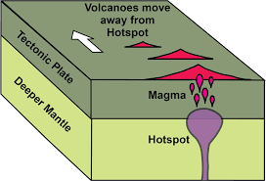
- Earth's Internal Heat: The Earth's interior is extremely hot. This heat is a combination of:
  - Residual Heat: Heat left over from the Earth's formation.
  - Radioactive Decay: The decay of radioactive isotopes (such as uranium, thorium, and potassium) within the Earth's mantle and crust releases a significant amount of heat.
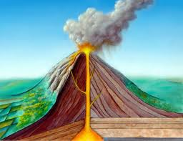
Causes of Vulcanicity summary
- Magma under high temperature and pressure moving through lines of weakness or faults.
- When tectonic plates move away from each other and boundaries give way to magma.
- Underground water coming into contact with hot materials hence changing into gaseous form.
Types of Vulcanicity:
Extrusive Vulcanicity (volcanic): in which materials intrude crustal rocks and don’t reach the earth’s surface. Magma is the molten material while it’s underground.
Intrusive Vulcanicity (plutonic): in which materials reach the earth’s surface. Lava is the molten material after it reaches the surface.
There are two types of lava and magma, acidic and basic. Acidic lava is viscous and solidifies quickly and doesn’t spread far but accumulates around the vent. Basic lava is more fluid or less viscous and takes longer before cooling and spreads for great distances before doing so. Other materials emitted are gases, ashes, dust and cinder. The solid materials are called pyroclasts. Materials come out through a hole/vent (vent eruption) or crack/fissure (fissure eruption).
Features Resulting From Vulcanicity
-Divided into intrusive and extrusive features or landforms.
Intrusive/Plutonic Features
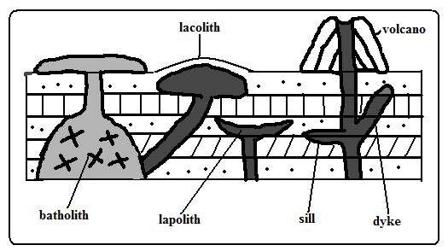
-Features formed by intrusive Vulcanicity when materials intrude the earth’s crust.
Sill
-An igneous intrusion which lies along a bending plane of rock strata.
-Formed when magma forces its way between rock layers then cools and solidifies.
-It forms ridge like escarpments when exposed by erosion e.g. Fouta Djalon highland of Guinea and 3 sisters of S. Africa.
Dyke
-A wall-like igneous intrusion which lies across the bedding plane of rock strata.
-Formed when magma intrudes cracks or faults cutting across bedding planes of rocks then cools and solidifies.
-Can be vertical or inclined.
When exposed it forms ridges e.g. Kaap Valley in Transvaal S. Africa and Jos Plateau in Nigeria.
Laccolith
-A mushroom-shaped igneous intrusion lying between bending planes of a country rock.
-Formed when viscous magma pushes its way through a vent and accumulates around the vent before reaching the earth’s surface pushing the overlying rock into a dome shape.
-It’s so high that land is turned into mountains e.g. El Koub Hill in Algeria, Henry Mountains in Utah U.S.A and Fonjay Massif in Madagascar.
Batholiths
-Largest igneous intrusion formed underground formed when very hot magma intrudes bedding planes of rocks and replaces or metamorphoses it e.g. Chaila Massif in Gabon, Ikhonga-Murwe in Kakamega and the largest is in British Columbia.
Lopolith
-a large saucer shaped igneous intrusion formed when viscous magma intrudes into bedding planes of a country rock. They form shallow depressions on the earth’s surface of the earth e.g. Bushveld complex in S. Africa and Duluth Gabbro mass in U.S.A.
Phacolith
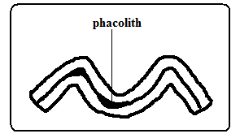
-A lens shaped igneous intrusion which forms in the crest or trough of an anticline e.g. Corndon Hill in England.
Stocks: Smaller, irregular-shaped intrusions similar to batholiths.

Extrusive/Volcanic Features
-Formed when magma reaches the earth’s surface through vents or fissures.
1. Volcanoes
A volcano is a cone shaped hill formed when volcanic materials flow out and accumulate around a vent. Volcanoes are classified into three groups:
- Active volcano- which is known to have erupted in recent times e.g. OL Donyo Lengai in Tanzania and Mt. Cameroon, and Mauna Loa in Hawaii.
- Dormant volcano-not known to have erupted in the recent past but show signs of volcanic activity such as presence of hot springs, geysers and fumaroles e.g. Mt. Kilimanjaro, Longonot and Menengai.
- Extinct volcano-which has not shown signs of possible future eruptions e.g. Mountains Kenya and Elgon.

- Other types of volcanoes include:
  - Shield Volcanoes: Broad, gently sloping volcanoes built by fluid, basaltic lava flows. Eruptions are generally effusive (non-explosive). Example: Mauna Loa, Hawaii.
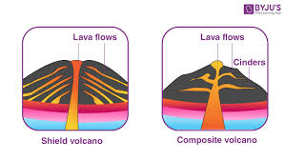
  - Composite Volcanoes (Stratovolcanoes): Steep-sided, cone-shaped volcanoes composed of alternating layers of lava, ash, and pyroclastic material. Eruptions can be both effusive and explosive. Example: Mount Fuji, Japan.
  - Cinder Cones (Scoria Cones): Small, steep-sided cones made of pyroclastic material (cinders or scoria) ejected from a single, short-lived eruption. Example: Paricutin, Mexico.
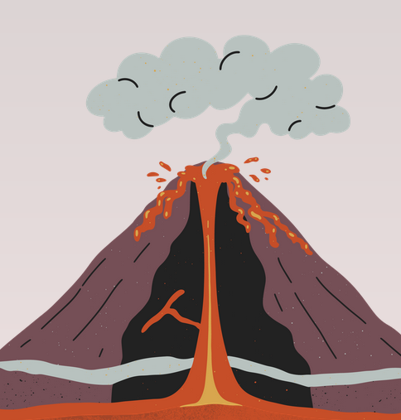
- Lava Plateaus: Extensive, flat areas formed by the accumulation of large volumes of fluid basaltic lava flows. Example: Deccan Plateau, India.
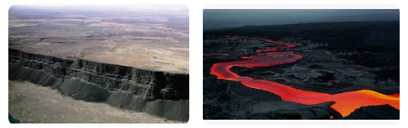
- Calderas: Large, basin-shaped depressions formed when a volcano collapses after a major eruption empties the magma chamber beneath. Example: Yellowstone Caldera, USA.

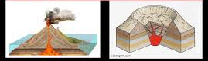
- Geysers: Hot springs that periodically erupt steam and hot water. Eruptions are caused by the heating of groundwater that becomes trapped in underground chambers. Example: Old Faithful, Yellowstone National Park, USA.
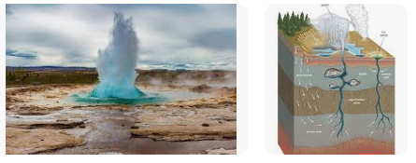
- Hot Springs: Springs that are heated by geothermal energy. The water is often rich in dissolved minerals.
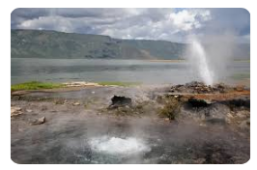
- Fumaroles: Vents that emit volcanic gases, such as steam, sulfur dioxide, and carbon dioxide.
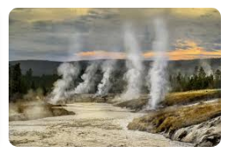
Types of Volcanoes
Acidic Lava Domes
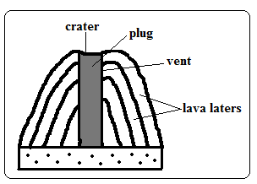
-A steep dome shaped volcanic hill made of acidic lava.
- Viscous lava flows out through a vent.
- It accumulates around the vent because it’s viscous.
- Eruptions occur later and lava flows out covering the layers below.
- A steep sided dome shaped mound of volcano is formed e.g. Itasy Massif of Madagascar, Mt. Kenya and Kilimanjaro.
Characteristics
- Its dome-shaped
- Has steep slopes
- Made of acidic lava
- Has lava layers
- Has steep slopes
- Has a narrow base
Basic Lava Domes/Shield Volcanoes
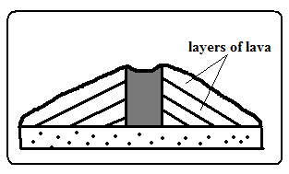
-A low lying volcanic hill made of basic lava.
- Basic magma flows out to the surface through a vent.
- The lava flows far before solidifying because its fluid.
- Eruptions occur later and lava spreads over the old lava.
- A shield shaped mound of volcano is formed e.g. Canary Islands, Cape Verde and Sao Tome which are volcanic Islands in the Indian Ocean.
Characteristics
- Dome/shield shaped
- Has gentle slopes
- Made of basic lava
- Has lava layers
- Has a broad base
Ash and Cinder Cones
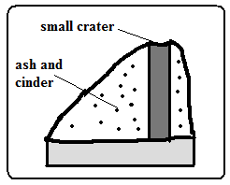
A volcano built from ash and cinder or small fragments of lava.
- Violent vent eruption occurs.
- Ash and pyroclasts are emitted and thrown high.
- Some materials fall and settle around the vent forming a hill.
- Light materials are blown by wind to the leeward side e.g. Chyulu Hills, Teleki and Likaiyu near L. Turkana.
Characteristics
- Made of pyroclasts
- Asymmetrical about the axis
- Cone shaped
- Has smooth slopes
- Has steep windward slope and gentle leeward slope
Composite /Complex/Stratified Volcanoes
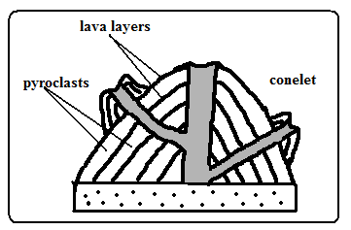
A volcano made of alternating layers of lava and pyroclasts and conelets.
- The first eruption throws out pyroclasts.
- Then viscous lava flows out and solidifies on them.
- Eruption occurs later blowing the rocks sealing the vent.
- The pieces of rock settle on earlier solidified lava.
- Another mass of lava flows out and spreads over pyroclasts and solidifies.
- The process is repeated causing the volcano to build upwards
- The conelets are formed when magma is unable to overcome the plug and finds its way through weak lines at the sides and then pyroclasts and lava accumulate around the side vent e.g. Mountains Kenya, Longonot, Elgon and Kilimanjaro.
Characteristics
- Cone shaped
- Stratified (made of alternating layers of lava and pyroclasts.
- It has conelets (parasitic cones).
- It has steep slopes.
- Made of acidic lava
Plug Dome/volcano/Spine
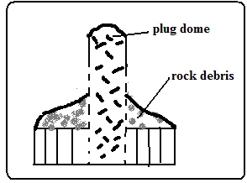
-A column of very viscous lava which sticks above the ground.
- A column of very viscous magma flows out of the ground.
- It cools and hardens rapidly as it rises vertically.
- Pieces of rock break from the plug and accumulate on the sides e.g. Mont Pelee in West Indies, Hyrax and Fischer’s Tower at Hells gate in Naivasha and Devils Tower in U.S.A.
Characteristics
- Made of very viscous lava.
- It is dome shaped like a mushroom germinating out of the ground.
- Has debris on its sides.
- Has very steep sides
- Cylindrical in shape
- Disintegrates fast due to rocks undergoing rapid cooling.

Volcanic Plug
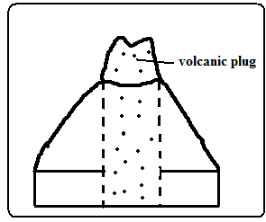
-Stump of rock formed when magma which solidified inside a vent (plug) is exposed by denudation.
- A volcano is first formed.
- Lava on the sides of the volcano is eroded fast due to cooling fast.
- The lava in the vent which is hard due to slow cooling is exposed forming a stump of rock e.g. Peaks of Mt. Kenya, Rangwa Hill and Tororo Rock.
Characteristics
- It resembles a stump of a tree.
- Its dome shaped.
- Very steep at the top and less steep at the bottom
- Made of hard/resistant rock
Lava Plains and Plateaus
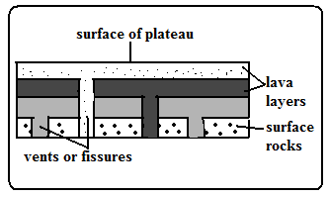
Lava plain: fairly level lowland below 500m above sea level covered by thin lava layers.
Lava plateau: fairly level highland/upland above 500m above sea level covered by thick layers.
-Formed by fissure eruption.
- Magma of low viscosity comes out of the ground through a fissure.
- It flows for a long distance before cooling and solidifying filling depressions and valleys forming a plain.
- Eruption occurs later and lava flows out through lines of weakness on crustal rock and solidified lava.
- The new lava spreads on top of the old lava forming a new layer.
- The process is repeated and a plateau is formed e.g. Mwea, Nandi and Laikipia Plains and Yatta and Uasin Gishu Plateaus.
Craters
-A funnel shaped depression found on top of a volcano.
Modes of Formation
Cooling and Contraction of Magma
- Eruption occurs and a volcano is formed.
- Magma in the vent cools and contracts.
- It withdraws into the vent leaving a depression at the vents mouth e.g. Ngorongoro and Menengai craters.
- Rain water or water from melting snow may collect into craters to form crater lakes e.g. L. Paradise on Mt. Marsabit, L. Magadi on Ngorongoro Crater and L. Chala on Kenyan Tanzanian border.
Explosion
- Gases underground expand due to heat from magma.
- They force their way out through a weak line in the crustal rocks.
- An explosion occurs leaving a hole in the ground called a ring crater e.g. Ghama and Dobot craters in Tanzania and Hora craters in Ethiopia.
- Water from underground or rivers may accumulate into ring craters to form lakes called maars e.g. Lakes Katwe and Nyungu in Uganda.
Falling of a Meteorite
- A meteorite falls on the earth’s surface.
- It sinks into the rocks leaving a depression.
- Water may collect into the depression forming a lake e.g. L. Bosumtwi in Ghana.
Calderas/Basal Wreck
-A very large basin-shaped depression on the summit of a volcano.
Modes of Formation
Violent Explosion
- Gases and water heated by magma expand.
- They force their way through a vent.
- The rocks at the top of the volcano are blown off forming a large depression e.g. Nyirarongo Caldera in DRC and Sabiro Caldera in Uganda.
Block Subsidence/Cauldron
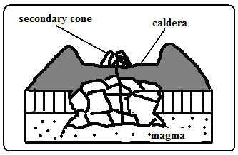
- Eruption occurs to form a volcano.
- An empty space (cauldron) is left in the magma reservoir in the mantle.
- The rocks forming the middle of volcano are pulled inwards by gravity.
- The middle of the volcano collapses forming a large depression at the top e.g. Menengai Caldera near Nakuru and Ngorongoro caldera which is the largest in E. Africa and 6th largest in the world.
- Water from rain or underground may fill calderas to form lakes e.g. L. Magadi in the Ngorongoro caldera and L. Ngozi in Tanzania.
Outward Collapsing
- Ash and pyroclasts volcano grows high.
- Materials on top exert pressure on those below.
- Materials at the base begin to spread outwards.
- The top of volcano collapses inwards forming a collapse caldera e.g. Napak Caldera in Uganda.
-A vent in a volcano which emits gases.
Fumaroles
The gases come from chemical reactions in crustal rocks when heated by magma or when minerals in rocks come into contact with hot air and steam underground.
They are of two types:
Mofette: fumarole which emits carbon dioxide.
Solfatara: fumarole which emits gases with sulphurous compounds.
Hot Springs and Geysers
Hot spring is a place where hot water is emitted from the ground quietly e.g. at the shores of Lakes Magadi and Bogoria.
A geyser is a jet of water and steam which are violently ejected from the ground e.g. at Olkaria and western shores of L. Bogoria.
How They Are Formed
- Percolating water is heated by hot rocks or magma.
- Some collect into chambers called sumps where it develops pressure causing it to be superheated super heated.
- The pressure forces the steam outwards towards the earths surface through holes and cracks in rocks.
- The steam comes out of the ground which reduces pressure in sumps causing the water to expand/boil and come to the surface.
- The steam comes out with a whistling sound accompanied by water forming a geyser.
- The escaping steam heats ground water in surrounding rock.
- The heated water may find its way to the surface where it quietly comes out of the ground forming a hot spring.
Differences
Hot spring | Geyser
-Water comes out quietly.  -only water comes out.  -water may just be warm. | -Water and steam come out violently.  -water is accompanied by steam.  -water is very hot.
Pools of Boiling Water
-Small area of still water which appears to be boiling.
- Actual heating of pool water by gases and steam causing the water to boil.
- Gases and steam coming out below the pool of water causing the pool to bubble and appear as if it’s boiling.
Global Distribution of Features Due to Vulcanicity
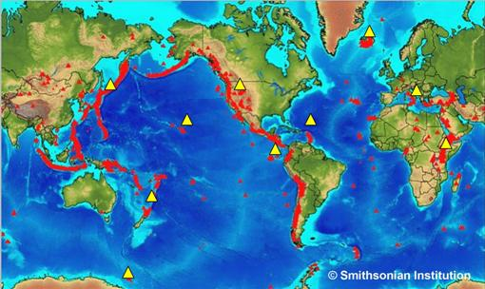
Volcanic activity is not randomly distributed across the globe. It is concentrated in specific zones primarily associated with plate boundaries:
- The Pacific Ring of Fire: This is the most volcanically active region in the world, a zone of intense seismic and volcanic activity that encircles the Pacific Ocean. It is associated with subduction zones along the edges of the Pacific Plate. Many composite volcanoes are found here. Countries located along the Ring of Fire include:
  - Japan
  - Indonesia
  - Philippines
  - Chile
  - United States (West Coast)
  - Canada (West Coast)
- Mid-Ocean Ridges: These are underwater mountain ranges formed at divergent plate boundaries where new oceanic crust is created. Volcanic activity along mid-ocean ridges is primarily effusive, producing basaltic lava. The Mid-Atlantic Ridge is a prominent example.
- Rift Valleys: Formed at divergent plate boundaries on continents, such as the East African Rift Valley. Volcanic activity is common within rift valleys, including both effusive and explosive eruptions.
- Hot Spot Volcanoes: These occur in the middle of tectonic plates, away from plate boundaries. Examples include:
  - The Hawaiian Islands (in the Pacific Plate)
  - Yellowstone National Park (in the North American Plate)
- Other Volcanic Regions:
  - The Mediterranean region (influenced by the collision of the African and Eurasian plates)
  - Iceland (located on the Mid-Atlantic Ridge)
- Regions of faulting e.g. the Great Rift Valley of E. Africa.
- The western coast of America.
- Zones of recent mountain building e.g. fold mountains of S.E Asia.

Significance of Vulcanicity
Positive
- Volcanic rocks weather to form fertile agriculturally productive soils e.g. basalt.
- Geysers are sources of geothermal electricity e.g. at Olkaria.
- Hot springs water is pumped into houses for heating during winter e.g. Iceland.
- Volcanic features are a tourist attraction e.g. hot springs, geysers and snow capped Mt. Kenya.
- Igneous rocks e.g. phonolites are crushed to make ballast for building roads, bridges, etc.
- Crater lakes are a source of fish e.g. L. Katwe in Uganda, sources of minerals e.g. L. Magadi and sources of water for domestic use.
- Volcanic mountains are catchment areas, sources of rivers and habitats for wildlife.
- Pumice a volcanic rock is used as a scrubbing stone.
- Vulcanicity is useful for production of gases e.g. carbon dioxide used in soft drinks manufacture.

- Fertile Soils: Volcanic ash and weathered volcanic rock are rich in nutrients, creating fertile soils that are excellent for agriculture. Many communities have thrived in the vicinity of volcanoes due to the agricultural productivity.
- Geothermal Energy: Volcanic areas often have geothermal resources, which can be harnessed to generate electricity. Geothermal energy is a clean and renewable energy source.
- Mineral Resources: Volcanic activity can bring valuable minerals to the surface, including sulfur, copper, gold, and silver.
- Construction Materials: Volcanic rocks like pumice and obsidian are used in construction.
- Tourism: Volcanic landscapes, such as geysers, hot springs, and volcanic mountains, attract tourists, boosting local economies.
- Scientific Research: Volcanoes provide valuable insights into the Earth's interior, plate tectonics, and the formation of the planet.

Negative
- Volcanic eruptions cause of life and destruction of property e.g. sulphur dioxide, ash, cinder and lava may bury houses and farm land.
- Volcanic mountains are barrier to transport and communication.
- Volcanic mountains on the path of rain winds cause leeward slopes to receive little rainfall by preventing rain bearing winds from reaching there.
- Volcanic eruptions cause environmental pollution from dust, ash and sulphur dioxide.
- Destruction and Loss of Life: Volcanic eruptions can cause widespread destruction through lava flows, pyroclastic flows (fast-moving currents of hot gas and volcanic debris), ashfall, and volcanic mudflows (lahars). These events can lead to loss of life, injuries, and property damage.
- Climate Change: Large volcanic eruptions can inject significant amounts of ash and gases (such as sulfur dioxide) into the atmosphere. These materials can block sunlight, leading to temporary global cooling and affecting weather patterns.
- Air and Water Pollution: Volcanic eruptions release harmful gases (such as sulfur dioxide, carbon dioxide, and hydrogen sulfide) that can pollute the air and cause respiratory problems. Ashfall can contaminate water supplies.
- Disruption of Transportation: Ashfall can disrupt air travel by damaging aircraft engines and reducing visibility. It can also disrupt ground transportation by making roads slippery and reducing visibility.
- Economic Disruption: Volcanic eruptions can cause significant economic losses due to damage to infrastructure, destruction of crops, and disruption of businesses and tourism.
2.3.5 Effects of Vulcanicity on the Environment
Short-Term Effects:
- Air Pollution: Eruption columns release large quantities of gases (SO2, CO2), ash, and fine particles into the atmosphere.
- Water Pollution: Ash and dissolved gases can contaminate surface water and groundwater.
- Habitat Destruction: Lava flows, pyroclastic flows, and lahars can destroy vegetation, forests, and animal habitats.
- Climate Change: Large eruptions can cause temporary global cooling by injecting aerosols into the stratosphere, which reflects sunlight.
- Increased Soil Fertility: Ashfall can initially increase soil fertility in the surrounding areas.
Long-Term Effects:
- Formation of New Landforms: Volcanic activity creates new landforms, such as volcanic mountains, plateaus, and calderas, which alter the landscape and influence drainage patterns.
- Soil Formation: Weathering of volcanic rocks contributes to the formation of fertile soils over long periods.
- Biodiversity: Volcanic landscapes can support unique ecosystems and biodiversity.
- Geothermal Activity: Creates unique habitats that support extremophiles.
- Alteration of Drainage Patterns: Volcanic eruptions can block river valleys, create new lakes, and change the course of rivers.
- Long-Term Climate Impacts: While short-term cooling is common, volcanic activity also releases greenhouse gases like CO2, which can contribute to long-term warming over geological timescales.
To measure the magnitude of volcanic eruptions, scientists use the Volcanic Explosivity Index (VEI). It ranges from 0 to 8, with higher numbers indicating larger, more explosive eruptions.
major volcanic eruptions in world history:
Ancient Eruptions
- Santorini (Thera), Greece, c. 1610 BC: This massive eruption is believed to have significantly impacted the Minoan civilization. The eruption likely caused a large tsunami.
  - VEI: Estimated 6-7
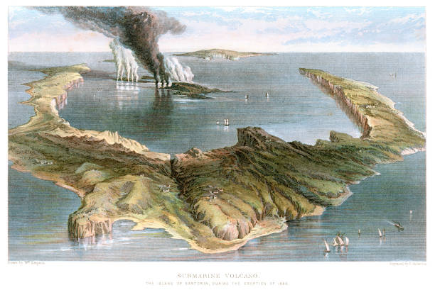
  - eruption of Santorini.
- Vesuvius, Italy, 79 AD: The eruption of Mount Vesuvius buried the Roman cities of Pompeii and Herculaneum under layers of ash and pumice, preserving them for centuries.
  - VEI: 5
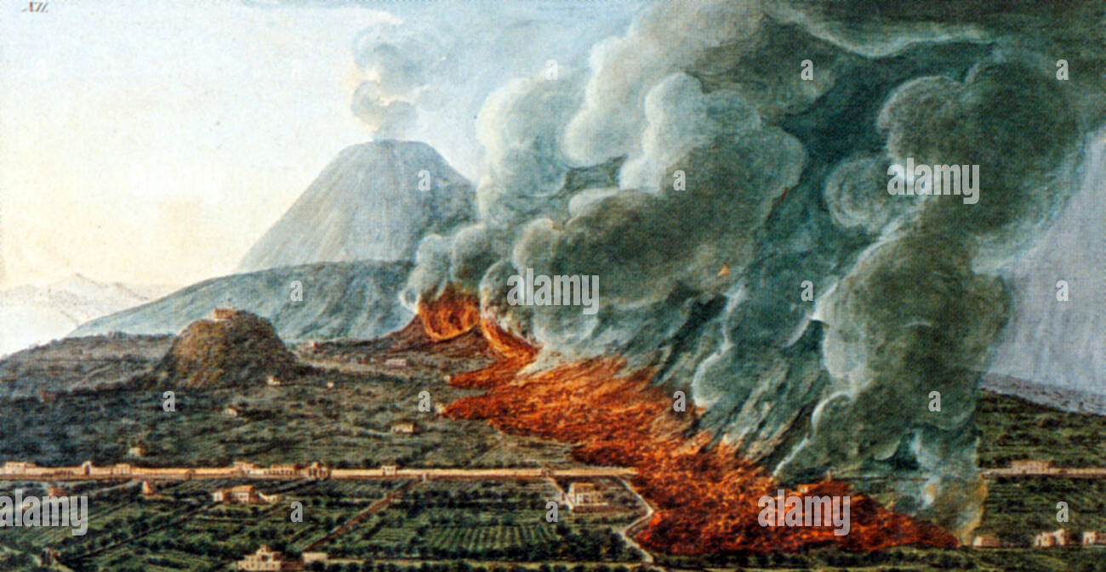
  - Image: A painting of the eruption of Mount Vesuvius in 79 AD.
16th - 19th Centuries
- Huaynaputina, Peru, 1600: This eruption was the largest in South American recorded history and had global climatic effects.
  - VEI: 6
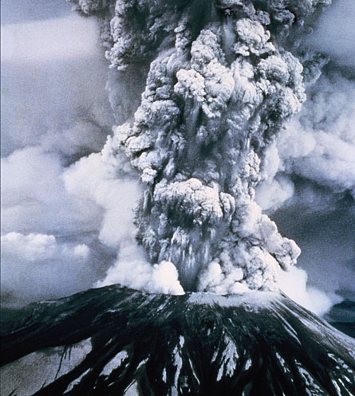
  - depiction of Huaynaputina eruption
- Laki, Iceland, 1783-1784: A series of eruptions at the Laki fissure released massive amounts of lava and volcanic gases, causing a famine in Iceland and contributing to widespread cooling in the Northern Hemisphere.
  - VEI: 6
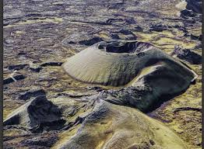
  - The Laki fissure in Iceland.
- Tambora, Indonesia, 1815: The eruption of Mount Tambora was the largest volcanic eruption in recorded history. It caused the "Year Without a Summer" in 1816, with global climatic disruptions and widespread famine.
  - VEI: 7
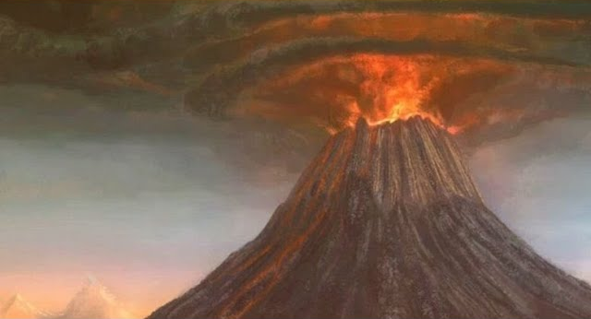
  - Tambora eruption.
- Krakatoa, Indonesia, 1883: The explosive eruption of Krakatoa had devastating consequences, including a massive tsunami that killed tens of thousands of people. The eruption also had global atmospheric effects.
  - VEI: 6
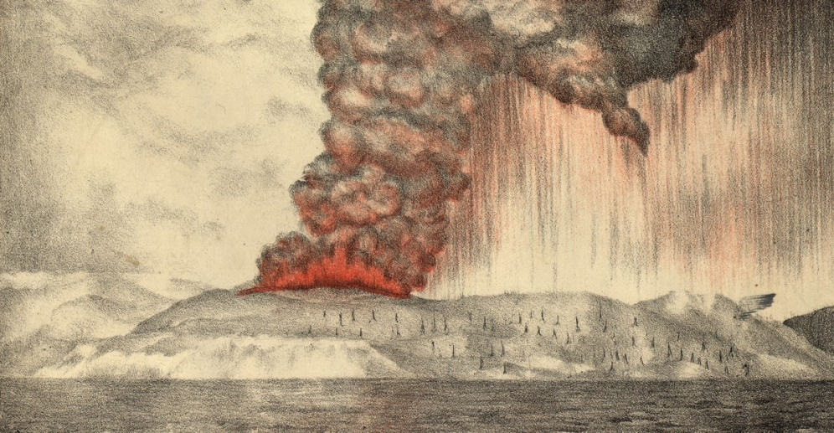
  - the 1883 eruption of Krakatoa.
20th Century
- Mount Pelée, Martinique, 1902: A pyroclastic flow from Mount Pelée destroyed the city of Saint-Pierre, killing thousands of people.
  - VEI: 4
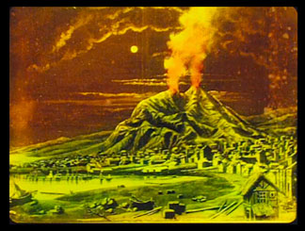
  - Image: Mount Pelee erupting in 1902
- Novarupta, Alaska, 1912: The eruption of Novarupta was the largest volcanic eruption of the 20th century.
  - VEI: 6
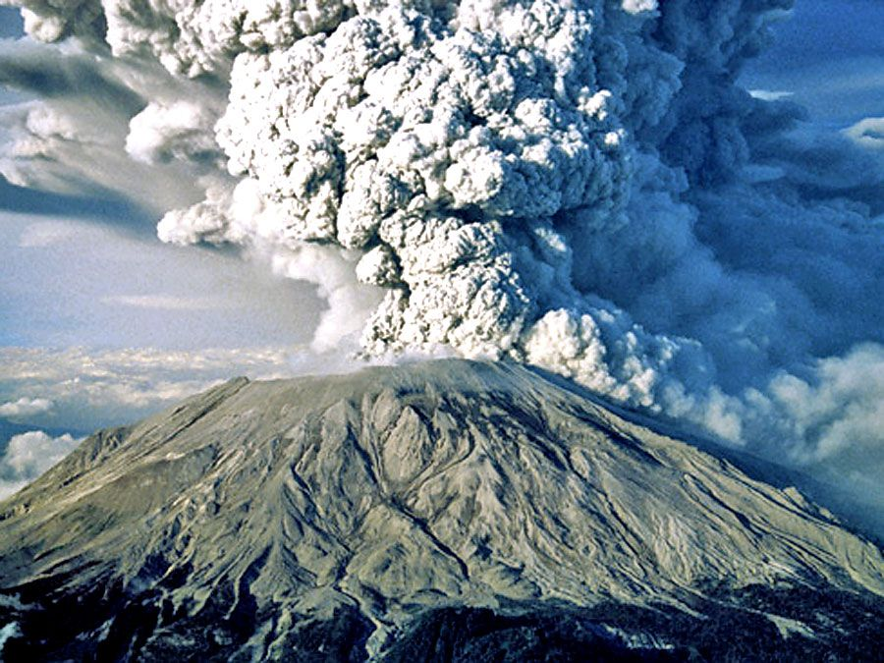
  - Image: Novarupta Volcano
- Mount St. Helens, USA, 1980: A major eruption of Mount St. Helens caused a massive landslide, a lateral blast, and a large ash cloud, causing significant destruction and loss of life.
  - VEI: 5
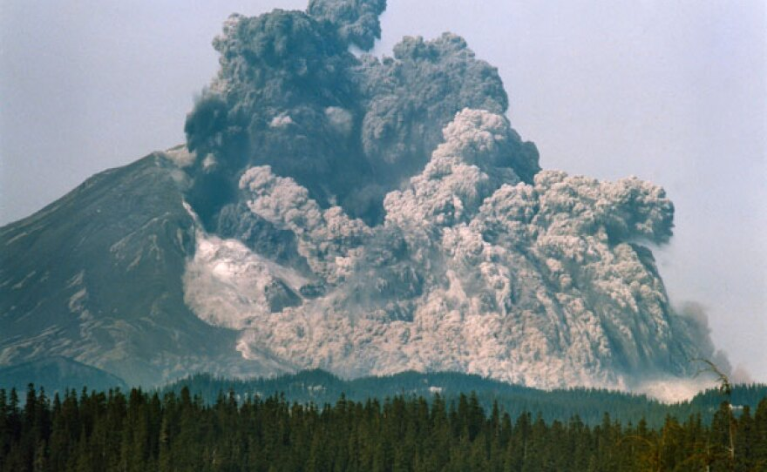
  - Image: The eruption of Mount St. Helens in 1980.
- Mount Pinatubo, Philippines, 1991: The eruption of Mount Pinatubo was the second-largest volcanic eruption of the 20th century. It ejected large volumes of ash and volcanic gases, leading to global cooling.
  - VEI: 6
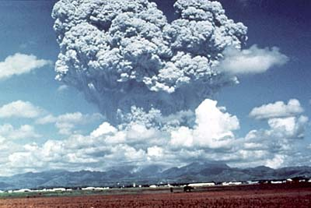
  - Image: The eruption of Mount Pinatubo in 1991.
21st Century
- Hunga Tonga-Hunga Ha'apai, Tonga, 2022: This undersea volcanic eruption in Tonga was one of the largest in recent history. Its effects were felt worldwide, with a tsunami and significant atmospheric disturbances.
  - VEI: 5-6
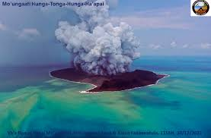
Image: Hunga Tonga-Hunga Ha'apai eruption in 2022
EARTH QUAKES
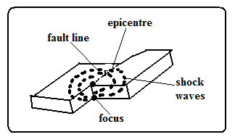
-Sudden and rapid movement of the earth’s crust.
-areas prone to them are called seismic zones and those not prone are called aseismic zones.
It’s caused by shock waves.
There are 3 types of earthquake waves namely:
- Primary waves-which travel fastest and cause the rock particles to vibrate in a push and pull manner and can pass through gases, liquids and solids.
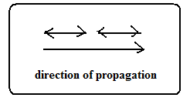
- Secondary waves-which cause rock particles to vibrate at right angles to the direction of wave movement.
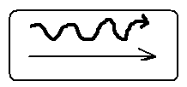
- Surface longitudinal waves-which cause surface rocks to shake sometimes causing buildings to collapse.
    - Rayleigh waves-Which cause surface rocks to move in elliptical orbits.

    - Love waves-which cause rock particles to move in a horizontal manner at right angle to the direction of wave.

Earth quake originates from a point known as seismic focus/origin.
The part of the earth vertically above the seismic focus and where the shock waves are first experienced is called epicentre.
Causes of Earthquakes
Natural Causes
- Tectonic movements e.g. movement of tectonic plates. They cause tectonic earthquakes.
- Tectonic Plate Movement: This is the most significant cause of earthquakes. The Earth's lithosphere is divided into several tectonic plates that are constantly moving.
  - Faulting: The movement of these plates causes stress to build up along the edges (boundaries). When this stress exceeds the strength of the rocks, they fracture or slip suddenly along a fault. This sudden movement releases energy in the form of seismic waves, causing an earthquake.
    - Types of Faults:
      - Normal Fault: Occurs at divergent plate boundaries where plates move apart. The hanging wall moves down relative to the footwall.
      - Reverse (Thrust) Fault: Occurs at convergent plate boundaries where plates collide. The hanging wall moves up relative to the footwall.
      - Strike-Slip (Transform) Fault: Occurs at transform plate boundaries where plates slide past each other horizontally.
- Vulcanicity when magma movement displaces rocks suddenly shaking and shuttering them.
- Volcanic Activity: The movement of magma within a volcano can cause earthquakes. These earthquakes are often smaller and more localized than those caused by tectonic plate movement. Volcanic eruptions can also trigger earthquakes.

- Gravitative force when crustal rocks collapse into cauldron due to gravity.
- Energy release in the mantle when radioactivity takes place in mantle releasing explosive energy which sends shock waves outwards.
- Isostatic adjustment when the continental masses rise to restore the upset state of balance between sial and sima layers.
- Landslides: Large landslides can sometimes trigger small earthquakes.
- Meteorite Impacts: The impact of a large meteorite can cause a significant earthquake.

Human Causes
- Exploding nuclear bombs underground which causes shock waves which spread outwards and are felt in the neighbourhood.
- When a train rolls on its rails causing the ground to vibrate.
- Explosion of explosives used in mining and quarrying which cause vibrations to be felt in the neighbourhood.
- When large reservoirs are constructed and the heavy weight of water reactivate dormant faults causing tremors.
- Human-Induced Earthquakes (Induced Seismicity): Some human activities can trigger earthquakes, although these are usually small.
- Reservoir-Induced Seismicity: The weight of water in large reservoirs can increase pressure on underlying rocks, potentially triggering earthquakes.
- Mining: The removal of rock and the creation of underground voids can destabilize the ground and cause earthquakes.
- Fracking (Hydraulic Fracturing): The injection of fluids into deep underground rock formations to extract oil and natural gas can sometimes trigger small earthquakes.
- Nuclear Explosions: Underground nuclear tests can cause significant earthquakes.

Measurement of Earthquakes
Seismograph is a pendulum based instrument used to measure earthquakes.
It records seismic impulses on a graph-like record called seismogram mounted on it.
Earthquakes are measured by their intensity and magnitude.
Intensity
-Measure of how strong/hard the quake shakes the ground.
It’s seen from the effects the earthquake has on people, buildings and other structures.
It’s measured on the Mercalli Scale which uses a scale running from Roman i-xiii e.g.
- I- description -imperceptible
- V-rather strong-sleepers are awakened and there is swinging of objects.
- VIII-destructive-gaping cracks in walls some brought down.
- XII- major catastrophe-every building destroyed.
The Modified Mercalli Intensity Scale (MMI):
Developed by Giuseppe Mercalli, it measures the intensity of shaking and the damage caused by an earthquake. It is a subjective scale, ranging from I (not felt) to XII (total destruction), based on observations of damage to structures, ground effects, and human experience. Intensity varies with distance from the epicenter, local geological conditions, and building construction.
Magnitude
-Measure of amount of energy given off by an earthquake.
- Magnitude Scales: Measure the energy released at the source of the earthquake (the focus or hypocenter).
  - The Richter Scale: Developed by Charles Richter in 1935, it measures the magnitude of local earthquakes based on the amplitude of the largest seismic wave recorded on a seismograph. It is a logarithmic scale, meaning that each whole number increase represents a tenfold increase in the amplitude of the seismic waves and approximately a 32-fold increase in energy. While still used, it is less common for very large earthquakes.

It’s measured on Ritcher Scale which ranges from 0-8.9.
Intensity values depend on how far a place is from epicentre.
The higher the scale the more severe the earthquake is.
- Intensity I-magnitude 2
- Intensity VIII-magnitude 6
- Intensity XII-magnitude 8.5.

  - The Moment Magnitude Scale (Mw): This is the most widely used scale today, especially for large earthquakes. It measures the total energy released by the earthquake, taking into account the area of the fault rupture, the amount of slip, and the rigidity of the rocks. Like the Richter scale, it is also logarithmic.
World Distribution of Earthquakes
- Within the zones of major faulting e.g. Rift Valley.
- In areas of Vulcanicity e.g. Oldonyo Lengai in Tanzania.
- Along boundaries of tectonic plates e.g. Japan, Philippines, East Indies and west coast of north and South America.
- The Pacific Ring of Fire: This is the most seismically active region in the world, a zone of intense seismic and volcanic activity that encircles the Pacific Ocean. It is associated with subduction zones and transform faults along the edges of the Pacific Plate. Many of the world's largest and most destructive earthquakes occur here. Countries located along the Ring of Fire include:
  - Japan
  - Indonesia
  - Philippines
  - Chile
  - United States (West Coast)
  - Canada (West Coast)
- The Mid-Ocean Ridges: These are underwater mountain ranges formed at divergent plate boundaries where new oceanic crust is created. Earthquakes along mid-ocean ridges are generally shallow and less intense.
- The Alpine-Himalayan Belt: This zone extends from the Mediterranean region eastward through Turkey, Iran, and the Himalayas to Southeast Asia. It is associated with the collision of the Eurasian and African plates, and the collision of the Indian and Eurasian plates. This zone is characterized by both shallow and deep-focus earthquakes.
- Intraplate Earthquakes: While most earthquakes occur at plate boundaries, some earthquakes occur within the interior of tectonic plates (intraplate). These are less common and their causes are not always fully understood. Examples include earthquakes in central and eastern North America.
- East African Rift System: A zone of active faulting and volcanism associated with the divergence of the African plate.
World Map Showing Earthquake Zones (Learners should draw this):
A world map should be drawn highlighting these major earthquake zones:
- Draw and label the Pacific Ring of Fire around the Pacific Ocean.
- Draw and label the Mid-Ocean Ridges, especially the Mid-Atlantic Ridge.
- Draw and label the Alpine-Himalayan Belt across southern Europe and Asia.
- Indicate the general location of the East African Rift System.
Effects of Earthquakes on the Environment
Earthquakes can have devastating effects on the environment:
- Ground Shaking: The most direct effect, it can cause buildings, bridges, and other structures to collapse. The intensity of ground shaking depends on the magnitude of the earthquake, the distance from the epicenter, and the local geological conditions.
- Surface Rupture: Fault movement can cause cracks and displacements on the Earth's surface, damaging roads, pipelines, and other infrastructure.
- Landslides and Rockfalls: Ground shaking can trigger landslides and rockfalls, especially in mountainous or hilly areas. These can bury communities, block roads, and dam rivers.
- Liquefaction: In areas with saturated, loose soil, ground shaking can cause the soil to lose its strength and behave like a liquid. This can cause buildings to sink, pipelines to break, and landslides to occur.
- Tsunamis: Large earthquakes that occur underwater, particularly at subduction zones, can generate tsunamis. These are giant waves that can travel across oceans and cause widespread destruction when they reach coastal areas.
- Fires: Earthquakes can rupture gas lines and electrical lines, causing fires. In urban areas, these fires can spread rapidly and cause extensive damage.
- Changes in Ground Water: Earthquakes can alter groundwater levels and flow patterns, leading to the formation of new springs or the drying up of existing ones.
- Damage to Ecosystems: Earthquakes can disrupt ecosystems by causing landslides, altering habitats, and damaging vegetation and wildlife populations.
- Changes in Land Elevation: Large earthquakes can cause uplift or subsidence (sinking) of the land surface, altering coastlines and drainage patterns.

Effects of Earthquakes summary
- Can cause loss of life and property when buildings collapse burying people.
- Disrupt transport and communication by vertically and laterally displacing land which disconnects pipelines, electricity lines, roads and railways.
- Causes landslides which also cause loss of life and property and disrupts communication.
- Causes raising and lowering of the sea floor and the coastal regions.
- Cause huge sea waves called Tsunami which may flood the neighbouring coastal areas.
- Trigger folding, Vulcanicity and fires.
- Give off a lot of explosive energy more than an atomic bomb.
- Cause fear and panic.
- Hinder settlement as it is restricted to aseismic areas.
- Cause violent motions of the earth’s surface.
Disaster Preparedness and Management Strategies for Coping with the Effects of Earthquakes
Effective disaster preparedness and management are crucial for minimizing the impact of earthquakes:
Preparedness Strategies:
- Earthquake-Resistant Construction: Designing and constructing buildings, bridges, and other structures to withstand ground shaking. This includes using reinforced concrete, flexible foundations, and other engineering techniques.
- Land-Use Planning: Avoiding construction in areas at high risk of earthquakes, such as near active faults or in areas prone to liquefaction or landslides.
- Early Warning Systems: Developing systems that can detect the first seismic waves and provide a few seconds to minutes of warning before the arrival of stronger shaking. This can allow people to take protective actions.
- Public Education and Awareness: Educating the public about earthquake hazards, safety procedures (e.g., "drop, cover, and hold on"), and emergency plans.
- Emergency Response Planning: Developing plans for evacuation, search and rescue, medical care, and providing essential supplies in the event of an earthquake.
- Stockpiling Supplies: Storing emergency supplies, such as food, water, first-aid kits, and tools, in homes and communities.
- Regular Drills: Conducting earthquake drills to practice safety procedures and ensure that people know what to do during an earthquake.
Management Strategies:
- Search and Rescue: Deploying trained personnel and equipment to locate and rescue people trapped in collapsed buildings.
- Medical Care: Providing immediate medical attention to the injured and establishing temporary hospitals or field clinics.
- Shelter and Relief: Providing temporary shelter, food, water, and other essential supplies to people who have lost their homes.
- Damage Assessment: Assessing the extent of damage to buildings, infrastructure, and the environment to prioritize relief efforts and plan for reconstruction.
- Reconstruction and Rehabilitation: Rebuilding damaged infrastructure and communities, and providing support for people to recover from the trauma and economic losses caused by the earthquake.
- Monitoring and Research: Monitoring seismic activity to detect aftershocks and improve understanding of earthquake processes. Conducting research to improve earthquake prediction and mitigation strategies.
- International Cooperation: Seeking and providing international assistance in the form of personnel, equipment, and financial aid.
Communication Messages on Disaster Preparedness and Management:
- "Drop, Cover, and Hold On! Protect yourself during an earthquake."
- "Know your evacuation route. Be prepared for an earthquake."
- "Build strong, build safe. Support earthquake-resistant construction."
- "Emergency kit ready? Food, water, first aid, and more."
- "Stay informed. Listen to official warnings and instructions."
- "Aftershocks are dangerous. Be prepared for more shaking."
- "Help your neighbors. Community support saves lives."
Key points to remember:
- Earthquakes are measured by magnitude (Richter scale, moment magnitude scale).
- Tsunamis are giant waves, most often caused by earthquakes, but also by volcanic eruptions, landslides, or meteorite impacts. They are characterized by their wave height, speed, and inundation distance.
Major historical earthquakes examples:
1. Ancient Events
- c. 1610 BC: Santorini Eruption (Greece): A massive volcanic eruption on the island of Santorini is believed to have caused a tsunami that devastated the Minoan civilization on Crete.
2. 18th Century
- 1755 Lisbon Earthquake and Tsunami (Portugal): A massive earthquake off the coast of Portugal triggered a devastating tsunami that, combined with the earthquake and subsequent fires, nearly destroyed Lisbon.
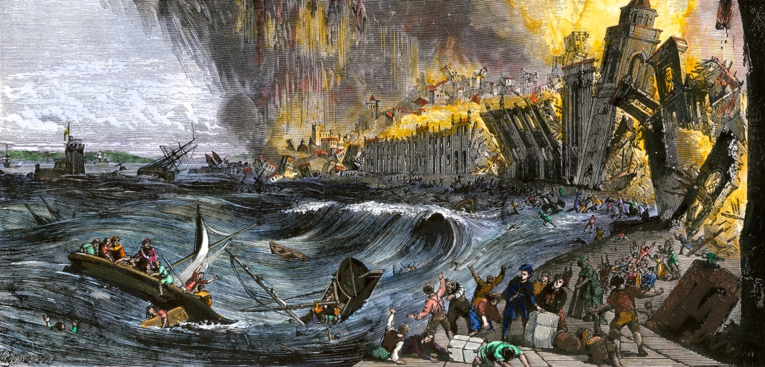
  - Image: A historical depiction of the Lisbon earthquake and tsunami.
3. 19th Century
- 1883 Krakatoa Eruption (Indonesia): The eruption of Krakatoa volcano caused a series of powerful tsunamis that devastated coastal areas in Indonesia and were recorded across the Indian Ocean.
4. 20th Century
- 1960 Valdivia Earthquake and Tsunami (Chile): The most powerful earthquake ever recorded (magnitude 9.5) triggered a massive tsunami that affected much of the Pacific Ocean, causing damage as far away as Hawaii and Japan.
  - Image: Damage caused by the 1960 Valdivia tsunami in Chile.
- 1964 Alaska Earthquake and Tsunami (USA): A magnitude 9.2 earthquake in Alaska generated a tsunami that devastated coastal communities in Alaska and caused damage along the west coast of North America.
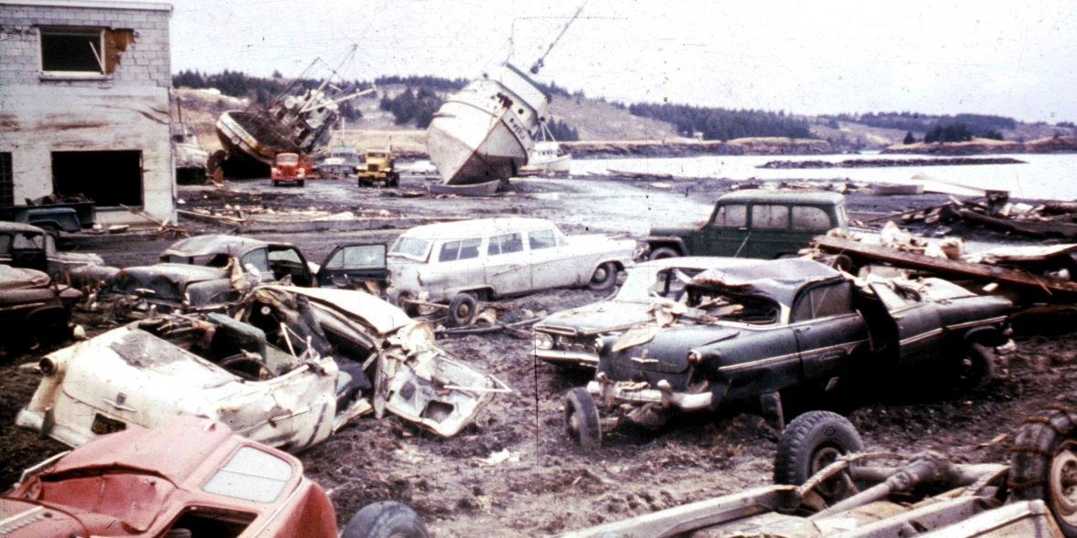
  - Image: Damage from the 1964 Alaska earthquake and tsunami.
5. 21st Century
- 2004 Indian Ocean Earthquake and Tsunami: A magnitude 9.1-9.3 earthquake off the coast of Sumatra, Indonesia, triggered one of the deadliest tsunamis in recorded history, devastating coastlines across the Indian Ocean and killing hundreds of thousands of people.
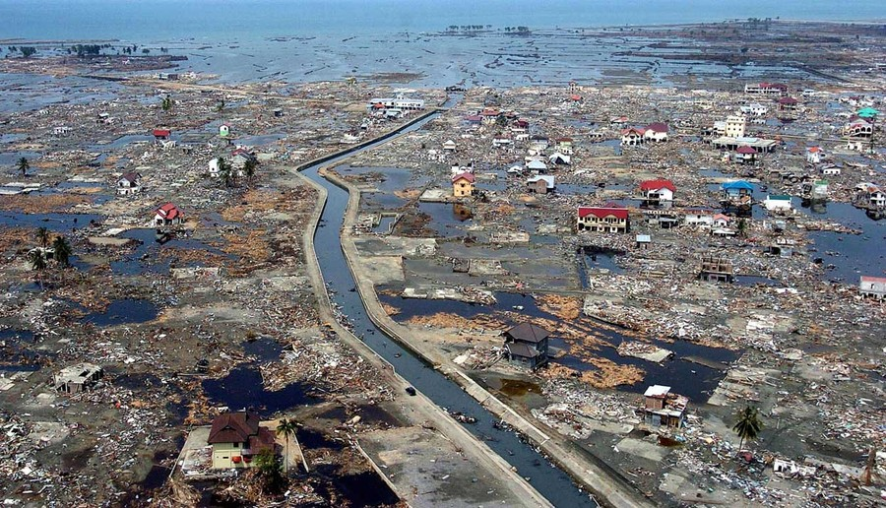
  - Image: A satellite image showing the damage caused by the 2004 Indian Ocean tsunami in Indonesia.
- 2011 Tōhoku Earthquake and Tsunami (Japan): A magnitude 9.0 earthquake off the coast of Japan generated a powerful tsunami that devastated the northeastern coast of Honshu, Japan, causing widespread destruction and triggering the Fukushima Daiichi nuclear disaster.
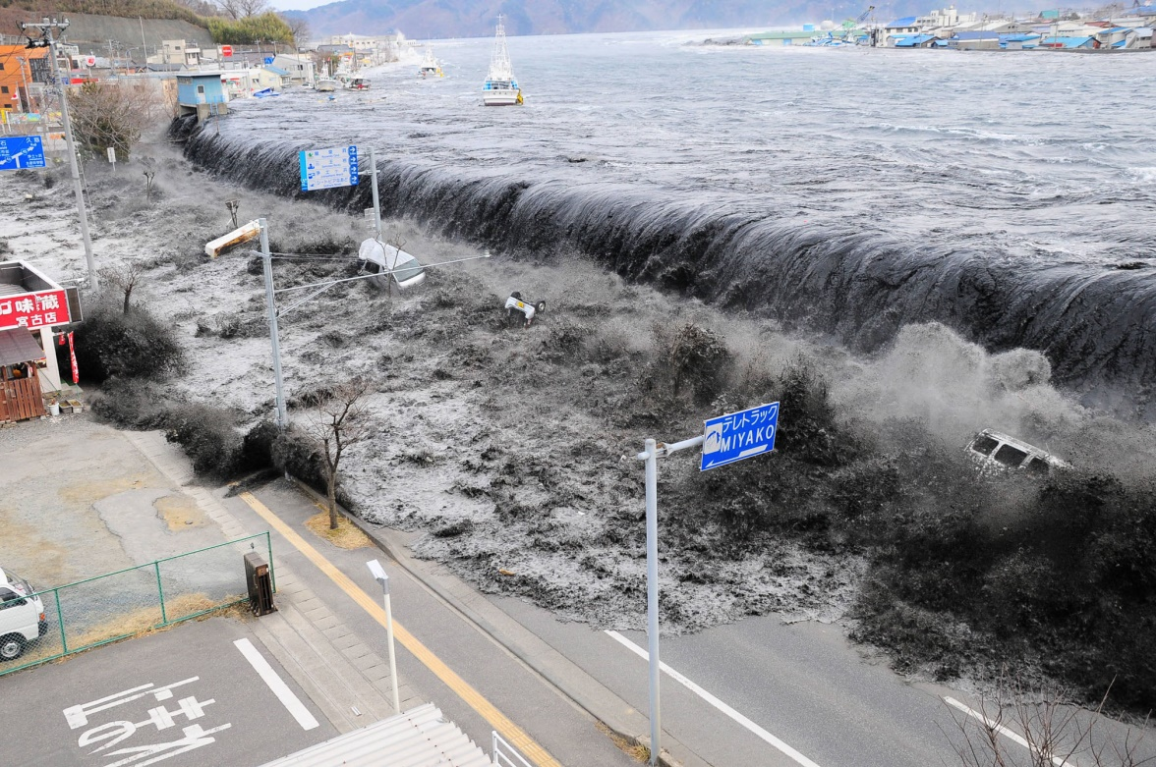
  - Image: A view of the tsunami waves hitting the coast of Japan in 2011.
- 2023 Turkey-Syria Earthquakes: A magnitude 7.8 earthquake struck southern Turkey and northern Syria, causing widespread building collapse and tens of thousands of deaths.
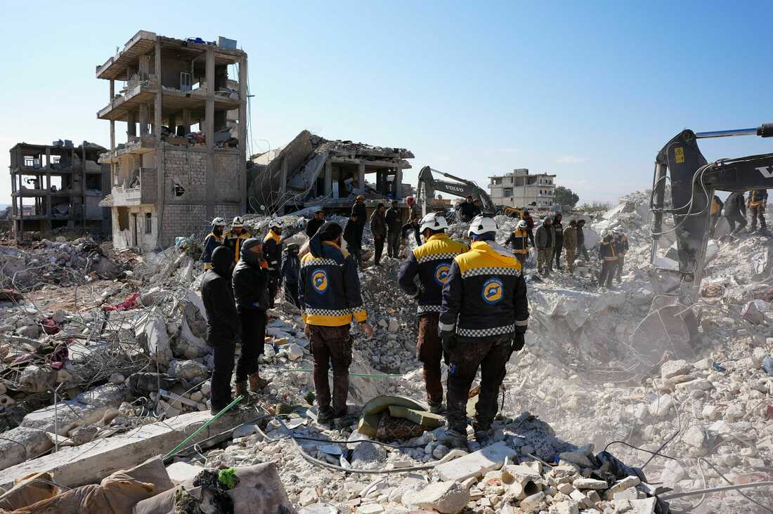
  - Image: Rescue efforts in the aftermath of the 2023 Turkey-Syria earthquakes.
- 2025 Myanmar Earthquake: A magnitude 7.7 earthquake struck central Myanmar in March 2025, causing widespread damage.
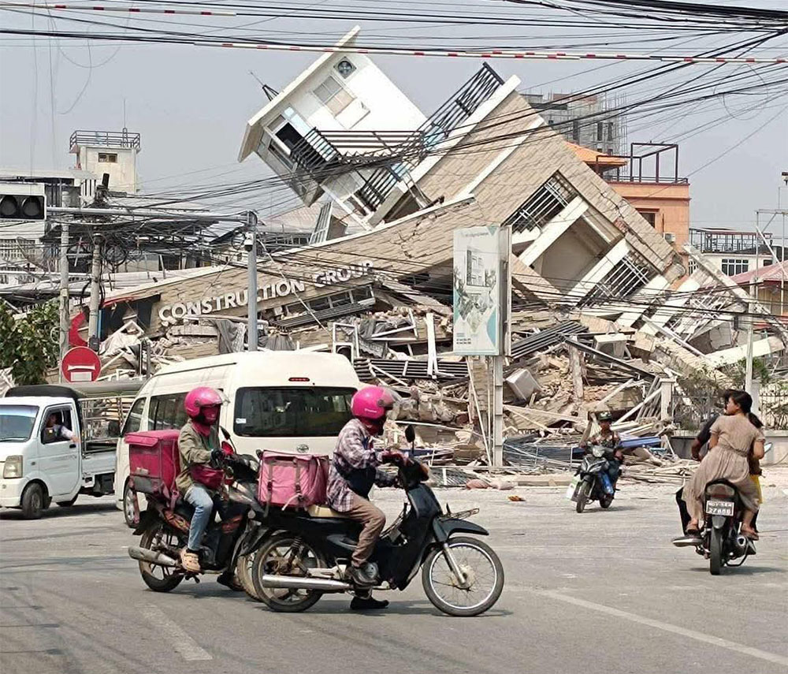
  - image of the 2025 Myanmar earthquake's

3.0 HUMAN AND ECONOMIC ACTIVITIES AGRICULTURE
3.1, AGRICULTURE:
a) Types of Agriculture in the World
Agriculture is the practice of cultivating plants and rearing animals for food, fiber, and other products. Here are some main types:
- Subsistence Agriculture:
  - Farming primarily for the farmer's own consumption.
  - Characteristics:
    - Practiced mainly in developing countries.
    - Uses traditional farming methods and low technology.
    - Relies heavily on family labor.
    - Often involves crop cultivation and animal rearing for consumption.
    - Characterized by small-scale farming, low technology, and labor-intensive methods.
  - Types include:
    - Shifting cultivation: Clearing a patch of forest, farming it until the soil is exhausted, and then moving to a new patch.
    - Practiced in tropical regions like the Amazon Basin and parts of Africa.
    - It is labor-intensive and environmentally challenging.
    - Pastoral nomadism: Herding animals from place to place in search of pasture and water.
    - Intensive subsistence: Cultivating a small plot of land intensively to produce enough food for a large population.
- Commercial Agriculture:
  - Farming for profit, with crops and livestock sold in the market.
  - Characteristics:
    - Large-scale farming operations.
    - Highly mechanized and uses advanced technology.
    - Products are often sold in national or international markets.
    - Includes crops like wheat, maize, and cash crops such as cotton, tobacco, and tea.
    - Characterized by large-scale farming, high technology, specialization, and capital-intensive methods.
  - Types include:
    - Plantation agriculture: Large-scale farming of cash crops like tea, coffee, and rubber, often in tropical regions.
    - Extensive commercial grain farming: Large-scale farming of grains like wheat and barley in temperate grasslands.
    - Commercial livestock ranching: Raising animals like cattle and sheep on large ranches, often in semi-arid regions.
    - Dairy farming: Raising cattle for milk production.
    - Mediterranean agriculture: Growing fruits, vegetables, and cereals in regions with a Mediterranean climate.
- Urban Agriculture:
  - Growing food in and around cities.
  - Can involve various methods like:
    - Community gardens: Plots of land cultivated by groups of people.
    - Rooftop gardens: Growing plants on the roofs of buildings.
    - Vertical farming: Growing crops in vertically stacked layers.
    - Hydroponics: Growing plants without soil, using water and nutrients.
    - Aquaponics: A system that combines raising fish and growing plants.
- Intensive Agriculture:
  - Definition: This type of agriculture focuses on maximizing output from a small piece of land using significant labor and capital inputs.
  - Characteristics:
    - Common in densely populated regions.
    - Uses fertilizers, irrigation, and high-yielding varieties of crops.
    - Often practiced in areas where land is limited but there is a high demand for food.
- Extensive Agriculture:
  - Definition: This involves large areas of land with minimal input of labor or capital, often used for grazing livestock or growing crops with low labor costs.
  - Characteristics:
    - Land is more abundant than labor.
    - Uses few inputs per unit area.
    - Common in regions with low population density like parts of Australia and the Americas.
- Mixed Farming:
  - Definition: Involves the cultivation of crops alongside raising livestock on the same farm.
  - Characteristics:
    - A combination of both crop production and animal husbandry.
    - It allows for diversification of farm income.
    - Used widely in many parts of the world, including Europe and North America.
b) Importance of Agriculture in Society
Agriculture plays a crucial role in society:
- Food security: Provides food for the population.
- Economic development: Provides income and employment, contributes to GDP, and generates foreign exchange through exports.
- Raw materials: Supplies raw materials for industries like textiles, food processing, and pharmaceuticals.
- Employment: Provides livelihoods for a large portion of the population, especially in developing countries.
- Cultural heritage: Agriculture is often tied to cultural traditions and practices.
- Environmental Benefits:
  - Sustainable agricultural practices can help maintain soil fertility, biodiversity, and water resources.
- Rural Development:
  - Agriculture helps improve infrastructure in rural areas, such as roads, schools, and health facilities.
c) Trends in Agriculture in Africa
- Increasing adoption of technology (e.g. phones for information, precision agriculture).
- Growing emphasis on sustainable agriculture practices.
- Expansion of commercial farming.
- Increased participation of women in agriculture.
- Challenges related to climate change, land degradation, and access to resources.
- Increasing Urbanization:
  - As more people move to cities, there is a decline in rural populations and a shift towards urban-based food systems.
- Technological Advancements:
  - There is growing adoption of new agricultural technologies, such as drought-resistant crops, mobile apps for farmers, and modern irrigation systems.
- Climate Change Impacts:
  - Unpredictable weather patterns, droughts, and floods are affecting agricultural productivity and forcing farmers to adopt climate-smart practices.
- Agricultural Investment:
  - There is a rising trend of both government and private sector investment in agriculture, particularly in agribusiness ventures like processing, packaging, and exportation.
- Sustainable Farming Practices:
  - There is an increasing focus on promoting sustainable farming practices such as organic farming and agroforestry to protect the environment.
- Youth Involvement:
  - More young people are getting involved in agriculture, driven by initiatives that aim to make farming more attractive and profitable for the younger generation.
d) Challenges Facing Agriculture in Kenya
- Climate change: Droughts, floods, and unpredictable rainfall.
- Land degradation: Soil erosion, deforestation, and desertification.
- Limited access to credit and markets: Difficulty in obtaining loans and selling produce.
- Pests and diseases: Crop and livestock losses.
- Inadequate infrastructure: Poor roads, storage facilities, and irrigation systems.
- Land tenure issues: Disputes over land ownership and use.
- Low technology adoption: Limited use of modern farming techniques.
- Land Degradation:
  - Overuse of land, deforestation, and soil erosion reduce soil fertility and land productivity.
- Insecurity and Conflict:
  - In some areas, insecurity and land disputes disrupt farming activities and displace farmers.
e) Strategies Towards Enhancing Agricultural Productivity in Kenya
- Climate-smart agriculture: Practices that increase productivity, enhance resilience, and reduce greenhouse gas emissions.
- Sustainable land management: Practices that conserve soil and water resources.
- Improving access to credit and markets: Providing farmers with loans and connecting them to buyers.
- Integrated pest and disease management: Using a combination of methods to control pests and diseases.
- Developing infrastructure: Building better roads, storage facilities, and irrigation systems.
- Land reforms: Addressing land ownership and use issues.
- Promoting technology adoption: Training farmers on modern farming techniques and providing access to technology.
- Investing in agricultural research and development: Developing new crop varieties and farming methods.
f) Role of Agriculture Towards Food Security in Kenya
- Agriculture is essential for ensuring food security, which means that all people, at all times, have physical, social, and economic access to sufficient, safe, and nutritious food that meets their dietary needs and food preferences for an active and healthy life.
- By increasing agricultural productivity, Kenya can produce enough food to feed its growing population and reduce reliance on food imports.
- Sustainable agricultural practices are crucial for long-term food security.
- Local Food Production:
  - By increasing agricultural productivity, Kenya can reduce its dependence on food imports and produce enough food to meet local demand.
- Improved Access to Food:
  - With increased agricultural output, food prices can stabilize, making food more affordable for the population, especially in rural areas.
- Nutrition Security:
  - Agriculture provides a diverse range of food products, contributing to better nutrition and healthier diets for Kenyans.
- Job Creation:
  - Agriculture provides employment to a large portion of the population, especially in rural areas, supporting livelihoods and economic development.
- Export Revenue:
  - Agricultural exports like tea, coffee, and horticultural products contribute significantly to the country’s foreign exchange earnings.
3.2 Mining

What is Mining? Extraction of valuable minerals from the earth surface

Formations in Which Minerals Occur

i) Veins and Lodes
- Occurrence of minerals in crevices, cracks or faults in igneous rocks.
- Veins - Occur there in small quantities.
- Lodes - Occur there in large quantities e.g. zinc, copper and silver.

ii) Reef
- Veins and lodes which are exposed on the surface.
iii) Seams/Layers/Beds
- Occurrence of minerals as sedimentary or as a result of compression of accumulated organic or inorganic material e.g. coal and halite.
iv) Alluvial Deposits
- Occurrence of minerals while mixed with materials such as sand, gravel, silt, etc. These were minerals which were detached from the veins by weathering and carried away by streams and rivers and got deposited e.g. gold, diamond and platinum.

v) Weathering Products
- Minerals formed by deep weathering of rocks then leaching carried minerals from the top to lower layers where they accumulated e.g. aluminium, nickel, iron and manganese.

vi) Oil pools/Wells
- Occurrence of minerals in pools or wells in sedimentary rocks e.g. petroleum and natural gas.
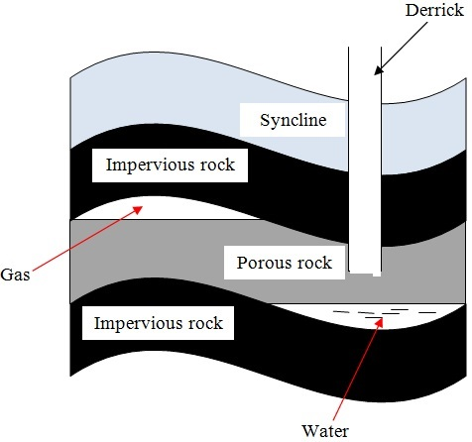
- Presence of fossils or organic remains
- Presence of sedimentary rocks for burying organic remains
- Presence of pressure to compress organic remains to cook the oil and natural gas out of organic matter
- Presence of a porous reservoir rock to store and transmit petroleum to the oil pools e.g. limestone and sandstone
- Presence of a trap like a syncline to hold petroleum in a reservoir to prevent its escape
- Presence of impermeable rocks below the trap or syncline to prevent petroleum from percolating further underground

Factors Influencing Exploitation of Minerals

1. Value of Mineral
Minerals of high value will be mined even if they occur in small quantities because one sold it will be possible to offset mining costs and make a profit and vice versa.

2. Quality of Ore
Mining can be done if the mineral deposits have high mineral content because they are economical to work on but deposits with low mineral content are rarely worked on except if the mineral in them is rare e.g. uranium.

3. Size of Deposit
Minerals which aren't of high value have to occur in large quantities for them to be mined so that it will be a possible to recover mining costs and make a profit.

4. Capital
Lack of capital causes developing countries not to exploit minerals and leave it to international companies because a lot of money is needed for exploration, infrastructure, salaries, energy etc e.g. titanium mining at Kwale is being done by Tiomin company from Canada.

5. Method of Mining
A mineral requiring open cast mining will be mined even if the mineral deposit is large but one requiring underground mining will be extracted if its in large deposit or if its of high value or rare.

6. Transport costs
Minerals occurring in remote areas far from the markets are not likely to be exploited if the transport system is poorly developed since mineral ore is heavy and bulky and transporting it by road and railway is expensive.

7. Market for the Mineral
Mining can be done if the mineral is in demand and if the prices are reasonable so that mining costs are offset and a profit is realized.

8. Political Influence
Mineral deposits at the borders of two countries may not be exploited as a dispute may arise concerning whom mine it e.g. dispute between Iraq and Kuwait over Rumaila should oil field.

9. Labour
Exploitation of some minerals require skilled workers and if they lack it may not be done as is the case in developing countries because expatriates have to be engaged and are very expensive to pay which may reduces the profits accruing from mining.
Factors Influencing the Occurrence and Exploitation of Minerals summary
The occurrence and exploitation of minerals are influenced by a combination of geological, technological, economic, and environmental factors:
- Geological Factors:
  - Mode of formation: Minerals form through various processes (igneous, sedimentary, metamorphic), influencing their location and type.
  - Rock type: The type of rock influences the minerals found (e.g., diamonds in kimberlite pipes, coal in sedimentary rocks).
  - Geological structures: Faults, folds, and intrusions can concentrate minerals.
  - Weathering and erosion: These processes can expose or concentrate minerals.
- Technological Factors:
  - Extraction technology: Advances in mining technology (e.g., open-pit, underground) determine if a deposit can be economically exploited.
  - Processing technology: Efficient processing methods are needed to extract valuable minerals from ore.
- Economic Factors:
  - Market demand: Demand for a mineral influences its price and the economic viability of mining it.
  - Transportation costs: Accessibility of the deposit and the cost of transporting the minerals to markets are crucial.
  - Investment capital: Mining requires significant investment.
  - Labor costs: The cost and availability of skilled labor.
- Environmental Factors:
  - Environmental impact assessment: Regulations and concerns about the environmental impact of mining can restrict or modify projects.
  - Reclamation requirements: Laws requiring the rehabilitation of mined land can add to the cost of mining.
- Political Factors
  - Government policies: Taxes, royalties, and regulations can affect mining.
  - Political stability: Investors prefer stable regions.

Methods of Mining
b) Methods Used in the Extraction of Minerals in the World
There are several methods used to extract minerals, depending on the type of mineral deposit and its location:
- Surface Mining:
  - Open-pit mining: Used to extract minerals near the surface, creating a large, open pit (e.g., copper, iron ore).
  - Quarrying: Used to extract stone, sand, and gravel (e.g., limestone, granite).
  - Strip mining: Used to extract minerals like coal that occur in horizontal seams near the surface.
  - Mountaintop removal mining: A form of coal mining that involves blasting the tops of mountains.
- Underground Mining:
  - Used to extract minerals located deep below the surface.
  - Methods include:
    - Shaft mining: Vertical tunnels are dug to access the ore.
    - Drift mining: Horizontal tunnels are dug into the side of a hill or mountain.
    - Slope mining: Inclined tunnels are used to access the ore.
- Placer Mining:
  - Used to extract valuable minerals (e.g., gold, tin) from riverbeds, alluvial deposits, or other unconsolidated sediments.
- In-Situ Mining:
  - Techniques that extract minerals without removing rock from the ground.
  - Solution mining (leaching): Used to dissolve and extract soluble minerals like salt and uranium.

1. Open Cast Mining
- Method of extracting minerals which are near the earth's surface.
- The types of open cast mining include:

a) Stripping
- Stripping off of the unwanted material lying on top of the mineral deposit and then digging to remove the mineral bearing rock if it's soft or if it's hard explosives may be used to loosen it and then huge power shovels are employed to dig up the mineral deposits.

b) Hill-slope Boring
- Using boring instruments known as augers to drill out mineral deposit and bring it to the surface.

2. Underground Mining
- Method employed when the mineral lies very deep below the surface and the overburden is too thick to be removed by mechanical means.
- The types of underground mining include:

a) Shaft Method
-Method employed when the mineral bearing rock doesn't out crop.
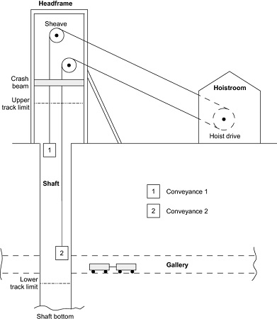
How it's carried Out
- Vertical shafts are sunk into the earth's crust to reach the layer with the mineral.
- Horizontal tunnels are dug from the vertical shaft to reach the mineral.
- Props are erected to support the roof to prevent it from collapsing.
- The mineral bearing rock is blasted loose by explosives.
- The deposit is transported on light rail or conveyor belt to the bottom of the shaft.
- It is then brought to the surface in a crane or a lift called cage.

b) Drift/Adit Mining
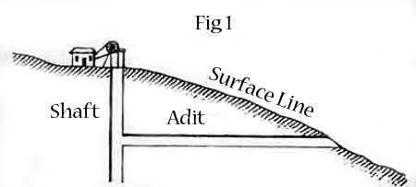
- Method employed when the mineral deposit can be reached from the valley sides.
- Horizontal tunnels (adits) are constructed from the side of the hill.
- Railway line is constructed into the mine to bring out the mineral e.g. mining of copper at Kilembe in Uganda.

c) Solution Method
- Method used in mining soluble minerals such as sulphur, salt, potash, etc.
- Superheated water is ejected into salt deposits.
- The mineral dissolves or melts.
- The solution is then pumped into the surface.

d) Drilling
- Method employed in exploitation of petroleum.
- Wells (oil derricks) are drilled.
- Oil and natural gas are brought to the surface under their own pressure or by pumping.

3. Alluvial/Placer Mining
-Method used to extract minerals occurring in alluvial deposits e.g. gold, tin, diamonds and platinum.
- The types of alluvial/placer mining include:

a) Panning
It involves:
- Digging a mixture of sand, gravel and mineral from the river bed.
- Putting it in a pan and rotating the pan while tilted.
- The lighter sand or gravel is washed on the side leaving the heavier mineral at the bottom of the pan e.g. gold mining in Migori and R. Morun Beds in W. Pokot.

b) Dredging
- A dredger scoops water logged alluvium from the bed of a lake.
- The alluvium is passed over sloping channels with series of traps.
- Wastes are washed away and denser materials are left at the bottom of the trap e.g. mining of soda ash at L. Magadi.

c) Hydraulic Mining
-Method used when alluvial deposit occurs on a valley side.
- A powerful jet of water is directed at the deposit.
- Gravel and mineral collect at the valley because of the great pressure.
- The mineral grains are recovered and washed out.

d) Sub-marine Mining
-Method employed in extracting minerals in alluvial deposits lying deep down the ocean floor.
- A sub-marine dredger goes down the ocean floor.
- It scoops mineral deposit and rises to the surface.
- The alluvium is passed over sloping channels with series of traps.
- Wastes are washed away and denser materials are left at the bottom of the trap.

Methods Used in Extraction of Minerals summary
- Open-pit Mining:
  - Process: This method involves removing large quantities of earth from the surface to access minerals. It is used for minerals that are found in shallow deposits.
  - Common Minerals Extracted: Gold, copper, coal, and iron ore.
  - Advantages: Cost-effective for shallow ore bodies, and allows for large-scale extraction.
  - Disadvantages: It causes significant environmental damage, such as habitat destruction and erosion.
- Underground Mining:
  - Process: Minerals are extracted by digging tunnels or shafts deep into the Earth. This method is used for minerals that are deep underground and cannot be mined via open-pit methods.
  - Common Minerals Extracted: Gold, diamond, and coal.
  - Advantages: More selective and less disruptive to the surface environment.
  - Disadvantages: Expensive due to the need for tunnels and ventilation, and more hazardous for workers.
- Placer Mining:
  - Process: Involves extracting minerals from alluvial deposits (sediments in rivers and streams) using water to separate the minerals from lighter materials.
  - Common Minerals Extracted: Gold, tin, and diamonds.
  - Advantages: Low-cost method and can be done with minimal equipment.
  - Disadvantages: Environmental degradation, including the destruction of aquatic habitats.
- Mountaintop Removal Mining:
  - Process: This method involves blasting away mountain tops to access buried minerals, typically coal.
  - Common Minerals Extracted: Coal.
  - Advantages: Allows for extraction of minerals from hard-to-reach places.
  - Disadvantages: Severe environmental impacts, such as destruction of ecosystems and water pollution.
- Solution Mining:
  - Process: A liquid solution is injected into the ore body to dissolve the minerals, which are then pumped to the surface.
  - Common Minerals Extracted: Salt, potash, and copper.
  - Advantages: Less disruptive to the surface environment.
  - Disadvantages: Requires specialized technology, and the solution can contaminate groundwater.
c) Exploration of Mining in Specific Locations
- Limestone in Kenya:
  - Limestone is mainly mined for the production of cement.
  - Locations: Coastal regions (Bamburi), Kajiado.
  - Methods: Quarrying (open-pit).
- Diamond in Botswana:
  - Diamonds are a major contributor to Botswana's economy.
  - Locations: Orapa, Jwaneng.
  - Methods: Open-pit mining, underground mining.
- Iron Ore in Australia:
  - Australia is a major producer of iron ore.
  - Locations: Pilbara region (Western Australia).
  - Methods: Open-pit mining.

Significance of Minerals/Mining in Kenya
1. Kenya earns foreign exchange from exportation of minerals which is used to import goods and services and fund development projects.
2. Mining is a source of employment to people such as those who work in mines, in cement factories, in transport sector, etc.
3. Mining has led to development of industries by providing raw materials used in those industries e.g. limestone used in cement factories, coal used in iron and steel industries, soda ash used in glass industry, etc.
4. Mining has led to development of transport system to make mining areas accessible e.g. Magadi soda mine is connected to the main Mombasa-Nairobi railway line.
5. Mining has led to development of settlements e.g. Magadi town which originated from the mining of soda ash. 6. Mining is a source of market for goods and services e.g. there are shops and markets, banking and insurance services offered to people working in mines and related industries.
7. Has led to development of social amenities by providing social facilities such as housing, health, electricity, water and education alongside infrastructure.
e) Significance of Minerals to the Economy of Kenya summary
Minerals contribute to Kenya's economy in several ways:
- Foreign exchange earnings: Export of minerals.
- Employment creation: Mining and related industries provide jobs.
- Raw materials for industries: Minerals are used in construction, manufacturing, and other sectors (e.g., limestone for cement, fluorspar).
- Infrastructure development: Minerals are used in building roads, buildings, and other infrastructure.
- Government revenue: Taxes and royalties from mining companies.

Distribution of Minerals in E. Africa
- Phosphates used in the manufacture of fertiliser. Found in Tororo in Uganda and Majingu Hill in Tanzania.
- Limestone used in cement manufacturing - Found in Hima in N.W Uganda, Tanga in Tanzania, Athi River and Bamburi in Kenya.
- Fluorspar a source of fluorine used in chemical industries - Found in Kerio Valley in Kenya.
- Common salt used for consumption - Found in Kilifi and Magadi in Kenya and L. Kitwe in Uganda
- Diatomite used in making insulators - Found in Kariandusi near Gilgil and Gicheru in Nyandarua
- Stones - Found in Machakos, Mutonga and Mbeere
- Carbon dioxide used in making dry ice and in beer and soft drinks industry - Found in Esagari in Baringo and Kagwe in Kiambu
- Diamond used to make ornaments, glass cutters and drills - Found in Mwadui in Tanzania
- Titanium used in the manufacture of insulators for aircraft - Found in Kwale district
- Gemstones - Found near Voi and Mwatate
- Soapstone used for sculpture - Found in Tabaka in Kisii
- Copper used to make electrical wires and coins - Found in Kilembe in Uganda
- Gold used to make medals and jewellery and as a basis of world currency - Found in Musoma in Tanzania, Kakamega and Migori in Kenya
- Coal used in smelting of iron and generation of thermal electricity - Found in in Ruvuma River Basin and Kivira Songwe in Tanzania

Problems Facing Mining Industry in Kenya
1. Inadequate capital making Kenya not to benefit from mineral resources because mining is left to multinational companies who pocket all the money to recover mining cost.
2. Areas where mineral deposits are inaccessible due to poor transport and infrastructure which makes prospecting and mining difficult.
3. Insufficient skilled personnel causing dependence on expatriates who are expensive to pay which reduces profits accruing from mining.
4. Most of mining is controlled by foreign companies so most of the mineral revenue ends up to them as salaries and dividends.
5. Occurrence of minerals in very small deposits which are not economically viable.
6. Lack of power supply especially in remote areas with minerals.
7. Land use conflicts which affect mining e.g. in Kwale between Tiomin and the local people due to inadequate compensation.

Effect of mining on the Environment
  - Renders land useless for other economic activities such as agriculture (dereliction) due to open pits left on land and heaps of rock waste litter dumped on land.
2. Pollutes the environment e.g. atmospheric pollution from dust and smoke from tractors and trucks, water pollution from spilling of oil from offshore oil drilling and soil pollution from chemicals and explosives used in mining.
3. Leads to loss of bio-diversity due to destruction vegetation which also destroys habitats of various animals leading to their destruction also.
4. Causes soil degradation e.g. by loosening the soil which makes it vulnerable to agents of erosion like wind and water, tractors and trucks compact the soil making water infiltration difficult and chemicals used interfering with soil chemical composition making it unsuitable for agriculture.
5. Causes mass wasting when explosives and heavy equipment used in mining shake the ground making weathered materials to move faster down slope under the influence of gravity.
d) Effects of Mining on the Environment and Possible Solutions summary
Mining can have significant environmental impacts:
- Deforestation and habitat destruction: Clearing land for mines.
- Soil erosion and contamination: Removal of topsoil, acid mine drainage.
- Water pollution: Contamination of surface and groundwater with heavy metals and chemicals.
- Air pollution: Dust, emissions from processing plants.
- Landscape degradation: Formation of pits, waste dumps, and tailings dams.
- Social impacts: Displacement of communities, health problems.
Possible Solutions:
- Environmental Impact Assessments (EIAs): To evaluate potential impacts before mining begins.
- Reclamation and rehabilitation: Restoring mined land to a useful state.
- Sustainable mining practices: Minimizing waste, using cleaner technologies.
- Water treatment: Treating contaminated water before discharge.
- Air pollution control: Using filters and scrubbers to reduce emissions.
- Community engagement: Involving local communities in decision-making.

Trona mining on L. Magadi
Location
L.Magadi is 120km S.W of Nairobi on the floor of the Great Rift Valley.
Occurrence
Trona deposits occur as a solution of sodium salts the main ones being sodium sequicarbonate and sodium chloride.
Mode of Formation
- Rain water dissolves soda salts in volcanic rocks.
- The solution percolates through the rocks and soil and gets beneath the basin.
- The accumulated solution is heated by the hot rocks beneath.
- Pressure builds up and the heated solution is pushed to the surface.
- It comes out of the ground inform of hot springs below or on the sides of the lake.
- Due to high temperature water evaporates leaving behind crystals of trona.
Extraction and Processing
- A dredger scoops trona out of the lake.
- It crushes it into smaller pieces and separates it from rock debris.
- The material is mixed with water to form slurry and transported to factory on the lake's shore.
- In the factory the slurry is mixed with water to wash out impurities such as mud and salt and dried.
- It is sent to desiccators and heated to remove moisture and hydrogen to form soda ash.
- Soda ash is cooled and ground into powder and sieved.
- It's packed into paper bags, weighed and transported to the market.

Uses of Soda ash
Used in the:
a) Glass industry in the manufacture of glasses and bottles.
b) Manufacture of soaps and detergents.
c) Softening water in paper making.
d) In textile industry.
e) In oil refining.
Benefits to the Economy
1. Has led to growth of Magadi town ship.
2. Has led to development of social amenities such as hospitals and schools and water from Oloibortoto River which has benefited the local people.
3. Has led to development of infrastructure e.g. railway line from Konza to L. Magadi.
4. The Magadi Soda Company employs many Kenyans including the nomadic Maasai.
5. Exports of soda ash earn Kenya a substantial amount of foreign exchange.
Problems
1. Stiff competition from developed countries with large soda deposits e.g. U.S.A and Israel.
2. Low value of salt is insufficient to meet its production cost.
3. High labour costs due to incentives given so that workers agree to work in the hostile environment of L. Magadi.

Gold in S. Africa
Gold occurs as small grains in a hard rock.
It's mined by shaft mining since its bearing rocks are deep below the surface. The main mining area is the Witwatersrand and others are Ogendaalrus and lydenburg.
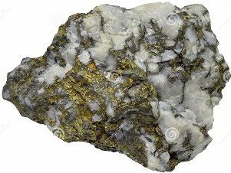
A Gold Ore
Processing
- Ore is crushed to a fine powdery dust.
- Mixed with water until it is fluid mud.
- Cyanide is added to dissolve gold.
- The fluid is runoff with gold dissolved leaving behind waste salts.
- Zinc dust is added to filter gold for solidification.
- Gold sinks as it is denser.
- Gold is smelted and cast into ingots.

Significance to the Economy of S. Africa
1. Earns the country foreign exchange used for paying foreign debts.
2. Offers employment to many people raising their living standards.
3. Has led to widespread urbanization contributing to formation of Witwatersrand conurbation.
4. Has formed a broad market for other industries e.g. engineering, foot wear, electrical and construction industries.
5. Has led to improvement of infrastructure and social amenities e.g. roads, schools, hospitals, etc.
6. Led to development of agriculture.

Problems Facing Gold mining
1. Expensive to mine for lying deeply.
2. Large capital is required to start mines.
3. Complication of mining by folds and faults in the crust.
4. Low gold content in the ore.
5. Problem of removal of underground water.
6. Lack of adequate supply of fresh water on the surface in mining areas.
7. Accidents resulting from collapsing of mine roofs.

Diamond Mining in S. Africa
- Diamond is the hardest known substance.
- Mined in Kimberly, Bloemfontein and Alexander Bay.
- Mined by underground mining or alluvial mining.
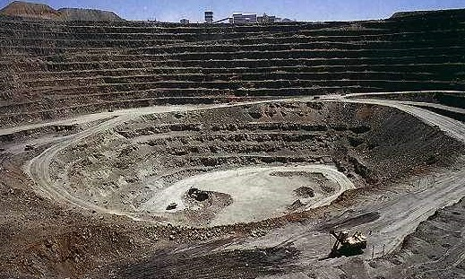
Finsch Diamond Mine, North Cape Province, South Africa
Processing
- Diamond bearing kimberlite is crushed
- Crushed rock is mixed with water
- Diamond sinks to the bottom as it's denser
- Water and less dense residue are drained off
- Remaining material is put on heavily greased trays and washed
- Diamond repels water so it sticks to grease while remnants are drained off
- Diamonds are then sorted out and graded into gem diamonds and industrial type (for cutting purposes).
Contribution to the Economy
1. Provides employment to thousands of people
2. Earns the country substantial foreign exchange
3. Has led to growth of urban centres e.g. Pretoria and Kimberly.
4. Has contributed to development of infrastructure

Problems Facing Diamond Mining
1. Fluctuation in the world market prices
2. High cost of mining and processing diamond
3. depletion of mines
4. Low mineral in the ore making mining expensive
5. labour competition with other sectors e.g. manufacturing and gold mining

Petroleum in the Middle East
- Oil is a thick black sticky liquid called crude oil.
- It was formed from small creatures that lived in shallow lagoons about 100- 200m ago.
- Decaying remains of those creatures mixed with mud at the bottom as sediments.
- The sediments piled on each other and slowly transformed into sedimentary rocks.
- Gradually the remains were converted into oil and gas.
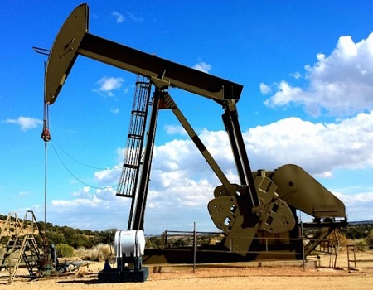
Petroleum Mining on Land
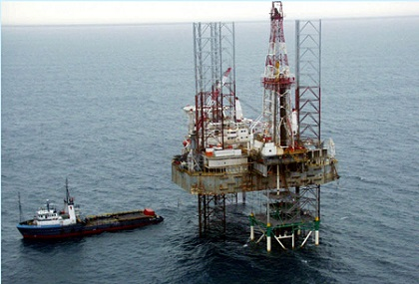
Petroleum Mining in the Sea
Major oil producers in the Middle East are Saudi Arabia with the largest reserves, Iraq, Kuwait and United Arab Emirates.
Middle East accounts for 64% of world oil reserves.
There are several giant oil fields in Ghawar in Saudi Arabia and Kirkuk in Iraq.
Processing
Crude oil is processed by refining using a technique called fractional distillation.
The process takes place near as possible to the market as it's cheaper to transport crude oil than the different refined products.
It's processed into secondary products such as petrol, paraffin, lubricating oils, dyes, fertilisers and plastics.
- Impurities are removed from the crude oil
- Crude oil is heated before entering fractionating column
- It's turned into vapour or gas
- Different ingredients turn back to liquid at different temperatures.
- Ingredients gradually cool, condense and collect in various trays and allowed to overflow until they reach an outlet.

e) Applying Statistical Skills to Establish Trends in Mineral Production in East Africa
- Data Collection:
  - Gather historical data on mineral production in East African countries such as Kenya, Tanzania, and Uganda. This data can include quantities of minerals mined, their market prices, and export volumes.
- Trend Analysis:
  - Use statistical tools to analyze trends, such as line graphs, bar charts, and pie charts, to track changes in mineral production over time.
  - Calculate growth rates of mineral production in specific years to identify patterns, peaks, and declines in the industry.
- Predictive Analysis:
  - Based on historical trends, predict future mineral production and demand in East Africa using statistical methods like regression analysis or time-series forecasting.
Contribution to the Economies
1. Arab's investments overseas have increased due to oil reserves.
2. High income per capita due to oil profits.
3. Has led to development of cities e.g. Tripoli in Libya.
4. Investment of oil money in other sectors e.g. power stations, cement factories and exploitation of other minerals.
5. Earns the countries substantial foreign exchange
6. Increased political and military power.
7. Artesian water is made available for domestic and irrigation purposes e.g. in Libya.
8. Oil companies help in fixing down the sand dunes and planting trees in the deserts.
3.3 Energy
a) Types and Sources of Energy for Domestic and Industrial Use
Energy is the capacity to do work. It exists in various forms and comes from different sources:
- Non-Renewable Energy Sources:
  - Fossil Fuels:
    - Coal: A solid fossil fuel formed from decayed plant matter, used for electricity generation and industrial processes.
    - Petroleum (Oil): A liquid fossil fuel formed from decayed marine organisms, used for transportation, heating, and electricity.
    - Natural Gas: A gaseous fossil fuel formed from decayed marine organisms, used for heating, cooking, and electricity generation.
  - Nuclear Energy: Energy released from nuclear reactions, primarily used in nuclear power plants to generate electricity.
- Renewable Energy Sources:
  - Solar Energy: Energy from the sun.
    - Photovoltaic (PV) cells: Convert sunlight directly into electricity.
    - Solar thermal: Uses sunlight to heat water or air, which can then generate electricity.
  - Hydropower: Energy from the flow of water, used to generate electricity in hydroelectric power plants.
  - Wind Energy: Energy from the wind, harnessed by wind turbines to generate electricity.
  - Geothermal Energy: Heat from within the Earth, used to generate electricity or for direct heating.
  - Biomass Energy: Energy from organic matter, such as wood, crops, and waste, used for heating, electricity generation, and fuel production.
    - Biofuels: Liquid fuels derived from biomass, such as ethanol and biodiesel.

a) Types and Sources of Energy for Domestic and Industrial Use summary
- Types of Energy:
  - Kinetic Energy: The energy possessed by an object due to its motion.
  - Potential Energy: The energy stored in an object due to its position or configuration.
  - Thermal Energy: Energy that comes from the heat produced by the movement of molecules in a substance.
  - Chemical Energy: Energy stored in the bonds of chemical compounds, such as fuels and food.
  - Electrical Energy: Energy generated by the flow of electric charge through a conductor.
  - Nuclear Energy: Energy released during nuclear reactions, either fission or fusion.
  - Mechanical Energy: The sum of potential and kinetic energy, typically used for machinery and equipment.
- Sources of Energy for Domestic Use:
  - Biomass: Wood, crop residues, and animal waste are used as fuel for cooking and heating.
  - Electricity: Generated from power plants and used to run household appliances, lighting, and heating.
  - Solar Energy: Solar panels are used to generate electricity or heat water for domestic use.
  - Natural Gas: Used for cooking, heating, and lighting.
  - Coal: Used in some areas for heating and cooking.
- Sources of Energy for Industrial Use:
  - Fossil Fuels: Coal, oil, and natural gas are widely used for powering large industries such as steel production, cement manufacturing, and power generation.
  - Electricity: Used in machinery, lighting, and production processes.
  - Nuclear Energy: In some countries, nuclear power is used to generate electricity for industrial use.
  - Hydropower: Water is used to generate electricity for industries, particularly in regions with abundant water sources.
  - Geothermal Energy: In countries like Iceland, geothermal energy is used for industrial heating and electricity generation.
b) Development of Renewable Energy in Kenya and Selected Countries
- Kenya:
  - Leading in geothermal energy in Africa (Olkaria Geothermal Power Station).
  - Growing investment in solar energy, both for on-grid and off-grid use.
  - Some hydropower potential, but facing challenges.
  - Increasing interest in wind energy, with several wind farms.
- Uganda:
  - Relies heavily on hydropower, with several dams on the Nile River.
  - Developing other renewable sources like solar.
- Italy:
  - Significant geothermal energy production, due to its volcanic activity.
  - Also utilizes solar and wind energy.
- Vietnam:
  - Rapidly growing solar energy sector, driven by government support.
  - Also developing wind and hydropower.
- Spain:
  - A leader in wind energy, with a well-developed wind power sector.
  - Also invests in solar and other renewables.
- Renewable Energy in Kenya:
  - Solar Energy: Kenya has abundant sunshine, which has led to the widespread use of solar power, particularly in rural areas for lighting and water heating. Kenya is also investing in solar-powered irrigation systems for agriculture.
  - Wind Energy: The Lake Turkana Wind Power Project is one of Africa’s largest wind farms, generating significant amounts of electricity.
  - Geothermal Energy: Kenya is one of the leading countries in Africa in geothermal energy production. The Olkaria Geothermal Plant is a major source of renewable electricity, and Kenya aims to increase its geothermal capacity to reduce dependence on fossil fuels.
  - Hydropower: Kenya also utilizes its rivers to generate hydroelectric power, though this is limited by seasonal changes in water flow.
- Renewable Energy in Other Countries:
  - Germany: Known for its robust renewable energy policies, Germany has made significant strides in wind, solar, and biomass energy. The country’s Energiewende policy aims to transition to a low-carbon energy system.
  - China: The world’s largest producer of solar panels and a leading investor in wind energy. China has also heavily invested in electric vehicle infrastructure to reduce fossil fuel dependence.
  - India: India has made significant progress in solar energy development and aims to become a global leader in solar energy production. India is also promoting wind energy and biogas projects.
  - United States: The U.S. has a large wind and solar energy capacity, particularly in states like Texas and California. It has also been a leader in technological innovations in renewable energy.
c) Significance of Renewable Energy on Socio-Economic Development
Renewable energy plays a vital role in socio-economic development:
- Environmental benefits: Reduces greenhouse gas emissions, mitigating climate change.
- Energy security: Reduces dependence on fossil fuel imports, enhancing energy independence.
- Economic growth: Creates jobs in manufacturing, installation, and maintenance of renewable energy systems.
- Rural development: Provides access to electricity in remote areas, improving living standards and enabling economic activities.
- Health benefits: Reduces air pollution, leading to improved public health.
- Sustainable development: Supports long-term economic growth without depleting natural resources.
d) Management and Conservation of Energy in the Community
Effective energy management and conservation are essential:
- Energy efficiency: Using less energy to achieve the same output.
  - Using energy-efficient appliances.
  - Insulating buildings to reduce heating and cooling needs.
  - Improving industrial processes to reduce energy consumption.
- Energy conservation: Reducing energy consumption through behavioral changes.
  - Turning off lights when not in use.
  - Using public transport, walking, or cycling.
  - Reducing water heating needs.
- Community initiatives:
  - Promoting energy-saving practices through education and awareness campaigns.
  - Supporting the development of community-based renewable energy projects.
e) Sustainable Use of Energy for Socio-Economic Development
- Sustainable energy use involves meeting current energy needs without compromising the ability of future generations to meet their own needs.
- This requires a transition to renewable energy sources, improved energy efficiency, and responsible energy consumption practices.
- Sustainable energy is crucial for long-term economic growth, social equity, and environmental protection.

c) Significance of Renewable Energy on Socio-Economic Development
- Economic Benefits:
  - Job Creation: The renewable energy sector creates numerous jobs in manufacturing, installation, maintenance, and research. This helps reduce unemployment and stimulates local economies.
  - Energy Security: By investing in renewable energy, countries can reduce their reliance on imported fossil fuels, thus enhancing energy security and stability.
  - Reduction in Energy Costs: Renewable energy sources such as wind and solar have lower operational costs once the infrastructure is set up, leading to lower long-term energy costs for both households and industries.
  - Attracting Investment: The renewable energy sector can attract both local and foreign investment, boosting economic growth and development.
- Environmental Benefits:
  - Reduction in Greenhouse Gas Emissions: Renewable energy systems have a minimal environmental impact compared to fossil fuels. By switching to renewables, countries can significantly reduce their carbon footprint.
  - Reduction in Pollution: Using renewable sources like wind, solar, and geothermal reduces air and water pollution associated with coal, oil, and gas power generation.
- Social Benefits:
  - Improved Quality of Life: Access to renewable energy can improve living standards, especially in remote and rural areas, by providing clean cooking solutions, lighting, and access to electricity.
  - Health Benefits: Reducing the use of biomass and coal for cooking and heating can significantly improve air quality, leading to better public health outcomes by reducing respiratory diseases.

d) Managing and Conserving Energy in the Community
- Energy Efficiency:
  - Using Energy-Efficient Appliances: Encouraging the use of energy-efficient light bulbs, refrigerators, and cooking appliances can help reduce energy consumption.
  - Building Design: Designing homes and buildings with energy efficiency in mind, such as proper insulation, energy-efficient windows, and natural ventilation, reduces the need for artificial heating and cooling.
  - Smart Meters and Grids: These technologies help monitor and control energy use, allowing consumers to adjust their energy consumption based on real-time data.
- Energy Conservation Practices:
  - Turning Off Unused Appliances: Educating communities to switch off lights, fans, and electronic devices when not in use can lead to significant energy savings.
  - Use of Renewable Energy at Household Level: Encouraging the use of solar panels for electricity and solar cookers can reduce reliance on non-renewable sources of energy.
  - Public Awareness Campaigns: Conducting campaigns to inform the public about the importance of conserving energy and adopting sustainable practices.
- Government and Institutional Measures:
  - Subsidies and Incentives: Governments can offer subsidies for renewable energy technologies such as solar panels and energy-efficient appliances to encourage adoption.
  - Energy Audits: Conducting energy audits in both households and industries to identify areas where energy can be conserved and efficiency can be improved.

e) Appreciating Sustainable Use of Energy for Socio-Economic Development
- Sustainable Energy Development:
  - Sustainability of Resources: Renewable energy sources such as wind, solar, and geothermal are inexhaustible, ensuring long-term energy availability without depleting resources or harming the environment.
  - Integrated Energy Solutions: Sustainable energy development involves integrating renewable energy sources with energy conservation strategies, ensuring that energy is produced, distributed, and consumed efficiently.
- Supporting Social and Economic Development:
  - Affordable and Clean Energy: Sustainable energy solutions ensure that energy is affordable and accessible to all, particularly in underserved communities. This is crucial for social development, as access to energy improves education, healthcare, and other social services.
  - Economic Empowerment: Access to sustainable energy enables small businesses and industries to grow, thus boosting the economy by providing a reliable and cost-effective power source.
  - Resilience Against Climate Change: By adopting sustainable energy practices, countries reduce their vulnerability to climate change, as renewable energy systems are less susceptible to disruptions compared to fossil fuel-based systems.
- Global Collaboration:
  - International Agreements and Initiatives: Countries around the world can collaborate on initiatives like the Paris Agreement to combat climate change and promote sustainable energy solutions globally. Joint ventures in research and development can foster innovation in renewable energy technologies.

Industry
Industry - Any form of economic activity through which people produce goods and services for their consumption.
Industrialisation- Process through which a country establishes manufacturing industries. A country is referred to as industrialised when production of manufactured goods is the main economic activity in that country. Less industrialised countries mainly produce agricultural raw materials.

Factors Influencing Location and Development of Industries
Raw Materials
- Industries are located near sources of raw materials to reduce transportation costs e.g. sugar milling factories in sugar growing areas, mostly in urban areas near airports and oil refineries at the coast since oil is bulky and expensive to transport inland.
- They are also established where there is a steady source of raw materials in order for them to be economically viable e.g. oil refineries at the coast
Power
- They are located near main power supply pints to reduce the cost of transmitting power e.g. those in Jinja town near Owen falls dam.
Transport and Communication
- They are located where transportation system is well established to ensure efficient and quick transportation of raw materials to industries and finished goods to the market e.g. in urban centres.
- They are located where there is efficient communication so as to stay in touch with their suppliers and their consumers.
- Well developed communication systems also lower the transport cost.
Market
- They are located where buyers of products are available or in areas with dense population to make their operation to be economically viable since they are established for commercial purpose to make a profit e.g. in urban areas, Kenya highlands, lake region and coastal strip.
- Location near markets is also due to the nature of goods e.g. perishable goods have to be consumed before they go bad e.g. bread and daily products. Industries making fragile goods are located near markets to prevent the high risk of breakage during transportation e.g. glass, bricks and roofing tiles.
Labour
- Labour intensive industries are located in densely populated areas where there is adequate and cheap labour to reduce production costs.
- Also so as to reduce the cost of transporting and housing workers.
- A country with skilled manpower has faster industrial growth than that without which are forced to depend on expatriates who are costly to hire and maintain which lowers the profits of such industries.
- Industries also require skilled manpower and management skills to ensure maximum output and low production costs.
Water Supply
- Some are located near sources of water such as large permanent rivers and lakes to provide water for processing raw materials e.g. coffee pulping, sugar milling e.g. Mumias near R. Nzoia, Sony near R. Migori and Chemilil near R. Nyando.
Government Policies
- Decentralisation of industries or encouraging by providing incentives location of industries from urban to rural areas.
Incentives
- Tax exemptions
- Protection from foreign competition.
Aims
- Develop all parts.
- Create jobs in rural areas to minimize rural-urban migration.
- Take industries where labour is found.
- Open remote or underdeveloped areas for development.
- To reduce congestion in the capital city.
- Environmental reasons whereby industries are located away from residential areas because they produce harmful fumes and a lot of noise.
- Security reasons to prevent industries from being attacked by terrorists because if they were all together there would be a great loss.
E.g. EPZ industries located at Athi River to reduce congestion in Nairobi industrial area and Mariakani and Kikuyu Steel Rolling Mills established in their respective areas to open up the region for development
Industrial Inertia
- Tendency of an industry to remain in a particular place even when the factors for its location no longer exist e.g. industries in the Ruhr Region of Germany have remained at the same place despite closure of coal fields and decline in coal as an energy source.
Causes
- It may be expensive to move to a new place because new factory buildings would have to be constructed, buying new machinery and equipment.
- Due to availability of experienced workers.
- To avoid the problem of transportation and other basic infrastructural facilities.
Capital
- A lot of capital is required in establishing and developing industry e.g. for purchasing land, putting up buildings and purchasing machinery and equipment.
- Countries with plenty of capital industrialise with greater ease than those with little capital which often rely on foreign aid and multinational corporations to set up domestic industries which reduces benefits accruing from such industries.
Personal Decisions
- Security to allow secure operations.
- Where they can get maximum benefits.
- To set industries in their home areas to offer jobs to their local people.
The Cost of Land
- A place where land is expensive discourages industrial development e.g. industries are now being established in the neighbouring towns of Kitengela, Ruiru and Athi River because land is expensive in Nairobi.

Summary
b) Factors Influencing Location and Development of Industries in the World
Several factors influence where industries are located and how they develop:
- Raw Materials: Industries that use bulky or perishable raw materials tend to locate near the source (e.g., sugar factories near sugarcane farms).
- Energy Supply: Industries that require large amounts of energy locate near energy sources (e.g., aluminum smelting near hydroelectric power plants).
- Labor Supply: The availability of skilled or unskilled labor influences location. Labor-intensive industries locate where labor is abundant and cheap.
- Transportation: Industries need access to efficient transportation (roads, railways, ports) to move raw materials and finished goods.
- Market: Industries that produce goods for a specific market locate near that market to reduce transportation costs.
- Capital: Access to financial resources is essential for establishing and expanding industries.
- Government Policies: Governments can influence industrial location through tax incentives, subsidies, and regulations.
- Land Availability: Sufficient land is needed for industrial facilities.
- Environmental Factors: Industries may be restricted from locating in environmentally sensitive areas.
- Infrastructure: Access to reliable infrastructure (e.g., water supply, electricity, communication networks) is crucial.

Types/Classification of Industries

a) According To Raw Materials Used, Products and Level Of Production
i) Primary /Processing Industries
Industries involved in the exploitation of natural resources (e.g. mining, fishing, forestry and agriculture) or processing raw materials into more useful and valuable form which are used in making final products e.g. coffee pulp factories, cotton ginneries, milk dairies, sugar factories, saw mills, abattoirs, leather tanneries, posho mills and sisal factories.
ii) Secondary /Manufacturing industries
Ones which rely on processed goods to make final products or which make final products directly from raw materials e.g. sweet industries, bread, cement factories, oil refineries, cigarette making, pulp and paper industries, etc.
iii) Tertiary /service industries
Industries involved in providing services and don‟t produce tangible goods e.g. transport and communication, trade, banking, tourism, administration, education, medical, etc.

b) According To the State of Finished Goods
i) Heavy Industries
- Manufacture heavy and bulky products.
- Use heavy raw materials.
- Involve heavy investment in their production.
- Production is in large scale e.g. ship building, car manufacturing and assembling, oil refineries, steel rolling mills, fertiliser making plants, glass industries etc.
ii) Light Industries
Ones involved in making goods with little volume and weight e.g. textile, cosmetics, plastic, printing, electronics, cigarette, etc.
- By Economic Activity:
  - Primary Industries: Extract raw materials from the Earth (e.g., agriculture, mining, forestry, fishing).
  - Secondary Industries: Process raw materials into finished goods (e.g., manufacturing, construction).
  - Tertiary Industries: Provide services (e.g., transportation, retail, healthcare, education).
  - Quaternary Industries: Involve intellectual activities (e.g., research and development, information technology).
  - Quinary Industries: Consist of high-level decision-makers (e.g., CEOs, government leaders).
- By Scale:
  - Large-Scale Industries: Involve large capital investments, employ many workers, and produce goods on a large scale (e.g., steel manufacturing, automobile production).
  - Medium-Scale Industries: Smaller than large-scale industries in terms of capital, employment, and production volume.
  - Small-Scale Industries: Involve small capital investments, employ a small number of workers, and produce goods on a small scale (e.g., workshops, handicrafts).
  - Cottage Industries: Very small-scale industries, often located in homes, where goods are produced by hand (e.g., pottery, weaving).
- By Product:
  - Extractive Industries: Extract raw materials from the Earth (e.g., mining, quarrying).
  - Manufacturing Industries: Process raw materials into finished goods.
    - Heavy Industries: Produce large, heavy products (e.g., steel, shipbuilding).
    - Light Industries: Produce smaller, lighter products (e.g., textiles, electronics).
  - Service Industries: Provide services (e.g., tourism, finance).
- Other Classifications:
  - Footloose Industries: Industries that can be located in various places because transportation costs are low (e.g., software development).
  - Jua Kali Industries (Kenya): Informal sector industries in Kenya, characterized by small-scale operations, often using simple technology.

Distribution of Industries in Kenya

Agricultural Industries
1. Agricultural Food Processing Industries
Located where raw materials are produced because they require immediate processing e.g. tea factories, sugar factories, milk Processing plants in the leading dairy farming regions e.g. Eldoret, Nakuru and Kiganjo, coffee factories in coffee growing areas e.g. Kiambu, Nyeri, Embu, fruit canning e.g. Del Monte in Thika and Kenya Orchards Company in Mua Hills in Machakos, Maize milling e.g. Unga Ltd in Eldoret Kisumu and Nairobi, Brewing industries e.g. East African Breweries at Ruaraka, KMC plants at Athi River, etc.
2. Agricultural Non-Food Processing Industries
Cotton ginneries, sisal factories, Bata Shoe Company in Limuru, cigarette making e.g. mastermind and BAT, Lumbering industries e.g. Pan African Paper Mills in Webuye near extensive pine plantations in Turbo And Webuye, textile industry e.g. Kisumu Cotton Mills in growing areas of W. Kenya.

Non-Agricultural Manufacturing Industries
Many are located in urban areas where there is a large ready market, reliable power supply and adequate labour force
- Cement factories at Athi River and Bamburi.
- Oil refining at Changamwe in Mombasa.
- Steel rolling mills in the industrial area of Nairobi where scrap metal is available.
- Central glass company at Kasarani.
- Clay products industries near Ruiruand Githunguri near sources of clay.
- Vehicle Assembling industries which import car components and join them to make cars e.g. General Motors in Nairobi
- Vehicle Assemblers in Mombasa.
- Pharmaceutical industries which manufacture medical products e.g. Glaxo Smithkline and Beta Health Care in Nairobi.

Cottage Industries
Industries involved in making products particularly in homes using hands and simple tools.
Characteristics
- Locally available materials are used.
- Capital infested is small.
- Most of the products are sold to the local market but few are exported.
- Skills are acquired informally.
- Use of hands and simple and sometimes advanced tools.
- Usually involve an art or skill possessed by a person to produce items that are in demand in the neighbourhood.
- it‟s labour intensive.
- Very few items are made because the market for items is usually small.

Examples of Cottage Industries
Pottery
- Cottage industry in which pots and flower vases are made using clay. - Its practised mainly in eastern and central provinces and by women. - Examples of areas are Kwale and Muranga.
- Wood and Stone Carving - Involves curving of wood and stone into various shapes of animals, humans, etc.
- Wood carving is practised in Kitui and Machakos while soapstone (soft metamorphic rock) carving is done in Kisii.
- Some products are sold locally while the rest are exported with some being bought by tourists as souvenirs (reminder).
Weaving
-Involves using sisal, dry palm leaves dry papyrus, nylon fibres etc to make products such as baskets, mats, and fish traps etc.
- Baskets mainly known as Ciondos are mainly done by Agikuyu women and are sold locally and to tourists.
- Weaving is also practised along the coastal region where dry palm leaves are used to make baskets, mats, etc.
- Other cottage industries are such as those making use of scrap metal to make metal boxes, wheel barrows, energy saving jikos, rain harvesting gutters, poultry harvesting equipment, swords, knives, spears, jembes, iron bells and jingles and boat making common among communities living around L. Victoria and along the coast.

Jua Kali Industries
- The most common and popular cottage industry.
- Jua kali practitioners include those who are employed in all informal sectors of the economy such as shoe repairers, tailors, carpenters, watch repairers, barbers, mechanics, and tyre-menders, - Jua kali industries are found in all urban centres.
- The most common activity is reprocessing old scrap metal to produce useful products listed above.
- The government has realised the importance of the industry and is encouraging its development in the following ways:
- The ministry of Trade and Industry has set up a department to promote this industry.
- KIE provides loans to Jua Kali industry for the purchase of materials.
- KIE has put permanent structures/sheds where the artisans can operate at low costs.
- The local authorities have set aside land for use by Jua Kali artisans
- Jua Kali artisans have been encouraged to form cooperatives to assist in the marketing of their products.

Importance of the Jua Kali Sector
- Has created employment opportunities to many people who would otherwise be jobless offering them a means of livelihood, alleviating poverty.
- It has helped to raise the standard of living of many Kenyans who rely on it for income.
- It utilises materials that would otherwise be thrown away to make items.
- Jua Kali products earn the country substantial foreign exchange when they are exported to COMESA countries.
- The industry produces cheaper goods than those produced in the formal industries.
) Analysis of the Development of Industries in Selected Areas
- Kenya:
  - Key industries: Food processing, cement, petroleum refining, consumer goods.
  - Challenges: Competition from imports, inadequate infrastructure, high energy costs.
  - Jua Kali sector: Plays a significant role in providing employment and producing a variety of goods.
- India:
  - Diverse industrial base: Textiles, IT, pharmaceuticals, automobiles.
  - Cottage industries: Important for providing employment, preserving traditional crafts.
  - Government initiatives: "Make in India" to promote manufacturing.
- Japan:
  - Known for high-tech industries: Electronics, automobiles, robotics.
  - Car manufacturing: A major industry, with companies like Toyota, Honda, and Nissan.
  - Focus on innovation and efficiency.

Significance of Industrialisation to Kenya
- Kenya earns foreign exchange after exporting her manufactured goods which is used to develop other sectors of the economy such as education, health care and transport.
- Industries employ people providing them with income which helps to raise their standard of living.
- Industrialisation has led to development of transport and communication and social amenities such as power, water, schools and medical facilities where industries have been established.
- Agricultural based industries have led to increased agricultural production in the process of meeting the rising demand for raw materials.
- Establishment of industries has led to diversification of the economy thereby helping the country to earn revenue throughout even when agriculture which is the backbone of the economy fails as a result of adverse weather conditions.
  - Workers in industries have joined together and formed co-operatives in which they save money and are then given loans which they use to start projects or generally enhance their living standards.
  - The government also gets revenue through taxation of the dividends got at the end of the year from the profits of SACCOs.
- Industrial exports help in maintaining a balance of trade between Kenya and her trading partners by reducing over reliance on imports.
- Industrial exports to other countries create a trading co-operation which in turn helps to foster good relationships among countries of the world.
- Industries based on locally available materials encourage utilisation of resources which would be otherwise be idle.
- Establishment of industries promote development of urban centres because it encourages people to move to the area in search of jobs and accommodation and other services are provided.
- Industrialised countries are likely to produce adequate goods making them to be self-sufficient in industrial goods.
e) Significance of Industries in Society summary
Industries play a crucial role in society:
- Employment creation: Provide jobs for a large portion of the population.
- Economic growth: Contribute to GDP and generate income.
- Production of goods and services: Provide the goods and services that people need and want.
- Technological advancement: Drive innovation and technological progress.
- Infrastructure development: Support the development of infrastructure.
- Foreign exchange earnings: Generate revenue through exports.

Problems of Industrialisation and Their Possible Solutions summary
- Kenya lacks adequate capital for industrial establishment forcing her to get loans from financial institutions such as I.M.F and World Bank whose interest rates are very high and sometimes come with strings attached.
- Industries suffer from the problem of raw materials e.g. agricultural industries when agriculture fails due to adverse weather conditions.
- Local market for industrial goods isn‟t sufficient to sustain production due to low purchasing power.
- Lack of skilled labour due to brain drain forcing the government to employ expatriates whose salary package is very high thus lowering the profits.
- Locally produced goods compete with imported goods which are in most cases cheaper leading to the decline or death of local industries.
- There is the problem of the high cost of energy due to importation of petroleum at very high cost causing the industrial costs
- Industries cause environmental degradation e.g. pollution from the emissions
- Rural to urban migration,caused congestion in urban areas leading to pressure on existing social amenities, inadequate job opportunities leading to crime and other social evils
- Has led to displacement of people by forcing people to vacate the area where manufacturing industries are being established e.g. the preparation for titanium mining at Kwale District.
- Has led to the neglecting of agriculture when able bodied people move to urban areas to look for jobs in industries
d) Challenges Facing Industries and Possible Solutions in Kenya
- Challenges:
  - Competition: From cheaper imports.
  - Inadequate infrastructure: Poor roads, unreliable electricity.
  - High energy costs: Increases production costs.
  - Limited access to credit: Makes it difficult for businesses to expand.
  - Corruption: Increases the cost of doing business.
  - Skills gap: Shortage of skilled workers.
  - Environmental degradation: Pollution from industrial activities.
- Possible Solutions:
  - Improving infrastructure: Investing in roads, railways, and energy supply.
  - Reducing energy costs: Developing renewable energy sources.
  - Increasing access to credit: Providing loans and other financial assistance to businesses.
  - Fighting corruption: Promoting transparency and accountability.
  - Bridging the skills gap: Investing in education and training.
  - Promoting sustainable industrial development: Enforcing environmental regulations and encouraging clean technologies.
Cottage Industry in India
The major areas in which it’s highly developed include Mumbai, Jabalpur, Magpur, Bhopal, Bhutan, Madras, Calcuta, Bangalore, Lucknow and Moradabad.
The industry involves weaving, making clothes, brass, Copper and silver ware ornamental ivory, jewellery, carpets, safety matches, etc.
Characteristics of Cottage Industry in India (Comparison)
- The cottage industries are rural based while in Kenya they are rural and urban based.
- The craftsmen are highly skilled while in Kenya not all are highly skilled.
- Labour in the industry is provided by individuals or members of the family while in Kenya its individuals or members of groups.
- Industry is owned by the family in India while in Kenya it’s owned by individuals.
- In India cottage industries are found almost everywhere (ubiquitous) while in Kenya they are mostly in urban areas and some few homes.
- There are middlemen who supply raw materials to the industry while in Kenya they obtain raw materials directly from their sources.
- Other characteristics are typical of cottage industries.
Factors for the Development of Cottage Industry in India
- The industry requires little capital outlay to establish.
- Majority of Indians are very skilled weavers and ornamental ware makers.
- The high demand for products in the populous sub continent has led to the development of the industry.
- India has a huge population which ensures a steady supply of cheap labour.
- The industries don’t require big space so they can be established anywhere e.g. in homes and small rented rooms.
- Abundant supply of locally available raw materials which are used in the cottage industry.
- Availability of hydroelectric power which is well distributed within the rural towns.
- The urge of people to earn an income in order to uplift their living standards.
- Availability of simple and affordable tools and machines.
Problems Faced By Cottage Industries in India
- Difficulty in obtaining raw materials at affordable prices.
- Shortages of capital as most of the people are poor and have little access to modern banking facilities.
  - Artisans could form co-operatives through which they could get raw materials and loans.
- Competition from other industries making similar products.
- Difficulties in making the products.
- Exploitation of the artisans by the middlemen when they sell raw materials to them at high prices.
  - Government of India to introduce policy to stop the interference of the middlemen.
Iron and Steel Industry in the Ruhr region of Germany
Ruhr Region derives its name from R. Ruhr a tributary of R. Rhine.
Its one of the most industrialised regions of the world. Other areas of the world which are highly industrialised are:
- Pittsburgh industrial region of U.S.A.
- Moscow area of former Soviet Union.
- Tokyo-Yokohama region of Japan.
- S.E England in Britain and
- Rotterdam area in the Netherlands.
One of the leading industries deals in iron and steel which is one of the most important industries in the present advanced technological world as it provides raw materials to many other industries.
The basic raw materials are iron ore, coal and limestone mixed in the blast furnace to get iron.
Factors Which Have Led To the Development of Iron and Steel Industry in the Ruhr Region of Germany
- There is availability of raw materials because the region has coal, iron ore and limestone making it economical to set up iron and steel industry there.
- There is availability of cheap water transport for transportation of raw materials and finished products because the region is served by navigable rivers and canals e.g. R. Ruhr, Lippe, Dortmurd-Ems Canal, etc.
- There is availability of ready market for iron and steel from the dense and affluent population in C. and W. Europe.
- There are abundant sources of power such as coal, oil and H.E.P. necessary in iron and steel industries.
- There is availability of capital for development of iron and steel industry due to presence of rich companies, companies and capital accrued from other industries like coal.
- The region is centrally located in Europe which offers easy access to all parts of Europe.
Significance of Iron and Steel Industry in the Ruhr Industrial Region
- Led to the improvement of transport network due to the need to transport raw materials and finished products related to iron and steel industry.
- Led to growth and expansion of towns e.g. Essen, Dortmund and Duisburg.
- Many people have been employed in the iron and steel industry as loaders, clerks, drivers and operators.
- Has led to promotion of agriculture due to the need to feed the huge population in the industrial towns in the Ruhr region.
- Led to provision of social amenities to cater for the workers in the industrial region e.g. schools, health centres, housing and recreational facilities.
Problems Facing the Ruhr Industrial Region
- There is environmental pollution from smoke and fumes from coal which is the major fuel and solid wastes which are discharged into the rivers.
- There is congestion and overcrowding in housing and social amenities due to the large influx of people to the Ruhr region in search of employment.
- Depletion of coal mines due to coal being a non-renewable resource and continued mining. Coal mining has become expensive as it has to be brought to the surface from great depths.
Car Manufacturing and Electronics Industry in Japan
Japan is a country to the east of Asiatic continent made of numerous major/large and minor/small islands.
Major Islands
- Hokkaido
- Honshu
- Kyushu
- Shikoku
Minor Islands
- Okinawa
- Nancei
- Zu
- Kagoshima and
- Chisima
80% of the land consists of the rugged mountainous landscape which doesn’t favour agriculture making the Japanese to concentrate on the development of manufacturing industries such as chemical, textile, iron and steel and automobiles (car manufacturing) and electronics which become very important.
Examples of automobile companies include the Mitsubishi and Toyota Motor Corporations while examples of electronics companies include Sony and Toshiba.
Factors Favouring Electronics and Car Manufacturing In Japan
- Advanced technology e.g. all the plants dealing with electronics and automobiles are automated (robots controlled by computers) which increases efficiency leading to production of large number of units, lowers production costs and leads to production of high quality goods which are competitive in the world market.
- Cars and electronics manufactured in Japan aren’t expensive compared with those from European countries which make them to be in high demand all over the world.
- 80% of the land consists of the rugged mountainous landscape which doesn’t favour agriculture making the Japanese to concentrate on the development of manufacturing industries of which automobiles (car manufacturing) and electronics have become very important.
- Japan produces cars which are fuel efficient which creates a high demand for them in the world market encouraging the country to produce more.
- There is availability of a ready market due to Japanese high population with high purchasing power and high demand for Japanese cars and electronics due to their high quality, affordability and fuel efficiency of their automobiles in Africa, S. America, Asia and Europe.
- There is availability of capital from the profits accrued from other industries like ship building, machinery, textiles, fishing and tourism which are invested in the development of other industries including automobiles and electronics.
- There is availability of skilled, dedicated and hardworking manpower is available in Japan which has led to production of quantitative and qualitative automobiles and electronics products which reduces production costs and makes goods to be of high demand which in turn stimulated more production.
- Japan is located in a strategic position making it accessible from all directions via the sea enabling the raw materials and manufactured goods to be transported to or from any part of the world through the modern ports of Tokyo, Nagoya and Osaka.
- There is abundant water from the lakes, many rivers within the highlands and the Pacific Ocean surrounding Japan which is a prerequisite in a manufacturing plant. It is used in the iron and steel industry whose products are in turn used in the automobile and electronics industry.
Major Car Manufacturing Zones in Japan
Tokyo-Yokohama Industrial Zone
-The most important and the leading motor vehicle manufacturing region.
Manufacturing cities in this region include Tokyo, Yokohama, Chiba and Hitachi (electronics products).
Osaka-Kobe Industrial Zone
-2nd most important car manufacturing zone.
It’s located on Honshu Island.
Manufacturing cities in the region are Kobe, Osaka, Kyoto, Otsu, Wakayama and Akashi.
Nagoya Industrial Zone
-3rd largest car manufacturing zone.
It’s also on Honshu Island.
Manufacturing zones include Nagoya, Honda, Toyota and Okazaki.
Toyota Motor Corporation has its headquarters at the City of Chiru 20km east of Nagoya.
Electronics
Major car manufacturing cities include Tokyo, Kobe and Osaka and others are towns of Hitachi and City of Chiru (Fuji machine).
Teachers are advised to also consult curriculum design as notes could not be exhaustive

