KENYAPLEX EXAMS

KENYA CERTIFICATE OF BASIC EDUCATION (K.C.B.E)
-AGRICULTURE- -003- -Senior School-

GRADE 10 APPLIED AGRICULTURE (Theory) TERM 1 MARCH 2026
PATHWAY: S.T.E.M
Time: 2 Hours
COMPETENCE BASED EDUCATION CKEAB 003

LEARNER’S DETAILS
Name: _______________________________________________________________________________________.
School: ______________________________________________________________________________________.
Assessment Number: ________________________________. Date: __________________________________.
School Code: _______________________________. Signature: ________________________________.

INSTRUCTIONS TO LEARNERS
- Write your name, assessment number, class and date on all the answer sheets provided.
- Answer all the questions in the spaces provided.
- Use a blue or black pen for writing. Pencils should be used only for drawings and diagrams.

SCORE GRID
No. | Question / Item | Maximum Marks | Learner’s Score | Performance Level
1 | Question 1 (a–c) | 8
2 | Question 2 (a–e) | 15
3 | Question 3 (a–c) | 12
4 | Question 4 (a–d) | 12
5 | Question 5 (a–d) | 13
6 | Question 6 (a–e) | 14
7 | Question 7 (a–b) | 6
 | TOTAL | 80
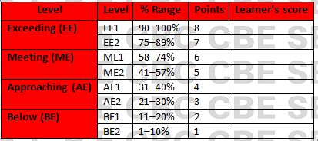

This paper has 7 printed pages. Please check out to ensure all pages are printed
Turn over
SECTION A: THEORY (80 Marks)
Answer all questions in this section.
- A school agriculture club plans to start a vegetable farming project within the local community.
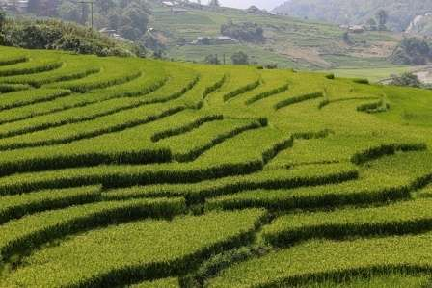
a) Identify THREE ways through which the club can access land for agricultural use. (3 marks)
- _____________________________________________________________________________________.
- _____________________________________________________________________________________.
- _____________________________________________________________________________________.
b) Explain THREE factors you would consider when evaluating the suitability of the land for crop production. (3 marks)
- _____________________________________________________________________________________.
- _____________________________________________________________________________________.
- _____________________________________________________________________________________.
c) State TWO reasons why land is important in agricultural production. (2 marks)
- _____________________________________________________________________________________.
- _____________________________________________________________________________________.
- During a field excursion, learners observed different soil layers in a farm.

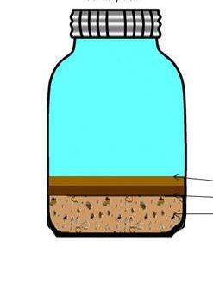
a) Name the types of soil labelled QRS. (3 marks)

Q: _______________________________________.
R: _______________________________________.
S: ________________________________________.

b) Name any two main categories of soil properties important in crop production. (2 marks)
- _____________________________________________________________________________________.
- _____________________________________________________________________________________.
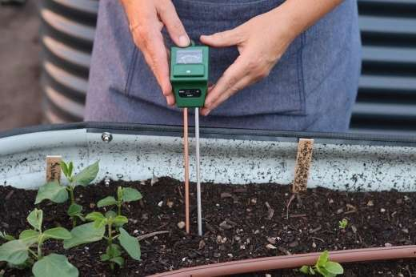
c) Identify the soil activity below. (1 mark)

___________________________________________.
d) Describe ONE test used to determine each of the following soil properties:(3 marks)
i) Soil texture: ___________________________________________________________________________________.
ii) Soil pH: ______________________________________________________________________________________.
iii) Soil porosity: _________________________________________________________________________________.
e) Explain THREE ways in which the soil profile influences crop production. (3 marks)
- _____________________________________________________________________________________.
- _____________________________________________________________________________________.
- _____________________________________________________________________________________.

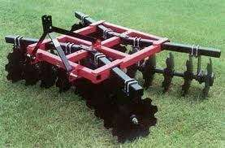
- A farmer wants to prepare a fallow piece of land for planting maize as shown below.

a) Outline FOUR activities carried out during land preparation to obtain a good seedbed. (4 marks)
- _____________________________________________________________________________________.
- _____________________________________________________________________________________.
- _____________________________________________________________________________________.
- _____________________________________________________________________________________.
b) Differences between primary cultivation and secondary cultivation. (4 marks)
 | Primary cultivation | Secondary cultivation
i
ii
c) Explain TWO conservation tillage practices used in crop production. (4 marks)
- _____________________________________________________________________________________.
- _____________________________________________________________________________________.
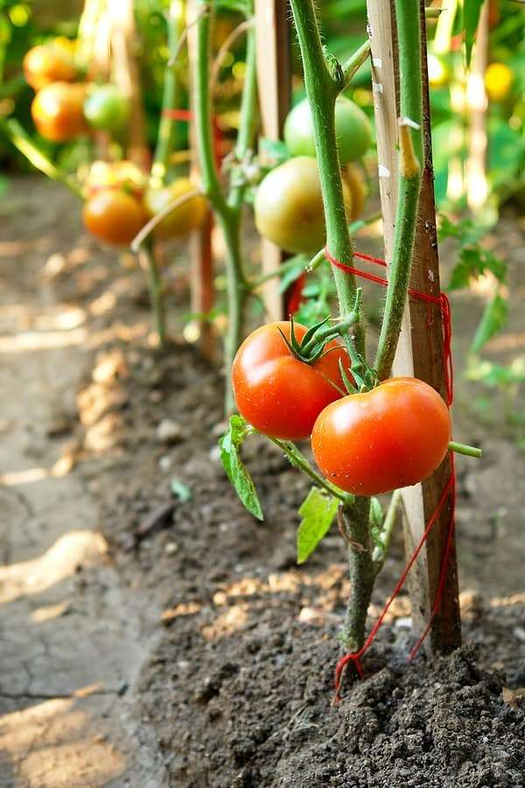
- A learner is managing tomatoes and capsicum in the school farm as shown below.
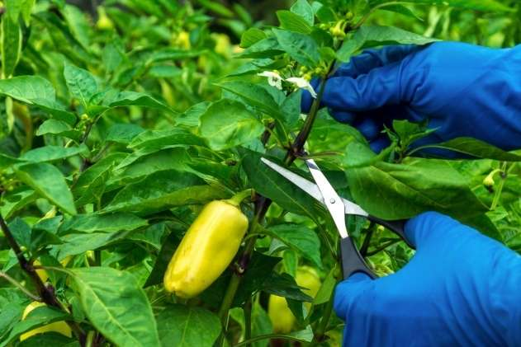

X Y
a) Identify the fruits X and Y. (2 marks)
X: __________________________________________. Y: __________________________________________.
b) Describe THREE pruning practices carried out on vegetable crops. (3 marks)
- _____________________________________________________________________________________.
- _____________________________________________________________________________________.
- _____________________________________________________________________________________.
c) Explain THREE reasons why top dressing is important in crop production. (3 marks)
- _____________________________________________________________________________________.
- _____________________________________________________________________________________.
- _____________________________________________________________________________________.
d) Identify four management practices carried out to tomato seedling in the farm. (4 marks)
- _____________________________________________________________________________________.
- _____________________________________________________________________________________.
- _____________________________________________________________________________________.
- A Grade 10 class established tomatoes using a nursery bed.
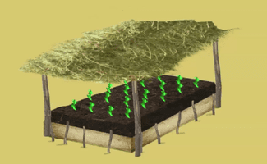
X

a) Identify the activity shown above.(1 mark)
___________________________________________________________________.
b) Identify FOUR crops that are established through a nursery. (4 marks)
- _____________________________________________________________________________________.
- _____________________________________________________________________________________.
- _____________________________________________________________________________________.
- _____________________________________________________________________________________.
c) Describe FOUR management practices carried out in a nursery bed. (4 marks)
- _____________________________________________________________________________________.
- _____________________________________________________________________________________.
- _____________________________________________________________________________________.
- _____________________________________________________________________________________.
d) Justify TWO reasons why nursery establishment is preferred in vegetable production. (4 marks)
- _____________________________________________________________________________________.
- _____________________________________________________________________________________.

- Learners noticed weeds growing among crops on the school farm.
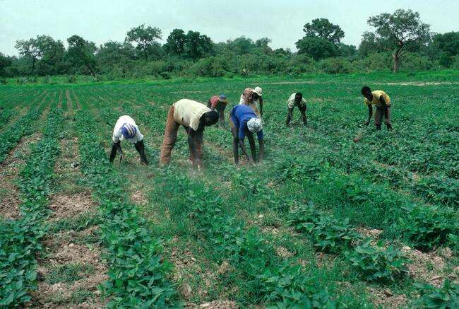
a) Identify the activity shown below. (1 mark)

___________________________________________________
b) Classify weeds based on life cycle. (3 marks)
- _____________________________________________________________________________________.
- _____________________________________________________________________________________.
- _____________________________________________________________________________________.

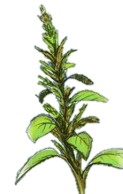
c) Identify the name of the weed shown below. (2 marks)
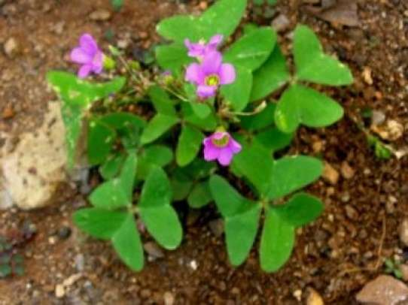
U V
U: ____________________________________.
V: ____________________________________.
d) Describe FOUR methods used to control weeds in a crop field. (4 marks)
- _____________________________________________________________________________________.
- _____________________________________________________________________________________.
- _____________________________________________________________________________________.
- _____________________________________________________________________________________.

e) State TWO economic effects of weeds on farming household. (2 marks)
- _____________________________________________________________________________________.
- _____________________________________________________________________________________.
- _____________________________________________________________________________________.
- A farmer is harvesting some farm produce.
- Identify the crops being harvested below: (2 marks)
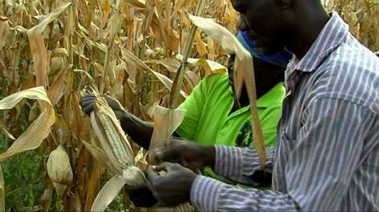
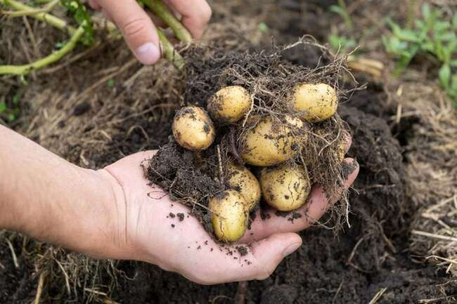
E F
E: __________________________________________________.
F: __________________________________________________.
b) Explain FOUR factors that determine the harvesting time of a crop. (4 marks)
- _____________________________________________________________________________________.
- _____________________________________________________________________________________.
- _____________________________________________________________________________________.
- _____________________________________________________________________________________.
c) State FOUR post-harvest practices carried out to reduce losses. (4 marks)
- _____________________________________________________________________________________.
- _____________________________________________________________________________________.
- _____________________________________________________________________________________.
- _____________________________________________________________________________________.

THIS IS THE LAST PRINTED PAGE

