cbckenyahub.com

KENYA CERTIFICATE OF BASIC EDUCATION (K.C.B.E)
-Biology- -Senior School-

GRADE 10 BIOLOGY TERM 2 MARCH 2026
PATHWAY: S.T.E.M
Time: 2Hours 30 Minutes
COMPETENCE ASSESSMENT EXAMINATION

LEARNER’S DETAILS
Name: _______________________________________________________________________________________.
School: ______________________________________________________________________________________.
Assessment Number: ________________________________. Date: __________________________________.
School Code: _______________________________. Signature: ________________________________.

INSTRUCTIONS TO LEARNERS
- Write your name, assessment number, class and date on all the answer sheets provided.
- Answer all the questions in the spaces provided.
- Use a blue or black pen for writing. Pencils should be used only for drawings and diagrams.
- Make your drawings neat, clear, and large, and label them correctly using ruled lines.
- SCORE GRID
No. | Question Area | Maximum Marks | Learner’s Score | Performance Level
1 | Introduction to Biology & Careers | 10
2 | Biodiversity & Specimen Collection | 15
3 | Microscope & Cell Structure | 20
4 | Cell Structure, Specialisation & Adaptation | 18
5 | Chemicals of Life & Enzymes | 9
6 | Enzymes & Importance of Water | 8
7 | Digestive & Cellular Enzymes | 6
8 | Catalase Enzyme Experiment | 11
9 | Photosynthesis | 13
 | TOTAL | 90

Performance Levels Grid
Level | Level | % Range | Points | Learner’s score
Exceeding (EE) | EE1 | 90–100% | 8
Exceeding (EE) | EE2 | 75–89% | 7
Meeting (ME) | ME1 | 58–74% | 6
Meeting (ME) | ME2 | 41–57% | 5
Approaching (AE) | AE1 | 31–40% | 4
Approaching (AE) | AE2 | 21–30% | 3
Below (BE) | BE1 | 11–20% | 2
Below (BE) | BE2 | 1–10% | 1
This paper has 7 printed pages. Please check out to ensure all pages are printed
Turn over
SECTION A: THEORY (90 Marks)
Answer all questions in this section.
- A career guidance teacher invited learners to explore how Biology influences everyday life and future careers.
a) Mention two main branches of Biology. (2 marks)
- __________________________________________________________________________________.
- __________________________________________________________________________________.
b) Explain TWO applications of Biology in everyday life. (2 marks)
- __________________________________________________________________________________.
- __________________________________________________________________________________.
- __________________________________________________________________________________.
- __________________________________________________________________________________.
c) Match each field of Biology with a suitable career. (4 marks)
Field of Biology | Career
Botany
Microbiology
Genetics
Ecology
d) State TWO factors that should positively influence career choice in Biology. (2 marks)
- __________________________________________________________________________________.
- __________________________________________________________________________________.

- Learners carried out a biodiversity study in their local environment.
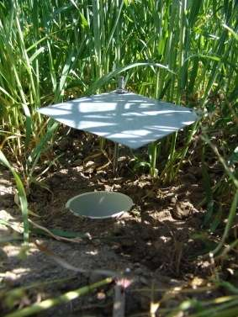
a) Identify the apparatus used to collect small animal specimens shown below. (2 marks)
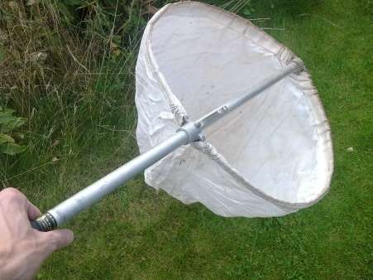

S T
S: _______________________________. T: _______________________________.
b) Other than the ones identified in (2.(a)) above, Identify TWO other apparatus used to collect small animal specimens. (2 marks)
- __________________________________________________________________________________.
- __________________________________________________________________________________.
c) Describe THREE steps followed when preparing a plant specimen for a herbarium. (3 marks)
- __________________________________________________________________________________.
- __________________________________________________________________________________.
- __________________________________________________________________________________.
d) Give THREE reasons why specimen collection and preservation are important in Biology. (3 marks)
- __________________________________________________________________________________.
- __________________________________________________________________________________.
- __________________________________________________________________________________.
- A learner used a light microscope during a Biology practical lesson.
a) Complete the table below by stating the use of each part of the microscope. (4 marks)
Part of the Microscope | Use
Eyepiece lens
Objective lens
Diaphragm
Coarse adjustment knob
b) State THREE differences between a light microscope and an electron microscope. (6 marks)
 | Light microscope | Electron microscope
i
ii
iii
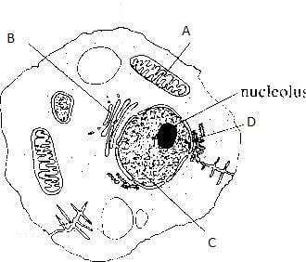
c) Name the cell organelles labelled A, B, C and D. (4 marks)

A: ______________________________.

B: ______________________________.

C: ______________________________.

D: ______________________________.

d) State the function of the following cell organelles. (2 marks)
Cell Organelle | Function

Cytoplasm

Smooth endoplasmic reticulum
- Cells are adapted to perform specific functions.
a) State FOUR differences between plant and animal cells. (4 marks)
 | Plant cell | Animal cell
i
ii
iii
iv
b) Identify the specialized animal or plant cell that performs each of the following functions.(6 marks)
 | Function | Specialised Cell
i | Transports oxygen in the body
ii | Absorbs water and mineral salts from the soil
iii | Transmits electrical impulses in the body
iv | Carries out photosynthesis efficiently
v | Controls opening and closing of stomata
vi | Enables movement by contraction
c) State the ways in which the following cells are adapted to their functions.
i) Root hair cell (1 mark)
________________________________________________________________________________________________.
________________________________________________________________________________________________.
ii) Red blood cell (1 mark)
________________________________________________________________________________________________.
________________________________________________________________________________________________.
- Learners tested food substances in a school laboratory.
a) Name TWO classes of chemicals of life found in cells. (2 marks)
- __________________________________________________________________________________.
- __________________________________________________________________________________.
b) Describe ONE test used to detect each of the following: (3 marks)
i) Starch: ________________________________________________________________________________.
ii) Proteins: ________________________________________________________________________________.
iii) Lipids: ________________________________________________________________________________.
c) State TWO factors that affect enzyme activity. (2 marks)
- __________________________________________________________________________________.
- __________________________________________________________________________________.

- Catalase enzyme was tested using liver tissue.
a) Define the term enzyme. (2 marks)
____________________________________________________________________________________________________________________________________________________________________________________________________
b) Explain TWO roles of enzymes in living cells. (2 marks)
- ____________________________________________________________________________________________
- ____________________________________________________________________________________________
c) State TWO importance of water in cells. (2 marks)
- ____________________________________________________________________________________________
- ____________________________________________________________________________________________
- Complete the table below by identifying the enzyme that performs each function. (6 marks)
 | Function of Enzyme | Name of Enzyme
i | Breaks down hydrogen peroxide into water and oxygen
ii | Breaks down starch into maltose
iii | Breaks down proteins into amino acids
iv | Breaks down fats (lipids) into glycerol and fatty acids
v | Breaks down lactose into glucose and galactose
vii | Breaks down RNA into nucleotides
- A learner conducted an experiment to investigate the action of catalase enzyme in living tissues.
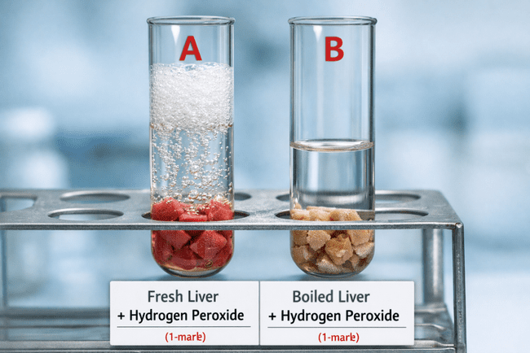
Two test tubes, A and B, were set up as shown below:

- Test tube A contained fresh liver pieces and hydrogen peroxide.
- Test tube B contained boiled liver pieces and hydrogen peroxide.
The learner observed that bubbles of gas were produced in test tube A, but no bubbles were observed in test tube B.
a) Name the gas produced in test tube A. (1 mark)
__________________________________________________.
b) Identify the enzyme present in the liver tissue. (1 mark)
_____________________________________________________________.
c) Explain why bubbles were observed in test tube A but not in test tube B. (2 marks)
______________________________________________________________________________________________________________________________________________________________________________________________________________________________________________________________________________________________________
d) State TWO conclusions that can be drawn from this experiment. (2 marks)
- ____________________________________________________________________________________________
- ____________________________________________________________________________________________
e) Give TWO precautions that should be taken to ensure reliable results in this experiment. (2 marks)
- ____________________________________________________________________________________________
- ____________________________________________________________________________________________
- Plants obtain nutrients in different ways.
a) Describe TWO structural features of the chloroplast related to its function. (2 marks)
- ____________________________________________________________________________________________
- ____________________________________________________________________________________________
b) Photosynthesis takes place in two stages. Name the part of the chloroplast where the light stage occurs. (1 mark)
_______________________________________________.

c) How is the dark stage dependent on the light stage of photosynthesis? (2mks)
____________________________________________________________________________________________________________________________________________________________________________________________________
d) State TWO importance of photosynthesis in nature. (2 marks)
- ____________________________________________________________________________________________
- ____________________________________________________________________________________________
e) Differentiate between the light stage and dark stage of photosynthesis. (2 marks)
____________________________________________________________________________________________
____________________________________________________________________________________________
____________________________________________________________________________________________
____________________________________________________________________________________________
f) State TWO factors affecting the rate of photosynthesis. (2 marks)
- ____________________________________________________________________________________________
- ____________________________________________________________________________________________
g) Write the word equation for photosynthesis. (2 marks)
____________________________________________________________________________________________
____________________________________________________________________________________________

THIS IS THE LAST PRINTED PAGE
,for marking scheme visit
Cbckenyahub.com

