Cbckenyahub.com

KENYA CERTIFICATE OF BASIC EDUCATION (K.C.B.E)
-CHEMISTRY GRADE 10 -Senior School-

CHEMISTRY (Theory) TERM 2 2026
PATHWAY: S.T.E.M
Time: 2 HOURS
COMPETENCY BASED EDUCATION

LEARNER’S DETAILS
Name: _______________________________________________________________________________________.
School: ______________________________________________________________________________________.
Assessment Number: ________________________________. Date: __________________________________.
School Code: _______________________________. Signature: ________________________________.

INSTRUCTIONS TO LEARNERS
- Write your name, assessment number, class and date on all the answer sheets provided.
- Answer all the questions in the spaces provided.
- Use a blue or black pen for writing. Pencils should be used only for drawings and diagrams.

SCORE GRID
Question No. | 1 | 2 | 3 | 4 | 5 | 6 | 7 | 8 | 9 | 10 | 11 | 12 | 13 | 14 | TOTAL
Question Marks | 8 | 7 | 8 | 7 | 10 | 6 | 10 | 7 | 2 | 5 | 2 | 8 | 3 | 2 | 80
Learner’s Score
Performance Level

Performance Levels Grid
Section | Max Marks |  | Learner Score
A | 70
B | 30
TOTAL | 100
Level | Level | % Range |  | Points | Learner’s score
Exceeding (EE) | EE1 | 90–100% |  | 8
Exceeding (EE) | EE2 | 75–89% |  | 7
Meeting (ME) | ME1 | 58–74% |  | 6
Meeting (ME) | ME2 | 41–57% |  | 5
Approaching (AE) | AE1 | 31–40% |  | 4
Approaching (AE) | AE2 | 21–30% |  | 3
Below (BE) | BE1 | 11–20% |  | 2
Below (BE) | BE2 | 1–10% |  | 1
This paper has 8 printed pages. Please check out to ensure all pages are printed
Turn over
SECTION A: Theory (80 Marks)
Answer all questions in this section.
- a) Define Chemistry as a field of science. (2 marks)
___________________________________________________________________________________________________________________________________________________________________________________________________
b) State four branches of Chemistry. (2 marks)
- ______________________________________________________.
- ______________________________________________________.
c) Identify two careers related to Chemistry relevant to Agriculture. (2 marks)
- _______________________________________________________________________________________.
- _______________________________________________________________________________________.
d) Give two reasons why Chemistry is important in farming. (2 marks)
- _______________________________________________________________________________________.
- _______________________________________________________________________________________.



- The diagram below shows areas where Chemistry is applied in daily life.

X Y Z
a) Identify three industries shown above that use Chemistry. (3 marks)
X: _________________________.
Y: __________________________.
Z: ___________________________.

b) Explain three ways Chemistry contributes to development in Kenya. (3 marks)
- _______________________________________________________________________________________.
- _______________________________________________________________________________________.
- _______________________________________________________________________________________.
c) State one negative effect of misuse of chemicals in daily life. (1 mark)
_______________________________________________________________________________________.
_______________________________________________________________________________________.
- A farmer applies chemicals without following instructions on the label.
a) Distinguish between the following pairs of terms: (4 marks)
i) Drug and medicine
____________________________________________________________________________________________________________________________________________________________________________________________________
ii) Legal drugs and illegal drugs
____________________________________________________________________________________________________________________________________________________________________________________________________
b) Explain three effects of drug and substance abuse on an individual. (3 marks)
- _______________________________________________________________________________________.
- _______________________________________________________________________________________.
- _______________________________________________________________________________________.
c) State one responsibility of learners in promoting a safe and healthy learning environment. (1 mark)
_______________________________________________________________________________________.
_______________________________________________________________________________________.

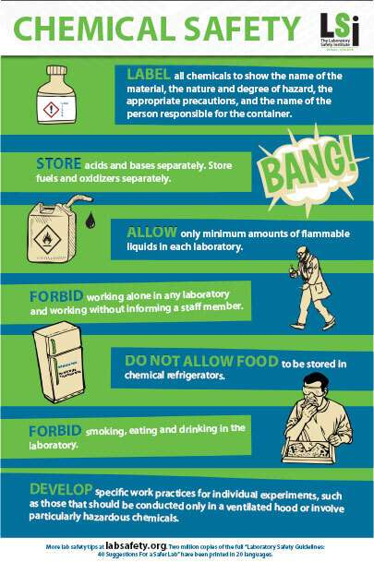
- Below is a poster displayed in a school laboratory.


a) Identify two safety messages shown in the poster. (2 marks)
- _______________________________________________________________________________________.
- _______________________________________________________________________________________.
b) Explain three consumer rights related to drug prescription and chemical use. (3 marks)
- _______________________________________________________________________________________.
- _______________________________________________________________________________________.
- _______________________________________________________________________________________.
c) State two ways students can sensitize the community about drug abuse. (2 marks)
- _______________________________________________________________________________________.
- _______________________________________________________________________________________.

- Grade 10 learners of Starehe Boys Centre drew diagrams to represents the structure of an atom.
a) Name three sub-atomic particles found in an atom. (3 marks)
- _______________________________________________________________________________________.
- _______________________________________________________________________________________.
- _______________________________________________________________________________________.
b) State one charge for each particle named in (a). (3 marks)
- _______________________________________________________________________________________.
- _______________________________________________________________________________________.
- _______________________________________________________________________________________.
c) Distinguish between: (4 marks)
i) Atomic number
____________________________________________________________________________________________________________________________________________________________________________________________________
ii) Mass number
______________________________________________________________________________________________________________________________________________________________________________________________________________________
- An element X has the following isotopes:
Isotope | Mass Number | Abundance (%)
X₁ | 35 | 75
X₂ | 37 | 25
a) Define isotopes. (2 marks)
____________________________________________________________________________________________________________________________________________________________________________________________________
b) Calculate the relative atomic mass of element X. (2 marks)

c) Write the electron arrangement of element X using s and p orbitals.(2 marks)

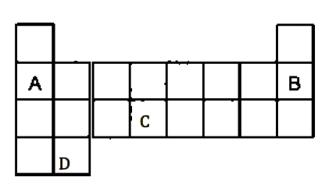
- The partial periodic table below shows elements A, B, C, and D.

X

a) Identify the elements represented by the letters above: (4 marks)
A: __________________________
B: __________________________
C: __________________________
D: __________________________
b) Identify the group and period of element B. (2 marks)

Group

Period
c) Explain how the position of an element in the periodic table relates to its electron arrangement. (2 marks)
____________________________________________________________________________________________________________________________________________________________________________________________________
d) Predict the type of ion formed by element X and explain your answer. (2 marks)
________________________________________________________________________________________________________________________________________________________________________________________________________________________________________________________________________________________________________________________________________________________________________________________________________

- A farmer mixes calcium hydroxide with ammonium sulphate fertilizer.
a) Define valency and oxidation number. (2 marks)
Valency: _________________________________________________________________________________________.
Oxidation number: ________________________________________________________________________________.
b) Derive the chemical formula of ammonium sulphate. (2 marks)

c) Write a balanced chemical equation for a neutralization reaction involving calcium hydroxide. (3 marks)

Define the following terms: (2 marks)
i) Atom:
____________________________________________________________________________________________________________________________________________________________________________________________________
ii) Compound:
____________________________________________________________________________________________________________________________________________________________________________________________________

(a) Write the chemical symbols of the following elements: (3 marks)
i) Hydrogen: _______________________
ii) Oxygen: ________________________
iii) Iron: __________________________
(b) Write the names of the elements represented by the following symbols: (2 marks)
i) Na: ____________________________________________
ii) K: _____________________________________________

(a) State one use of each of the following metals: (2 marks)
i) Calcium:
____________________________________________________________________________________________________________________________________________________________________________________________________
ii) Iron:
____________________________________________________________________________________________________________________________________________________________________________________________________

Complete the table below: (8 marks)
Compound Name | Element 1 | Element 2 | Chemical Formula
Water | Oxygen
Common salt | Sodium
Carbon dioxide | Carbon
Ammonia | Hydrogen

Name the following compounds: (3 marks)
i) HCl: __________________________________________
ii) MgO: _________________________________________
iii) CO₂: ________________________________________

Complete the following reactions: (2 marks)
i) Sodium + Chlorine → ____________________________
ii) Calcium + Fluorine → ___________________________
THIS IS THE LAST PRINTED PAGE
For marking scheme visit .Cbckenyahub.com

