cbckenyahub.com

KENYA CERTIFICATE OF BASIC EDUCATION (K.C.B.E)
-CORE MATHEMATICS -Senior School-

GRADE 10 CORE MATHEMATICS TERM 2 2026
PATHWAY: S.T.E.M
Time: 2 Hours
COMPETENCY BASED EDUCATION

LEARNER’S DETAILS
Name: _______________________________________________________________________________________.
School: ______________________________________________________________________________________.
Assessment Number: ________________________________. Date: __________________________________.
School Code: _______________________________. Signature: ________________________________.

INSTRUCTIONS TO LEARNERS
- Write your name, school, assessment number, date, school code and then sign.
- Answer all questions provided.
- Show all your working properly.
- Use mathematical tables or a calculator where necessary.

Question No. | 1 | 2 | 3 | 4 | 5 | 6 | 7 | 8 | 9 | 10 | 11 | 12 | 13 | 14 | 15 | 16 | 17 | 18 | 19 | 20 | 21 | Total
Marks | 3 | 3 | 3 | 3 | 10 | 10 | 7 | 10 | 7 | 3 | 3 | 3 | 4 | 3 | 4 | 4 | 3 | 3 | 10 | 10 | 10 | 100
Learner’s Score
Performance Level
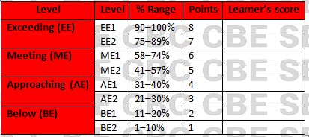
DESCRIPTION | SCORE
TOTAL SCORE | 100
LEARNER’S SCORE
PERFOMANCE LEVEL

This paper has 13 printed pages. Please check out to ensure all pages are printed
Turn over

CORE MATHEMATICS: (100 Marks)
Answer all questions provided in this assessment paper.
- Solve for x: 2 ^{x-3} x 8^{x2+2}=128 (3 marks)

- Use logarithms to evaluate 3 1.23 x 0.0468 (3 mks)
0.7782

- Evaluate without using tables.
Log (3x+8) – 3 log 2= log(x-4) (3mks)

- A classroom measures (x+2)m by (x-5)m. If the area of the classroom is 60m². Find its dimensions. (3mks)

- Three solids, a cylinder, a sphere and a cone, are such that their radii are equal. It is also given that their surface areas are the equal. If the volume of the sphere is 904.9cm3. Find the volume of;( Give your answers to 4 s.f)
- The cylinder (4 mks)

- The cone. (4mks)

- (a) A small filed was surveyed and the measurements recorded in the surveyor’s filed book as in the table below.(AF=100M)

 | F
E 30  C 20 | 65  50  30  20 | 40 D  25 B
 | A

- Using a scale of 1cm to 10m , make an accurate drawing of the map of the filed. (4mks)

- Find the area of the field. (3mks)

b)Assuming that the baseline used in (a) runs in a northerly direction, give the position of D, relative to A, using bearing and distance. (3mks)

- The heights of trees seedlings in a nursery were measured and recorded as in the table below.
Height x cm | 0-5 | 6-15 | 16-25 | 26-45 | 46-75
No of seedlings | 7 | 46 | 71 | 64 | 11
- Calculate the mean height. (4 mks)

- Using a scale of 1cm to represent 5 units along the horizontal axis, and a scale of 2cm to represent 5 units along the vertical axis, draw a histogram to represent the distribution. (3mks)

- (a) Complete the table below for the equation y=x²+3x-6 given -6<x<4. (5 marks)

X | -6 | -5 | -4 | -3 | -2 | -1 | 0 | 1 | 2 | 3 | 4
Y | 12 |  |  | -6 |  |  | -6 |  |  |  | 22
(b)using a scale of 1cm to represent 2 units in both axes draw the graph of y=x²+3x-6.

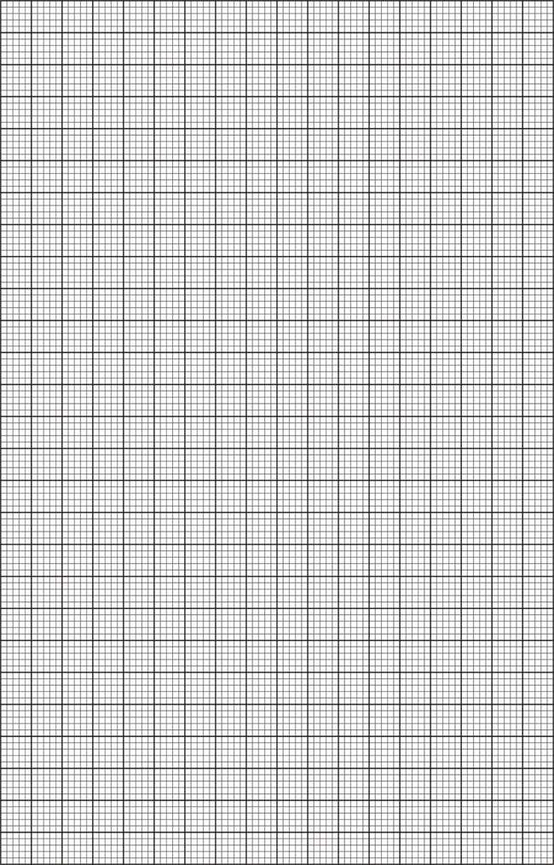

- Use the graph to solve the quadratic equations.
- X²+3x-6=0 (2mks)
- X²+3x-2=0 (3mks)

- (a) In the figure below O is the centre of the circle whose radius is 6cm and PQ is 9cm.

0

P
Q

Calculate the area of major segment. (4mks)

- Find the area of a triangle ABC with sides 7cm, 9cm and 11cm long. (3mks)

- A man withdrew some money from a bank. He spent $\frac{3}{10}$ of the money on his daughter’s school fees and $\frac{3}{5}$ of the remainder on his son’s school fees. If he remained with Ksh 10 500, calculate the amount of money he spent on son’s school fees. (3 marks)

- Solve for $x$ (3 marks)
$$9^{(x+1)}+3^{(2x+1)}=108$$

- The volume of two similar solid spheres are 4752 cm³ and 1408 cm³. If the surface area of the smaller sphere is 352 cm², find the surface area of the larger sphere. (3 marks)

- When a given length of a piece of wire is divided into pieces measuring 20 cm or 24 cm or 26 cm or 28 cm, a piece of wire 7cm always remained. Find the length of wire. (4 marks)

- Solve the equation $6x^{2}-13x+6=0$ using the completing the square method. (3 marks)

- Using a ruler and a pair of compasses only, construct a trapezium ABCD in which $AB=5 cm$, $AD=6 cm,DC=10 cm, ∠BAD=105°$ and AB is parallel to DC. Draw a perpendicular from B to DC hence measure the height of the trapezium. (4 marks)

- Two friends Ojwang and David live 40 km apart. One day Ojwang left his house at 9.00 a.m. and cycled towards David’s house at an average speed of 15 km/h. David left his house at 10.30 a.m. on the same day and cycled towards Ojwang’s house at an average speed of 25 km/h. Determine;
- The time taken before the two friends met. (3 marks)

- The time they met. (1 mark)

- Simplify completely; $\frac{{\left(m+5n\right)}^{2}+{\left(m-5n\right)}^{2}}{{3m}^{2}+75n^{2}}$ (3 marks)

- Use logarithms to evaluate. (3 marks)
$$\frac{39.51 × 614}{0.758}$$

- The vertices of a triangle ABC are A(1,1), B(4,1) and C(6,4)
- On the grid below, draw the triangles.
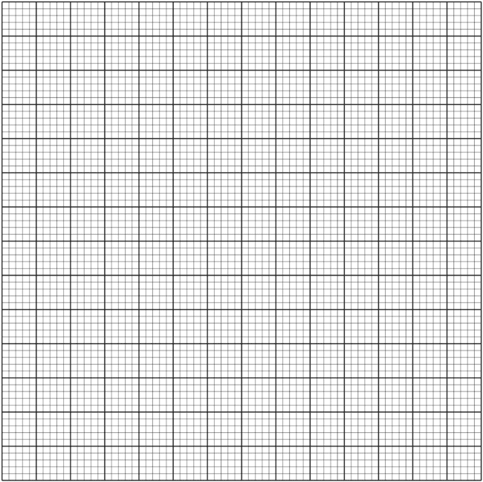
- ABC. (1 mark)
- $A'B'C'$, the image of triangle ABC under a negative quarter turn about the origin.
(2 marks)
- $A''B''C''$, the image of triangle $A'B'C'$, under reflection in the line $y=x$. (2 marks)

- Triangle $A'''B'''C'''$, with vertices $A^{'''}\left(-1, -5\right) B^{'''}\left(-4, -5\right)and C'''(-6, -2)$, is the image of , triangle $A''B''C''$, under a transformation T.

- Draw the triangle $A'''B'''C'''$, (1 mark)

- Describe fully the transformation T. (2 marks)

- State any pair of triangles which are:
  - Directly congruent. (1 mark)

  - Oppositely congruent. (1 mark)

- The figure below shows a triangle inside a circle. $AB=8 cm, BC=10 cm$ and $AC =13cm$
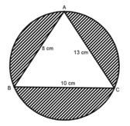
Calculate
- The area of triangle ABC. (3 marks)

- Angle BAC (2 marks)

- The radius of the circle. (2 marks)

- Area of the shaded region. (3 marks)

- A construction company makes concrete by mixing cement, sand and ballast such that the ratio of cement to sand is 1:2 and that of sand to ballast is 3:4.
- Determine:
- The ratio of cement to ballast in the concrete. (2 marks)

- The number of bags of ballast required to make a concrete with 27 bags of sand. (2 marks)

- The cost of a bag of cement, sand and ballast is Ksh 680, Ksh 136 and Ksh 102 respectively. Calculate the cost of one bag of concrete. (2 marks)

- The construction company requires to transport 30 tonnes of sand to a site using a tractor. The tractor carries a maximum of 3 600 kg of sand and costs Ksh 8 000 per trip. Calculate the least amount of money required to transport the sand to the site. (4 marks)

THIS IS THE LAST PRINTED PAGE
For marking scheme visit,cbckenyahub.com

